Water Quality Statistics
This project has been funded wholly or in part by the United States Environmental Protection Agency under assistance agreement PC-01J95801-2 to the Washington State Department of ECOLOGY. The contents of this document do not necessarily reflect the views and policies of the Environmental Protection Agency, nor does mention of trade names or commercial products constitute endorsement or recommendation for use.

Overview
We developed a set of inferential statistical models to estimate chemical concentrations in stormwater runoff across the Puget Sound watershed. Models were developed using spatial and temporal landscape predictors for a subset of constituents of concern (COCs). These models represent an advancement over current practices, which rely on categorical land use designations (e.g., high vs. low density residential, commercial, industrial) to approximate chemical concentrations in stormwater. While this method is convenient, it has some limitations. In particular, categorical land use designations vary by jurisdiction, limiting applicability of results between jurisdictions over a landscape. A qualitative comparison of existing land cover data sources and self-reported land use types revealed little agreement among jurisdictions’ definitions of land use categories. We therefore hypothesized that land use designation alone would be a poor predictor of chemical concentration in unmonitored basins.
Our objectives were to:
- Find a stronger, more data-driven method of predicting chemical concentration compared to the current method of using categorical land use designations to assign concentrations. Here, we investigate the potential for using continuous, measurable landscape spatial predictors (also referred to as spatial predictors) that can be objectively measured across large regions, thereby increasing the applicability of model results across jurisdictional boundaries.
- Determine whether a landscape spatial predictor approach produces stronger predictive power than either a null model or the current categorical land use model.
In order to achieve these objectives, we developed null, categorical land use, and landscape spatial predictor models to estimate concentrations for constituents of concern (COCs) in Puget Sound stormwater. We define these models in the following way (details provided later):
- Null Model: COC concentration is equal to median COC concentration over all sampling dates and locations.
- Categorical Land Use Model: COC concentration is modeled as a linear mixed effects model, utilizing land use category (high density residential [HDR], low density residential [LDR], commercial [COM], industrial [IND]), precipitation (rainfall and/or antecedent dry days) and season (for COCs where a seasonal trend appeared in the data).
- Spatial Predictor Model: COC concentration is modeled as a linear mixed effects model, utilizing one or two landscape spatial predictors, precipitation (rainfall and/or antecedent dry days) and season (for COCs where a seasonal trend appeared in the data).
Landscape spatial predictors were drawn from raster data (e.g., traffic, tree cover, impervious surface cover), raster land use layers (commercial, industrial, residential), and spatio-temporal layers (e.g., rainfall, seasonality). Spatial predictor models built from raster layers were then compared against the null and categorical land use models for fit and predictive ability. The best fit models were translated to the Stormwater Heatmap online communication tool using colors to show predicted pollutant concentration. For all COCs analyzed, the spatial predictor model out-performed the null model and the categorical land use model.
In addition to COC concentration estimates, we also provide information about the underlying variability in the estimates. We achieved this for each COC by calculating Bayesian confidence intervals (known as credible intervals) over a range of landscape predictor values. This gives users a sense of the median COC concentrations they might expect at an outfall with particular spatial predictor values.

Data Sources

Outfall Data
The primary source of observed stormwater data is the S8.D Municipal Stormwater Permit Outfall Data (referred to as the S8 Data in this document) provided by the Washington Department of Ecology (Hobbs et al., 2015). Special Condition S8.D of the 2007-2012 Phase I Municipal Stormwater Permit required permittees to collect and analyze data to evaluate chemical concentrations in stormwater discharged from catchments with the following self-reported land uses: High Density Residential (HDR), Low Density Residential (LDR), Commercial (COM) and Industrial (IND). Phase I Permittees measured water quality, discharge, and other parameters from stormwater outfalls during storm events.
Stormwater data collected from a total of 16 catchments by six Phase I Permittees were utilized in this modeling study. Catchment drainage basin boundaries were obtained or estimated based on a variety of sources (Table 1).
Table 1. Data sources for S8 catchment basin boundaries.
Agency | Data Sources for Polygon Boundaries
King County | LDR: Estimated based on: 1.) description of sampling location and water flow in Quality Assurance Project Plan for King County (2010), 2.) King County Maps ArcGIS: Catchment boundaries derived from terrain data (accessed 9/14/2026), and 3.) catchment size described in Dept. of Ecology S8.D report (Hobbs et al, 2015)  HDR, COM: Quality Assurance Project Plan for King County (2010)
Pierce County | LDR, HDR, COM: Pierce County Public Works and Utilities (2012)
Snohomish County | LDR, HDR, COM: Quality Assurance Project Plan for Snohomish County (2008)
City of Seattle | HDR, COM, IND: Section S8.D – Stormwater Characterization Quality Management System Planning Document (2011)
City of Tacoma | HDR, COM, IND: City of Tacoma (2014) - Thea Foss and Wheeler-Osgood Waterways Stormwater Monitoring QAPP
Port of Tacoma | COM: Estimated based on: 1.) location of the outfall provided on the EIM website, 2.) USGS StreamStats drainage delineation (https://streamstats.usgs.gov/ss/), and 3.) catchment size described in Dept. of Ecology S8.D report (Hobbs et al, 2015)

The S8 Data are available from the Washington Department of Ecology (hereafter referred to as Ecology) via an open-data api at: https://data.wa.gov/Natural-Resources-Environment/Municipal-Stormwater- Permit-Outfall-Data/d958-q2ci.
COCs analyzed in this study are:
- Total Copper
- Total Suspended Solids (TSS)
- Total Phosphorus
- Total Zinc
- Total Kjeldahl Nitrogen (TKN)
We extracted data for these COCs, and performed minimal data cleaning. We filtered out rejected data (values with a R or REJ flag), removed replicates, and removed one data point each for TKN, Phosphorus and TSS that were outliers (an order of magnitude higher than the majority of the data). Additionally, four Zinc samples above 800 mg/kg were also removed, as these high values had the potential to strongly influence the models. Figure 1 shows data before removal of outliers.
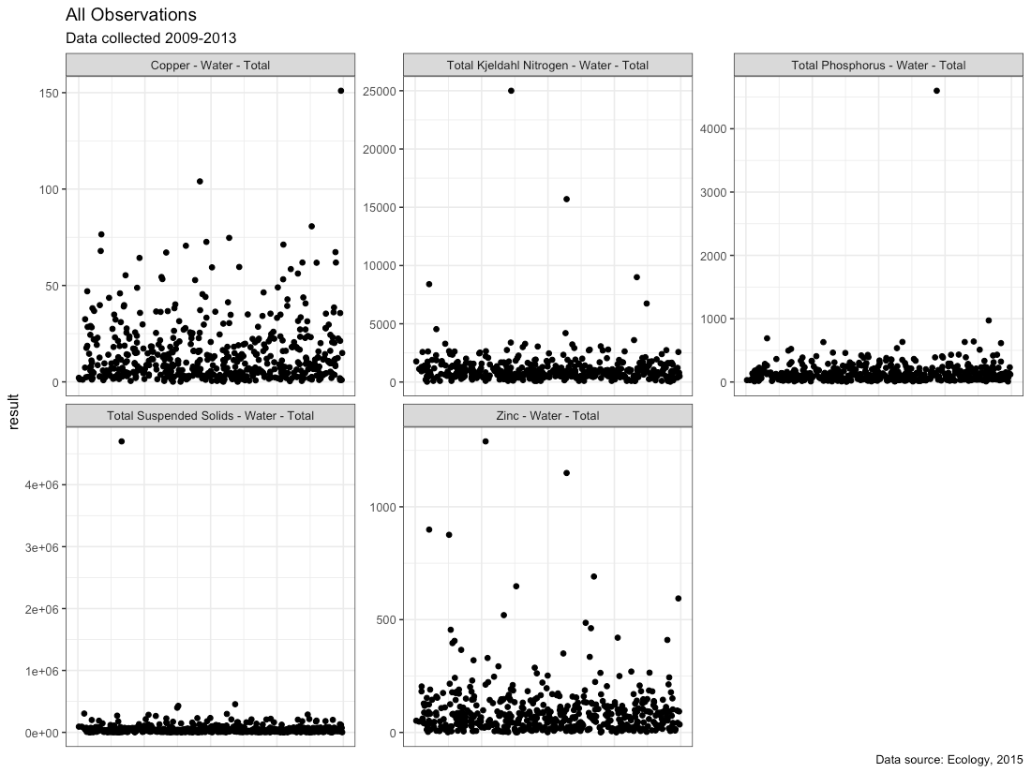
Figure 1. All observations with outliers in place.

Censored (Non-Detect) Data
All COCs had non-detect (ND; left-censored) data present (Table 2). Ecology flagged non-detect data and provided the reporting limit for each non-detect value. The EPA allows substitution of (0.5 x detection limit) for censored values when less than 15% of samples are non-detect (USEPA, 2009). However, substitution can add a pattern to the data that is different than the pattern of the data itself, with the likelihood increasing as the proportion of non-detect data increases (Helsel, 2012). In the S8 Data, most COCs had only a small percentage of data that were non-detect (<1.5%); for these, non-detect values were substituted with one-half of the reporting limit. TKN had a higher level of non-detect data (approximately 11%). We decided not to perform substitution of non-detect TKN samples to avoid introducing an extraneous pattern. Instead, regression on order statistics (ROS) and censored statistics were employed for TKN. (See the Total Kjeldahl Nitrogen section under the Results heading for details.)
Table 2. Percentage of data points that were non-detect (left-censored) for each COC. ND: non-detect
Chemical of Concern | Censored Data Percentage | Method for Estimation of Censored Statistics | Notes
Total Copper | < 1% | Substitution  (0.5 x detection limit) | 4 samples were field blanks misclassified as NDs. Censored data percentage was calculated following removal of these 4 field blanks.
Total Suspended Solids | < 1% | Substitution  (0.5 x detection limit) | None
Total Phosphorus | 1.5% | Substitution  (0.5 x detection limit) | 3 samples with high results were misclassified as ND, rather than as estimated. Censored data percentage was calculated following reclassification of these 3 data points.
Total Zinc | < 0.5% | Substitution  (0.5 x detection limit) | 4 samples were field blanks misclassified as NDs. Censored data percentage was calculated following removal of these 4 field blanks
Total Kjeldahl Nitrogen | 11% | Regression on  Order Statistics (frequentist models)  Censored Statistics (Bayesian models) | 1 sample was misclassified as ND, rather than estimated. 2 low ND samples were removed, as they were field blanks misclassified as ND. Censored data percentage calculated following reclassification of these data points.

Transformation of outfall data
Each COC was evaluated for its underlying distribution, to determine whether transformation would be beneficial prior to analysis. Quantile-quantile plots (QQ plots) using a normal distribution, gamma distribution, square-root transformed distribution, and natural log-transformed (ln-transformed) distribution were visually analyzed. For all COC’s, ln-transformation was deemed appropriate prior to model analysis (Figure 2).
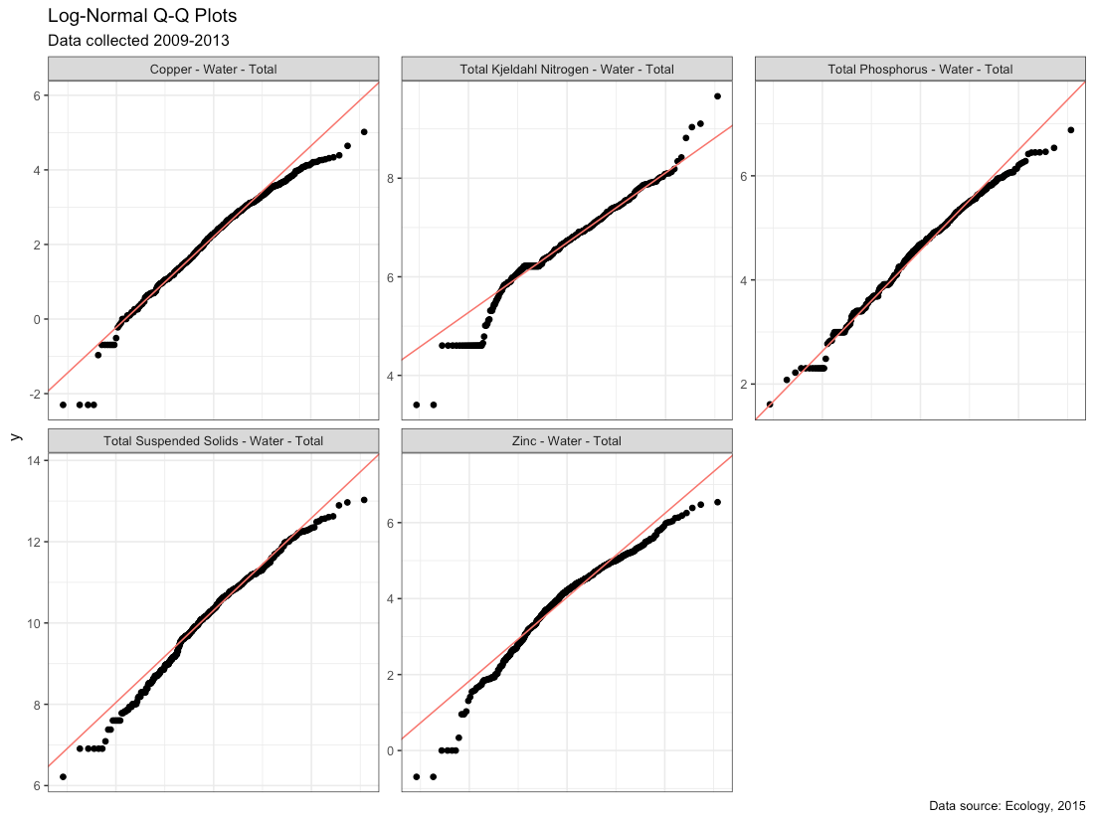
Figure 2. Quantile-quantile plots of COCs using a natural-log (ln) scale. Red line shows the QQ-line.

Landscape Spatial Data
We compiled a suite of continuous spatial datasets from raster layers for use in fitting spatial predictor models. Among these layers are datasets of continuous land use. These raster layers are distinct from the land use categories that are applied to entire catchments, as the raster layers allow accurate representation of mixed land use types within a single catchment.
Landscape spatial data layers and their source are provided in (Table 3). Several spatial predictors were derived from the original data layers, including:
- totRES and intURB_IND — each of these are a grouping of similar land use categories (urban + rural residential; intensive urban + industrial) from the Washington State Department of Commerce: Puget Sound Mapping Project. Combining categories allowed us to combine some less common land uses from the S8 dataset with similar, more common land uses;
- roof_urbRES, roof_totRES and roof_intURB – derived from rooftop density (Robertson et al, in prep) applied to land use data (Washington State Department of Commerce: Puget Sound Mapping Project);
- devAge – land development weighted by age, using Pesaresi et al., 2005 data in the following equation: devAge = 4*dev_pre_1975 + 3*dev_1975_1990 + 2*dev_1990_2000 + 1*dev_2000_2014;
- oldDev – land development older than 1990 weighted by age, using Pesaresi et al., 2005 data in the following equation: oldAge=2*dev_pre_1975 + 1*dev_1975_1990;
- CO2_transport – sum of road, rail and commercial marine vessel CO2 data from Gurney et al., 2019.
Spatial data layers or derived layers that were candidates for model selection are indicated in bold-face in Table 3. Spatial data layers were applied to boundaries of the S8 watersheds, and the mean spatial predictor values (hereafter refered to as spatial preditors) for each watershed were obtained.
Table 3. Sources of landscape spatial predictor data layers used to develop statistical models. Layers that were candidates for model selection are indicated in bold-face.
Layer | ID | Source
urban residential | urbRES | Washington State Department of Commerce: Puget Sound Mapping Project
rural residential | ruRES
intensive urban (commercial) | intURB
industrial | IND
total residential (urban + rural) | totRES | urbRES + ruRES
intensive urban + industrial | intURB_IND | intURB + IND
impervious surfaces | impervious | Robertson et al. (in preparation)
paved surfaces | paved | Robertson et al. (in preparation)
rooftop density | roofs | Robertson et al. (in preparation)
total residential roofs | roof_totRES | totRES applied to roofs predictor
intensive urban + industrial roofs | roof_ intURB_IND | intURB_IND applied to roofs predictor
grass & low vegetation | grass | Robertson et al. (in preparation)
trees | trees | Robertson et al. (in preparation)
undeveloped areas | nodev | Pesaresi et al., 2015
development pre-1975 | dev_pre_1975 | Pesaresi et al., 2015
development 1975-1990 | dev_1975_1990 | Pesaresi et al., 2015
development 1990-2000 | dev_1990_2000 | Pesaresi et al., 2015
development 2000-2014 | dev_2000_2014 | Pesaresi et al., 2015
age of development | devAge | 4*dev_pre_1975 + 3*dev_1975_1990 + 2*dev_1990_2000*+1*dev_2000_2014
old development | oldDev | 2*dev_pre_1975 + 1*dev_1975_1990
annual average daily traffic | traffic | Robertson & Howe (in preparation)
population | popn | United States Census Bureau, 2010 Census Blocks
particulate matter 2.5um | pm25_na | Amini et al., 2022
particulate surface area | partSA | Amini et al., 2022
NO2 | no2 | Amini et al., 2022
carbon emissions: commercial marine vessel | CO2_cmv | Gurney et al., 2019
carbon emissions, commercial | CO2_com | Gurney et al., 2019
carbon emissions, rail | CO2_rail | Gurney et al., 2019
carbon emissions, residential | CO2_res | Gurney et al., 2019
carbon emissions, road | CO2_road | Gurney et al., 2019
carbon emissions, nonroad | CO2_nonroad | Gurney et al., 2019
carbon emissions, total | CO2_total | Gurney et al., 2019
carbon emissions, transport | CO2_transport | CO2_road + CO2_rail + CO2_cmv

Transformation
For some spatial predictors, the presence of outliers or extended tails of the data indicated that transformation would be beneficial. Square-root transformation was performed on the raw data layers for following predictors: popn, CO2_com, CO2_res, CO2_road, CO2_nonroad, CO2_total and CO2_transport. The square-root transformed layers were then applied to S8 watershed boundaries, and the mean spatial predictor values were obtained.

Transformation and convolving of traffic data
The traffic data layer has an especially large spread of values, so was transformed using natural-log (ln) transformation. Afterward, the traffic predictor received an additional step of pre-processing. Vehicle traffic on paved roads has been shown to generate airborne particulate matter that extends up to 150 m from the roadway (Zhu et al., 2002a & 2002b), with some of these particulates inevitably end up in stormwater. To account for the effect of vehicle traffic that extends beyond roadways, we convolved the traffic predictor with a 100-meter gaussian kernel. The transposed and convolved traffic layer was then applied to the S8 watershed boundaries and the mean spatial predictor values for traffic were obtained.
Figure 3 shows the spatial data following transformation. Prior to use in models, spatial data sets were scaled and centered using the mean and standard deviation from the 14 catchments in this study.
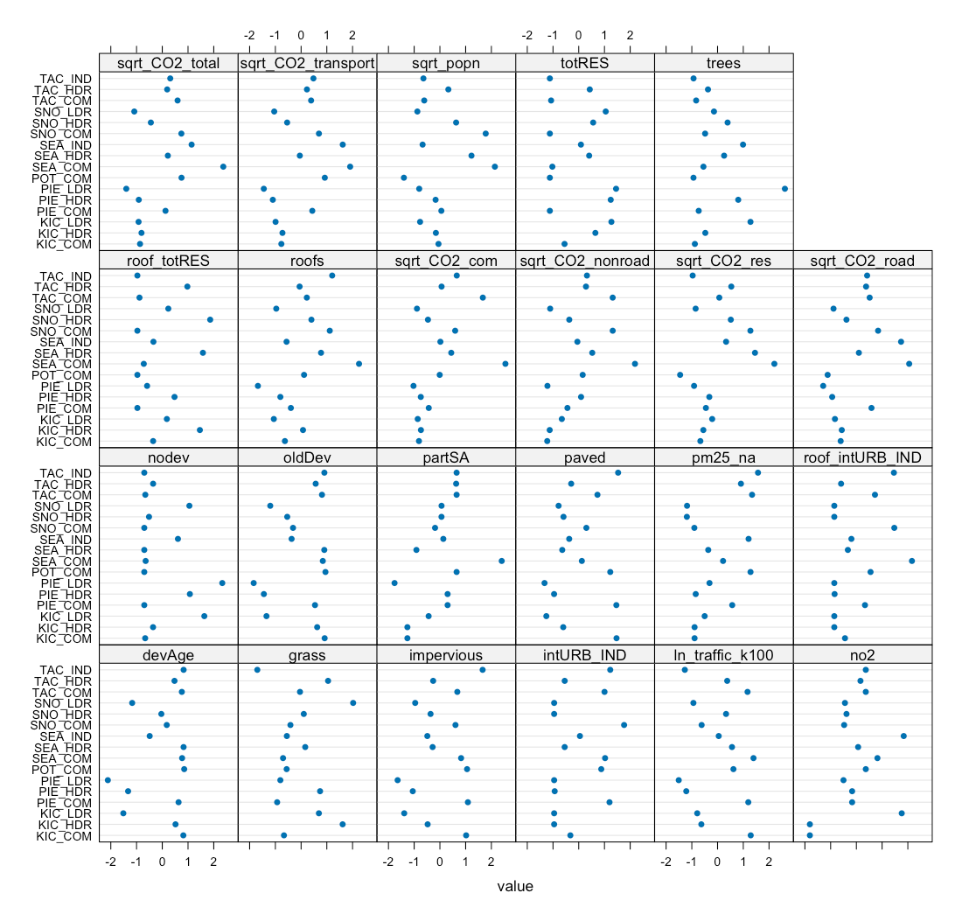
Figure 3. Spatial data following transformation where needed, and standardization.

Precipitation Data
Daily rainfall data were obtained from the Daymet website operated by NASA (https://daymet.ornl.gov/; Thornton et al 2022). Daily data were obtained for years 2009 to 2013, and cumulative one-day, three-day, seven-day, 14-day, 21-day and 28-day antecedent precipitation was calculated for each sampling date. For example, for a sampling date of March 24, cumulative three-day precipitation would include precipitation occurring on March 22, 23 and 24. Antecedant dry days leading up to each sampling date were also calculated.
For each COC, ln-transformed COC concentrations were plotted against each precipitation measurement, and the plots were visually assessed to select the most appropriate time scale for precipitation. Ultimately, copper and zinc models used cumulative 14-day precipitation, phosphorus and TKN models used a combination of cumulative 14-day precipitation and cumulative one-day precipitation, and the TSS model used a combination of cumulative 21-day precipitation and cumulative one-day precipitation.

Model Construction and Selection
The structure of the data, with multiple data points over time for each of the 16 catchments, indicated that mixed effects models would be appropriate. We considered both a frequentist statistical framework, as well as a Bayesian framework for running the mixed effects models, and ended up utilizing a combination of the two. The frequentist framework has a significantly faster computation speed, and was used to identify the best set of spatial predictors as fixed effects, as well as to identify the best variance structure (see Steps 1-7, below).
Once the best fit model was selected, we fit the same model in a Bayesian framework; this allowed us to compute credible intervals around estimated COC values. Frequentist statistical methods are not able to properly estimate variability around random effects, so Bayesian methods were needed for this step.
Within a frequentist statistical framework, selection of the best model for each COC was performed using the methodology of Zuur et al. (2009), as outlined in Steps 1-7 below. Statistical analyses and model fitting were performed in R (R Core Team, 2021). Following the frequentist analysis, we moved into a Bayesian framework for Steps 8-9, which included model examination and credible interval calculations.

Step 1. Select strong potential spatial predictors
The initial step was to find a suitable set of potential spatial predictors for each of the COCs evaluated. Single-predictor linear models were constructed for the relationship between ln-transformed chemical concentration and each spatial predictor, in turn. Plots were visually assessed to determine candidate predictors for linear mixed effects models. We looked for slopes with a p-value of < 0.05, and for data points to fall roughly along the best fit model line.

Step 2. Construct a beyond-optimal model, controlling for collinearity
The starting point of our model selection process was a “beyond-optimal” model, where the fixed component of the mixed effects model contained as many strong spatial predictors as possible, as well as weather-based spatio-temporal predictors with potential importance (cumulative precipitation, season, antecedant dry days):
$$ln(C)_{ijk}=fixed.effects_{ijk}+ϵ_{ijk}$$
Where:
C = concentration of chemical
i = sample
j = monitored catchment (location)
k = reporting agency, and
$ϵ_{ijk}$ = unexplained error
To prevent using highly correlated spatial predictors together in the beyond-optimal model, we calculated the correlation coefficient for each pair of spatial predictors and eliminated select predictors to reduce correlation. We then constructed a generalized least squares (gls) model in R (nlme package, Pinheiro et al., 2021) using the beyond-optimal set of fixed effects and utilizing restricted maximum likelihood estimation (REML).
Throughout the model selection process, highly correlated spatial predictors (correlation coefficient ≥0.85) were not used together in any models.

Step 3. Control for heterogeneity (heteroskedasticity)
Normalized residuals from the beyond-optimal gls model were plotted against the model’s fitted values and examined for heteroskedasticity. We also plotted residuals against reporting agency, year, season, land use, cumulative precipitation, antecedent dry days, and all potential spatial predictors, to look for patterns in residuals. If residual plots showed evidence of heteroskedasticity, we tried a series of gls models (fitted with REML) with different variance structures that utilized reporting agency, location, season, and precipitation as variance covariates. Variance structure for each COC was selected based on the lowest Akaike information criterion (AIC) score.
If no heteroskedasticity was present, residuals were assumed to be normally distributed, with mean 0 and standard deviation
$$σ$$
$$ϵ_{ijk}∼N(0,σ)$$
Controlling for heteroskedasticity involved allowing each location j or each reporting agency k to have a different standard deviation, such that:
$$sd(ϵ_{ijk})=σ_{j}; ϵ_{ijk}∼N(0,σ_{j})$$
or
$$sd(ϵ_{ijk})=σ_{k}; ϵ_{ijk}∼N(0,σ_{k})$$

Step 4. Find the proper random effects structure
Next, we used the beyond-optimal model with the correct variance structure to find the proper random effects structure. In the case of our data set, we had six sampling agencies, each with 1 to 3 locations, and multiple samples collected over time at each location. The nested structure of our data, along with our interest in using the model to predict results in locations that haven’t been sampled (rather than to compare sampled locations and agencies to each other), led to the identification of reporting agency and location as potential nested random effects. In this situation, the random part of a nested mixed effects model has the form:
$$random.effects_{ijk}=a_{k}+a_{j|k}+ϵ_{ijk}$$
where $a_{k}$ is a random intercept that allows for variation between agencies, while $a_{j|k}$ represents variation between locations (j) from the same reporting agency (k). We assumed that $a_{k}$ and $a_{j|k}$ are normally distributed, with standard deviations given below:
$$a_{k}∼N(0,σ_{agency})$$
$$a_{j|k}∼N(0,σ_{location})$$
The beyond-optimal gls model was compared to a linear mixed effects (lme) nested random-intercept model (nlme package, Pinheiro et al., 2021) fitted with REML, where the intercept was allowed to change per agency, and per location nested within reporting agency. Because the gls model and the random-intercept model are nested models, they were compared using a likelihood ratio test to see if one model was significantly better than the other (p-value < 0.05). The best-fit model was then selected based on the lowest AIC value. For all COCs, the nested random-intercept model fit the data better than the gls model with no random effects.
Intuitively, a random intercept for location nested within reporting agency is suitable for the stormwater data. Each location was sampled multiple times over the 4-year data collection period, and we would expect data within a location to be more similar than data between two locations. Additionally, reporting agencies may have differed slightly in sample collection methodologies, including: timing of sample collection once a storm began, selection of laboratory for sample analysis, and any biases in selection of representative catchments. These differences could lead to variability in COC results by reporting agency, and can be neatly captured in the random component of the model.

Step 5. Check for temporal and spatial correlation
The beyond-optimal model with the correct variance structure and random effects structure was then examined for evidence of temporal and spatial auto-correlation. Temporal auto-correlation plots were generated and visually assessed for indications of correlation between various sampling time lags; no evidence of temporal autocorrelation was found for any COC. Spatial auto-correlation was assessed through two methods: variograms, and spatially-explicit bubble plots of model residuals; no compelling indications of spatial autocorrelation was found for any COC.
All tests for temporal and spatial auto-correlation were repeated following selection of best-fit models.

Step 6. Find the proper fixed effects structure
We used the strong potential spatial predictors from Step 1 to generate an exhaustive set of fixed-effects formulae with combinations of one, two and three spatial predictors. Predictors with high correlation coefficients (≥0.85) were not placed into formulae together.
A set of models was generated using the fixed effects formulae, along with the best-fit random effects and variance structures identified in steps 3 and 4. Linear mixed effects models were applied using the nlme package (Pinheiro et al, 2021), and fitting with maximum likelihood (ML) estimation. Models where the sign (+ or –) of the spatial predictor coefficients did not match the coefficient signs from the linear model from Step 1 were discarded. Models were then sorted according to AIC value, and the top 20 models were examined for fit to individual predictors. If weak spatial or spatio-temporal predictors (p-value > 0.05) were present in the model, these were generally eliminated, then plots of residuals versus fitted values, reporting agency, location, and spatial predictors were examined. One to five candidate models were selected for consideration as the best spatial predictor model. Selection priority was given to simpler models to prevent over-fitting. In general, we found that there wasn’t enough data to support three-predictor models such that all predictors had a p-value > 0.05; hence, only one- and two-predictor models were considered.
Candidate models all had low AIC values, acceptable residual plots, and good fit to individual spatial predictors. The form of the candidate models was:
$$ln(C)_{ijk}=fixed.effects_{ijk}+a_{k}+a_{j|k}+ϵ_{ijk}$$
Using knowledge of chemical contaminant sources and mobilization into stormwater, we selected the best spatial predictor model for each COC.

Step 7. Final model comparison to categorical land use models
Three models were ultimately fitted with REML and compared for each COC. This allowed us to assess the suitability of models built with spatial predictors, and to ultimately determine whether COC approximations made with spatial landscape predictors offer an improvement over those made with categorical land use designations. The three models for each COC include:
- Null Model: COC concentration is equal to median COC concentration over all sampling dates and locations
- Categorical Land Use Model: COC concentration is modeled as a linear mixed effects model, utilizing land use category (HDR, LDR, COM, IND), precipitation (rainfall and/or antecedent dry days), and season (for COCs where a seasonal trend appeared in the data).
- Spatial Predictor Model: COC concentration is modeled as a linear mixed effects model, utilizing one or two spatial predictors, precipitation (rainfall and/or antecedent dry days), and season (for COCs where a seasonal trend appeared in the data).
We compared these three models using AIC to determine which model had the best fit to data. For all COCs analyzed, the spatial predictor model out-performed the null model and the categorical land use model; thus, the spatial predictor model for each COC was pushed forward for Bayesian model analysis.
Bayesian models were expected to yield similar parameter values to the frequentist models. As previously mentioned, Bayesian analysis allows computation of confidence intervals (called credible intervals in Bayesian statistics) around estimated COC values when random effects are present. Frequentist mixed effects models are not capable of accurately estimating variability around random effects, so confidence intervals calculated using frequentist statistics underestimate the uncertainty around each COC estimate. As discussed in Step 6, given the structure of the S8 Data (repeat sampling over time at catchment locations), along with methodological differences in stormwater sampling that could introduce variability in COC values across agencies, we felt it critical to include random effects and their associated variability in the models and any resulting precision estimates.

Step 8. Bayesian model analysis
The best fit frequentist model structure from Step 7 (made up of the variance structure from Step 3, random effects structure from Step 4, and fixed effects structure from Step 6) was then applied to a Bayesian framework using the brms package in R (Buerkner, 2017). The brms package provides an R interface for performing Bayesian multi-level (mixed effects) regression models using the programming language Stan in the background (Stan Development Team, 2022).
The brms algorithm accepts a prior distribution for each parameter (we assumed an uninformative prior distribution for each spatial predictor: Normal distribution with mean = 0 and standard deviation = 10) and provides an output of 4000 sets of parameter estimates that collectively make up the posterior distribution. The parameter sets vary in their likelihood given the data, and the parameter set with the highest likelihood is used in the Stormwater Heatmap models.
Models were examined for the following elements:
- Model convergence and adequate sampling of the parameter space using posterior traces. These address the questions: did the model look at enough parameter values? Was it able to find a best fit model using the given predictors?
- Appropriateness of the variance structure. For some COCs, the difference in AIC value between models using location vs. reporting agency as a variance covariate was small. In these cases, the best-fit fixed effects and random effects structures were applied to models with different variance structures. The resulting models were compared using the leave-one-out information criterion (LOOIC - similar to AIC, where lower values indicate better model fit) to identify the best variance structure.
- Model diagnostics using leave-one-out cross-validation (LOOCV) to calculate the Pareto k shape parameter. The Pareto k shape parameter provides an assessment of reliability and convergence rate of the Bayesian model estimator: a Pareto k value is calculated for each data point, and influential outliers that may reduce the model’s reliability are identified by Pareto k values > 0.7. When we identified models with Pareto k values above 0.7, we fitted Bayesian models using an underlying Student-t distribution rather than the default Gaussian distribution, to see if this resolved the issue. The Student-t distribution has thicker tails, which can encompass some more extreme observations. Models utilizing the Student-t distribution include an extra parameter, nu ($ν$), for describing the shape of the Student-t distribution; this extra parameter was estimated by the Bayesian model in cases where a model using the Student-t distribution provided the best fit.
- Graphical posterior predictive checking. We generated density plots of observed data along with simulated values from the posterior predictive distribution to ensure that model-generated COC estimates fit observed data. We also examined observed vs. estimated plots. Graphical posterior predictive checking addresses the questions: Did the model correctly approximate the posterior distribution? Knowing that models are useful fiction and always fail in some way, how does our model fail?
- Calculate model precision using root mean square error (RMSE) and RMSE-observations standard deviation ratio (RSR). RMSE was calculated by squaring residuals, finding the average of the squared residuals, then taking the square-root of that average. RSR is a standardized version of RMSE, calculated as RSR=RMSE/standard deviation of observations.
- Analysis of sensitivity and uncertainty. We examined three facets of sensitivity in the models:
  - Are there influential data points, and if so, are the model conclusions sensitive to those influential data points?
  - Does changing the variance structure result in a quantitative change to the parameters for spatial landscape predictors?
  - If our selected random effects structure (samples nested within outfall locations nested within agencies) is incorrect, does a simpler structure (samples nested within outfall locations) result in qualitative differences to the model outcome?
The Bayesian model with the best variance structure and appropriate underlying distribution (Gaussian or Student-t) was then used to generate the heatmap layer.

Step 9. Obtain Credible Intervals from Bayesian model
Using the Bayesian model from Step 8, we calculated 50, 80 and 95% credible intervals (CIs; analogous to confidence intervals in frequentist statistics) for a range of landscape predictor values used to model each COC. To give an example for use, 80% CIs can be interpreted as follows: there is an 80% probability that the true (but unknown) mean COC concentration will lie within the credible interval, given the evidence provided by the observed data.
Stormwater Heatmap credible intervals need to account for a variety of realistic precipitation regimes and seasonal variation, because these factors are important in the COC models. We generated a set of realistic precipitation/season regimes by randomly sampling 20% of the S8 Data (94 samples total) for combined rain and season conditions. These samples were split up into season following the seasonal split in the S8 data. Precipitation/season regimes were crossed with eight values for each landscape predictor ranging from the lowest to highest value present in the S8 data. This generated a crossed data frame, where each combination of landscape predictors (8 for predictor #1 x 8 for predictor #2, in two predictor models) was paired with each of the 94 options for precipitation/season.
Credible intervals were calculated using the fitted function (brms package; Buerkner, 2017) applied to the crossed data frame. This runs each row of the data frame through all 4000 parameter combinations generated in the Bayesian model. Credible interval estimates were grouped by landscape predictor values and summarized for 50, 80 and 95% CIs. In this way, we were able to integrate precipitation and season into the credible intervals.
The credible intervals provide insights for new, unsampled locations, assuming that the new locations are sampled many times. The credible intervals account for two of the three sources of model uncertainty:
- uncertainty around the population-level intercept ($β_{0}$) and around the fixed effects parameters associated with spatial landscape predictors $β_{3}$ and $β_{4}$; and
- uncertainty around the variance parameters of the groups: $σ_{agency}$ and $σ_{location}$.
Residual (observation-level) variance, $ϵ_{ijk}$, is not accounted for in CIs.

Step 10. Translating Bayesian models to the Stormwater Heatmap
Bayesian model equations are substantially simplified for the Stormwater Heatmap communication tool, which displays over-annual mean predicted COC concentrations. Standardized spatio-temporal predictors (rain, antecedent dry days, season) are set to their mean (default, for season) value of 0, and the variance structure and nested random effects terms are also set to their mean values of 0. Thus, the generic COC equation:
$$ln({COC}_{ijk})=β_{0}+β_{1}*rain_{i}+β_{2}*summer_{i}+β_{3}*predictor1_{ijk}+β_{4}*predictor2_{ijk}+a_{k}+a_{j|k}+ϵ_{ijk}$$
$$a_{k}∼N(0,σ_{agency})$$
$$a_{j|k}∼N(0,σ_{location})$$
$$ϵ_{ijk}∼N(0,σ_{k})$$
simplifies to:
$$ln(C)=β_{0}+β_{3}*predictor1+β_{4}*predictor2$$
for the Stormwater Heatmap. See the section Translating Equations to the Stormwater Heatmap at the end of this chapter for more details.

Results
Spatial predictor models provided the best fit to data for all COCs analyzed, when compared with null models and categorical land use models. Table 4 shows the spatial predictor model equations for over-annual mean COC concentrations, which are displayed in the pollutant layers of the Stormwater Heatmap. The full spatial predictor models that were fitted to all data points may also include precipitation (rain, antecedent dry days) and season (summer or spring).
Detailed model-fitting results for each COC are provided in the sections below. Discussion of model fitting conclusions based on these results is provided for each COC at the end of this document, in the section titled “Model Fitting Conclusions.”
Table 4. Equations used in the Stormwater Heatmap visual layers for over-annual mean concentrations of constituents of concern.
Constituent of concern | Equation used in the Stormwater Heatmap  (over-annual mean concentration)
Total Copper | ln(Cu) = 1.96 + 0.50*impervious + 0.37*ln_traffic_k100
Total Suspended Solids | ln(TSS) = 10.24 + 0.36*oldDev + 0.25*sqrt_CO2_road
Total Phosphorus | ln(P) = 4.41 + 0.26*oldDev
Total Zinc | ln(Zn) = 3.78 + 0.53*oldDev + 0.64*sqrt_CO2_transport
Total Kjeldahl Nitrogen | ln(TKN) = 6.54 + 0.25*oldDev + 0.14*sqrt_CO2_res

Total Copper
Based on linear models of ln-transformed copper versus individual spatial predictors, the strong spatial predictors identified for copper include: totRES, trees, paved, roofs, impervious, nodev, ln_traffic_k100, sqrt_popn, pm25_na, partSA, sqrt_CO2_com, sqrt_CO2_road, sqrt_CO2_transport, sqrt_CO2_total, devAge2 and oldDev (Figure 4).
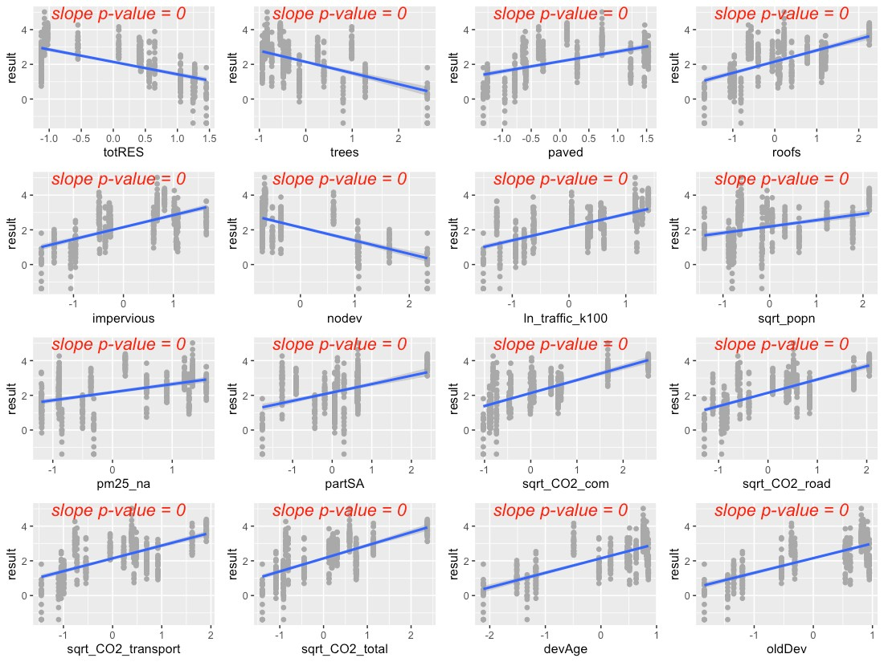
Figure 4. Strong spatial predictors for copper, showing linear model fit (blue line) for the relationship between ln-transformed copper concentration and each predictor in turn

The precipitation predictors used for copper include 14-day cumulative precipitation: rain14, and number of antecedent dry days prior to sample collection: dry. In addition, evidence of higher copper concentrations during summer led us to add summer as a categorical predictor to the copper model: summer1. During July, August and September, summer1 = 1, and summer1 = 0 for all other months.
Residuals plotted against fitted values showed signs of slight heterogeneity (Figure 5, top left). Of the variance structures tested, the best fit allows residual variation to differ by location j.
$$sd(ϵ_{ijk})=σ_{j}$$

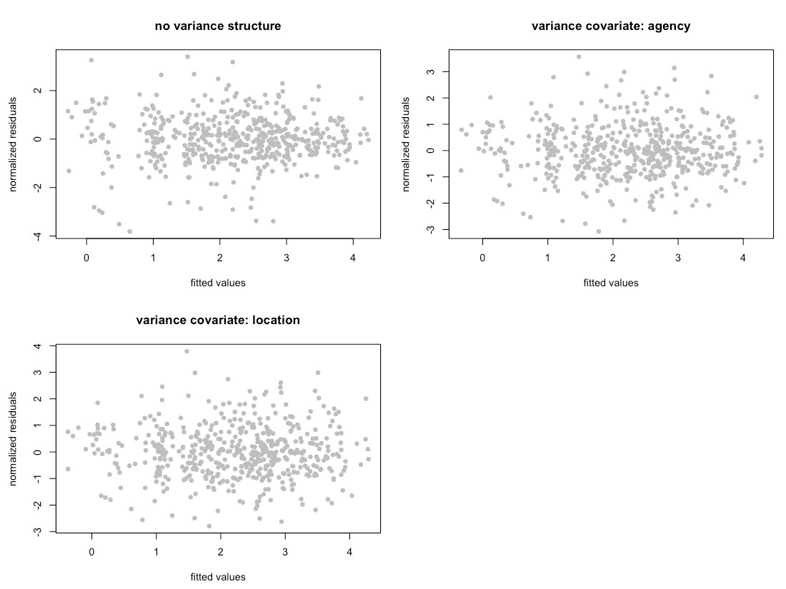
Figure 5. Normalized residuals from beyond-optimal model, with no variance structure (top left), with reporting agency as a variance covariate (top right), and with location as a variance covariate (bottom left). Location as the variance covariate provided the best model fit.

Frequentist Model Summary
The best model for copper is a random-intercept model, where the intercept of the linear model is allowed to vary by reporting agency (k), and by location within each reporting agency (j|k). No signs of temporal or spatial auto-correlation were detected in auto-correlation plots or variograms.
Two possible models emerged to capture the fixed effects:
$$ln\left(Cu_{ijk}\right)=β_{0}+β_{1}*rai{n14}_{i}+β_{2}*{dry}_{i}+β_{3}*summer_{i}+β_{4}*sqr{t.CO2.road}_{ijk}+β_{5}*{oldDev}_{ijk}+β_{6}*{{rain14}_{i}*oldDev}_{ijk}+a_{k}+a_{j|k}+ϵ_{ijk}$$
$$ln\left(Cu_{ijk}\right)=β_{0}+β_{1}*rai{n14}_{i}+β_{2}*{dry}_{i}+β_{3}*summer_{i}+β_{4}*{impervious}_{ijk}+β_{5}*{ln.traffic.k100}_{ijk}+β_{6}*{{rain14}_{i}*impervious}_{ijk}+a_{k}+a_{j|k}+ϵ_{ijk}$$
The first model’s AIC score was slightly lower than that of the second model (AIC=785.7 vs. 790.0, when models were fitted with ML); however, vehicle wear is more directly associated with copper in stormwater than are emissions. As a result, we selected the second model, with ln_traffic_k100 as a predictor. Figure 6 shows the model fit for each individual predictor, plotted against data points. Correlation between the two predictors was acceptable (correlation = 0.5).
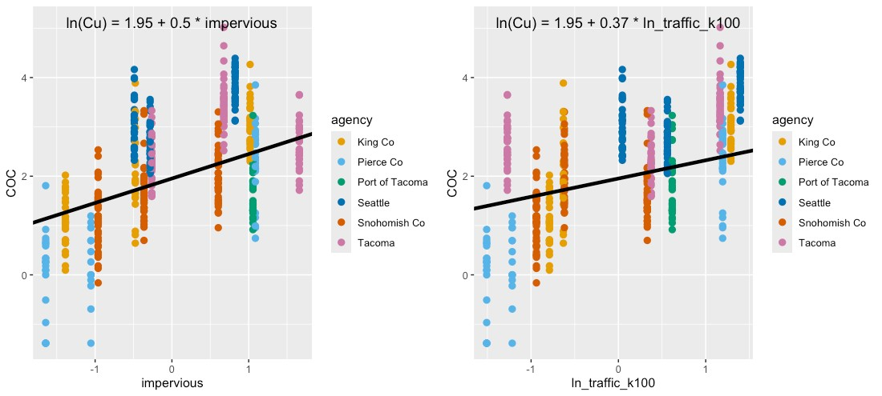
Figure 6. Single-predictor plots for copper, showing fit of the Spatial Predictor Model to each predictor in turn. Model fitting was performed using maximum likelihood (ML) estimation.

The interaction between rain14 and impervious is shown in Figure 7. When 14-day cumulative rainfall is low, highly impervious areas (yellow to light-green) display a first flush effect which tapers off as cumulative rainfall increases. In contrast, areas with little impervious structure (dark purple) have a more constant level of copper in stormwater regardless of cumulative antecedent rainfall.
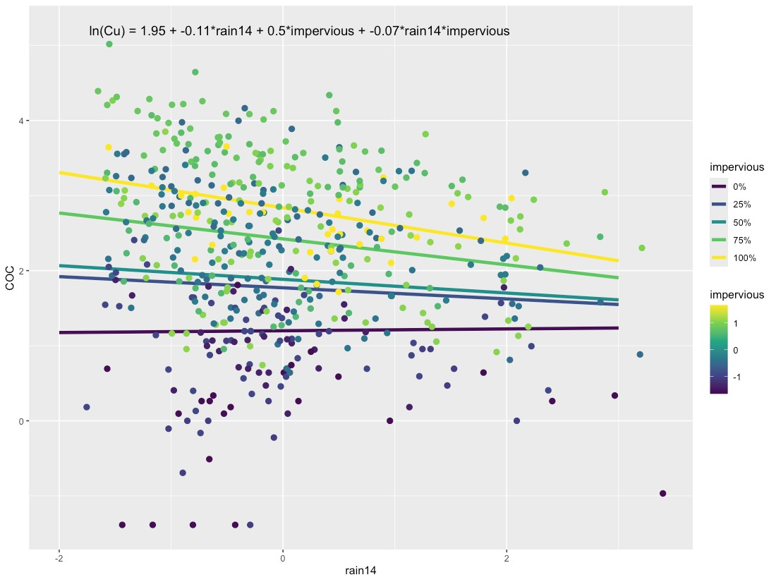
Figure 7. Interaction plot for copper, showing the relationship between impervious and rain14 (14-day cumulative rainfall).

Comparisons between the Null Model, Categorical Land Use Model, and Spatial Predictor Model can be visualized through residuals (Figure 8) and comparative metrics such as AIC. The residual plots clearly show good fit (residuals close to zero) for the Categorical Land Use Model and for the Spatial Predictor Model.
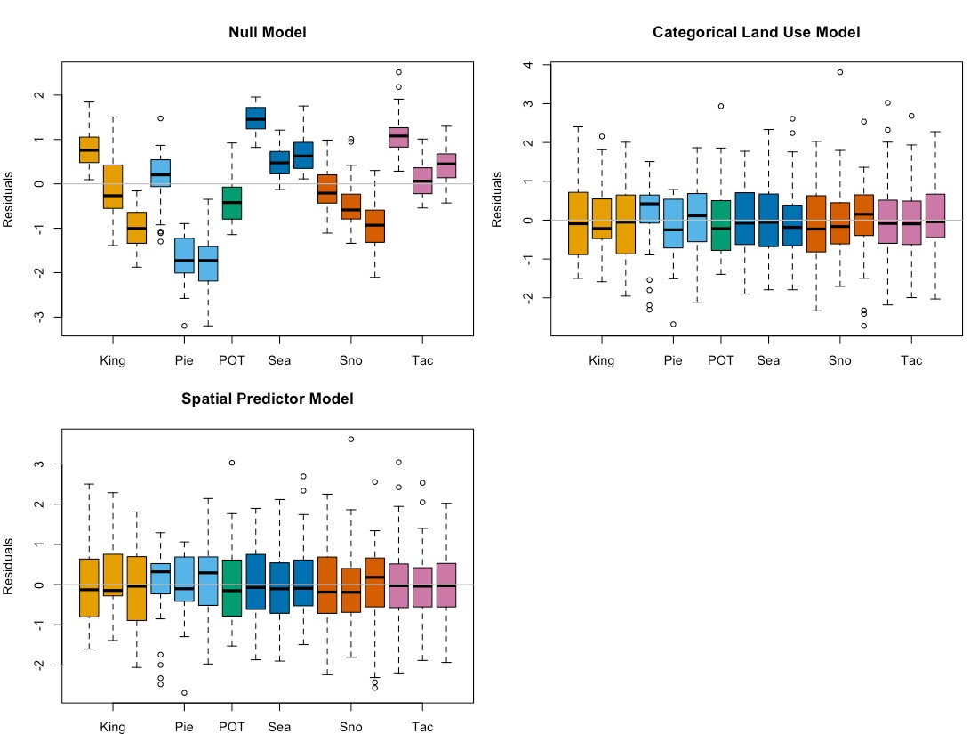
Figure 8. Copper model residuals for the Null Model, Categorical Land Use Model, and Spatial Predictor Model. Each bar represents one watershed, with colors representing reporting agencies. Model fitting was performed using maximum likelihood (ML) estimation

Final frequentist model AIC values (fitted with REML) for the three models are: 1571.9 (Null Model), 825.6 (Categorical Land Use Model) and 818.7 (Spatial Predictor Model), with the Spatial Predictor Model showing a significant improvement over the Categorical Land Use Model. Final coefficient values for all three frequentist models are shown in Figure 9. The large variability in coefficients for the Categorical Land Use Model (shown in orange) indicates lower predictive power of this model. As a result, the Spatial Predictor model outperforms the currently used Categorical Land Use-type model both in terms of AIC, as well as in its potential for generating tighter precision intervals around estimates of copper concentration. We selected this improved method of estimating COC loading for inclusion in the Stormwater Heatmap’s data visualizations.

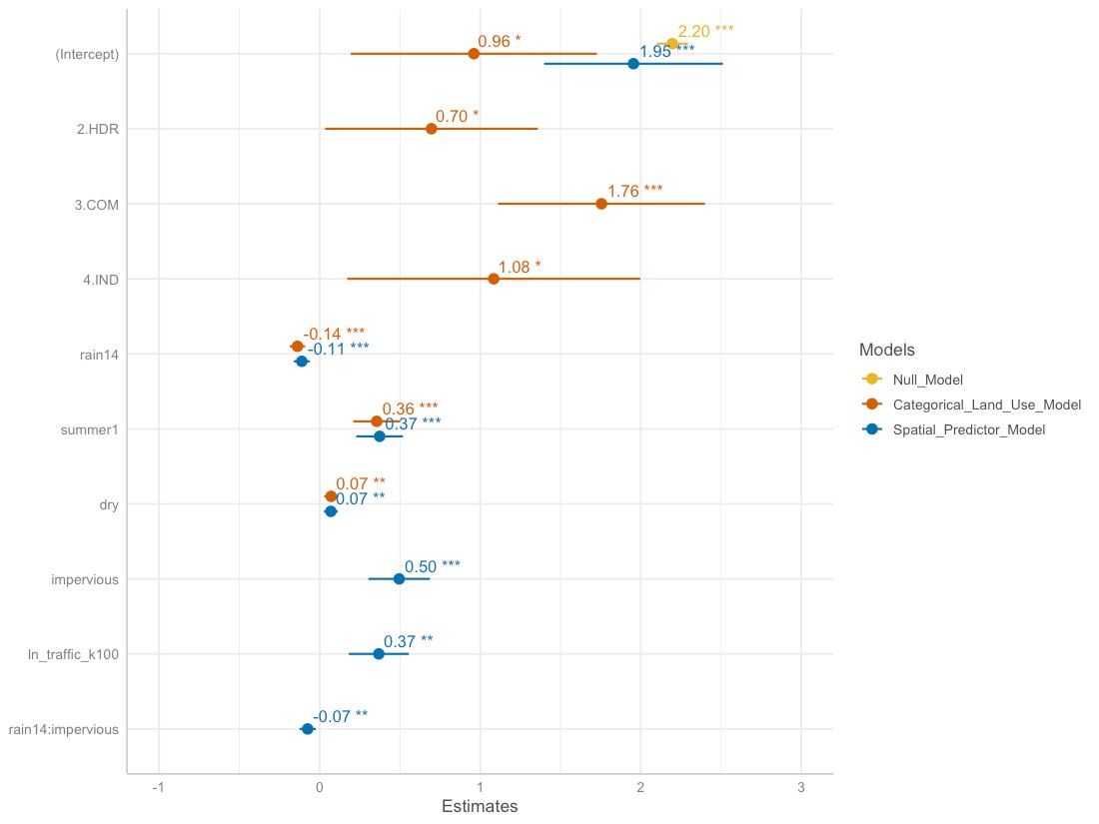
Figure 9. Frequentist model coefficients for the Null Model (goldenrod), Categorical Land Use Model (orange), and Spatial Predictor Model (blue). These coefficient values for linear mixed effects models are based on fitting with restricted maximum likelihood (REML) estimation, and may differ slightly from those fitted using maximum likelihood (ML) estimation.

Bayesian Model Summary
The Bayesian model for total copper follows a Student-t distribution with the form:
$$ln\left(Cu_{ijk}\right)=β_{0}+β_{1}*rai{n14}_{i}+β_{2}*{dry}_{i}+β_{3}*summer_{i}+β_{4}*{impervious}_{ijk}+β_{5}*{ln.traffic.k100}_{ijk}+β_{6}*{{rain14}_{i}*impervious}_{ijk}+a_{k}+a_{j|k}+ϵ_{ijk}$$
where:
$$β_{0}=1.96; β_{1}=-0.12; β_{2}=0.08; β_{3}=0.40; β_{4}=0.50; β_{5}=0.37; β_{6}=-0.07$$
$$a_{k}∼N(0,σ_{agency}); σ_{agency}=0.87$$
$$a_{j|k}∼N(0,σ_{location}); σ_{location}=0.26$$
$$ϵ_{ijk}∼t_{9.65}(0,σ_{j}); ln(σ_{j})=η+u_{j}; σ_{j}=e^{η}*e^{u_{j}}; η=-0.82;$$
$$u_{j}∼N(0,σ_{0}); σ_{0}=0.29$$
Subscripts indicate sample (i), location (j) and reporting agency (k).
Random effects $a_{k}$ (agency-specific contribution to the intercept) and $a_{j|k}$ (location-specific contribution to the intercept) follow a normal (Gaussian) distribution, with mean equal to 0 and standard deviation equal to $σ_{agency}$ for agency-specific contribution to the intercept, and $σ_{location}$ for location-specific contribution to the intercept. The residual variance $ϵ_{ijk}$ represents remaining variation in the data that cannot be explained by the model variables. For the copper model, residual variance follows a Student-t distribution, which is defined by three parameters: shape ($ν=9.65$), mean ($μ=0$), and scale ($σ=σ_{j}$). By imposing a variance structure with location (j) as the variance covariate, scale ($σ_{j}$) becomes a function of parameters $η$ and $u_{j}$, where $e^{η}$ represents population-level variability, and $e^{u_{j}}$ represents deviation of location j from the population-level variability. Finally, $u_{j}$ is normally distributed, with mean equal to 0 and standard deviation equal to $σ_{0}$.
Density plots for the 4000 sets of parameter estimates generated by the Bayesian model are provided in the left half of Figure 10, Figure 11, and Figure 12. The peaks show where the most likely values (along the x-axis) of a given parameter are concentrated. They also indicate how much variability exists around parameter estimates, shown by the shape of the curve (low and broad equals lots of variability; tall and narrow equals little variability). The y-axis on density plots represents the probability density function for the kernel density estimation, and can be disregarded for our purposes. Traces (right half of Figure 10, Figure 11, and Figure 12) indicate how well the parameter space was sampled in the four chains generated by the NUTS sampler (no U-turn sampling - an extension of Hamilton Monte Carlo) used when fitting brms models. Each chain generated 1000 sets of parameter estimates, for a total of 4000 sets of parameter estimates. For copper, the traces indicate that the sampling algorithm did not get stuck in one region of the parameter space, and that the parameter space was well sampled.

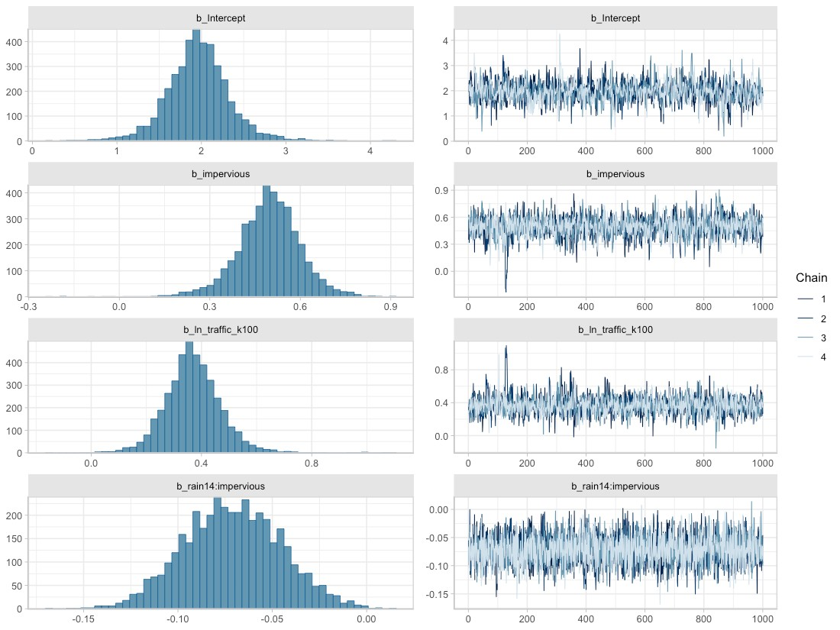
Figure 10, Posterior densities (left) and traces (right) for parameters associated with fixed effects obtained from the best-fit Bayesian model for total copper.

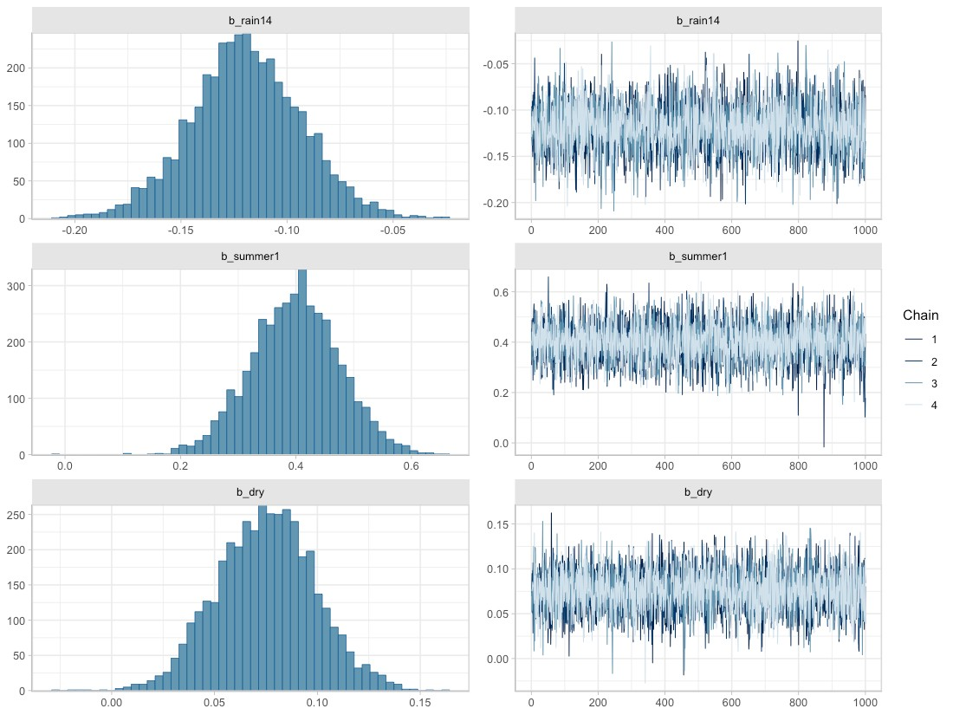
Figure 11. Posterior densities (left) and traces (right) for parameters associated with fixed effects, obtained from the best-fit Bayesian model for total copper.

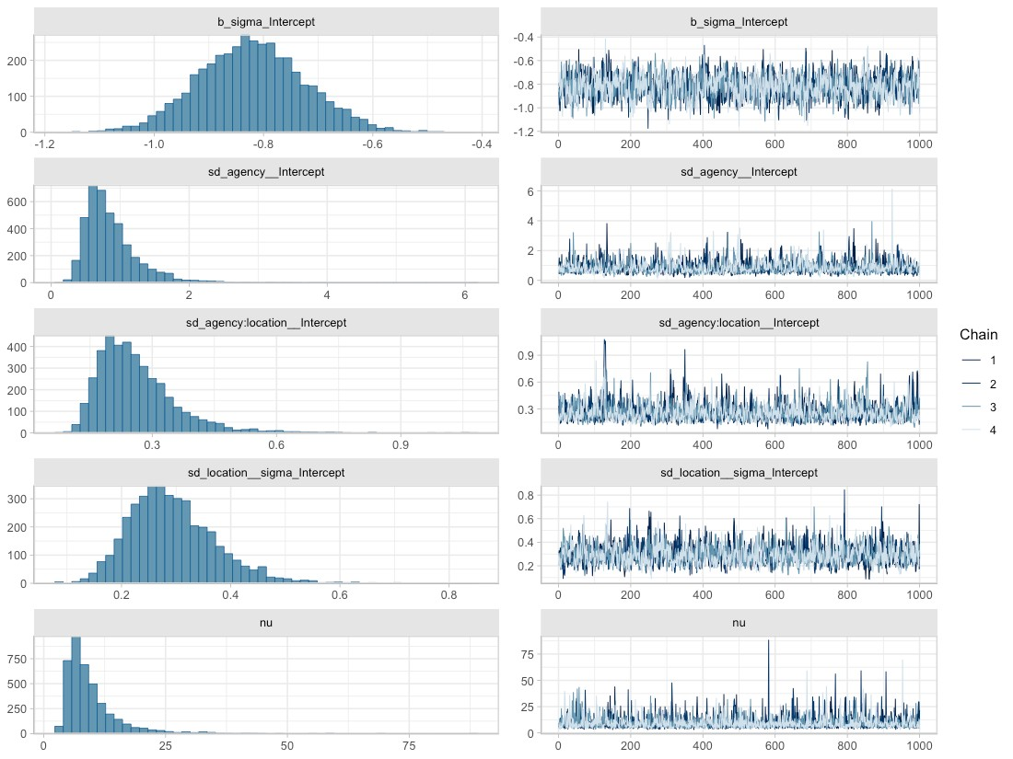
Figure 12. Posterior densities (left) and traces (right) for parameters associated with random effects, obtained from the best-fit Bayesian model for total copper. Here, b_sigma_intercept represents $η$ from the random effects equations, sd_agency__Intercept represents $σ_{agency}$, sd_agency:location__Intercept represents $σ_{location}$, sd_location__sigma_Intercept represents $σ_{0}$, and nu is the Greek letter $ν$, representing shape of the Student-t distribution.

Fit of the Bayesian copper model to data can be assessed through RMSE (0.520) or RSR (0.463), or visualized in estimated versus observed plots (Figure 13, Figure 14). We provide RSR as a measure of model precision, since RSR is a standardized form of RMSE. Singh et al. (2004) recommends that an RSR ≤ 0.50 indicates a well suited model, while Moriasi et al. (2007) elaborates on this recommendation, suggesting that an RSR ≤ 0.50 indicates a very good model, an RSR ≤ 0.60 indicates a good model, an RSR ≤ 0.70 indicates a satisfactory model, and RSR > 0.7 indicates an unsatisfactory model. According to these guidelines, the copper model (RSR=0.463) is a very good model.
In Figure 13 and Figure 14, the estimated ln(copper) values (vertical axis) are generated using the fitted function (brms package; Buerkner 2017), which applies the spatial predictors associated with each data point (location, rain14, dry, summer, impervious, ln_traffic_k100) to all 4000 parameter sets that make up the Bayesian posterior. Mean estimated values are then plotted against observed ln(copper) data (horizontal axis). Ideally, the points should form a swath along the 1:1 diagonal dashed line. This 1:1 line shows where estimated values exactly match the observed data. For copper, the estimated vs. observed plots show slightly better model fit at higher copper concentrations (Figure 13), evident because points in the upper right quadrant are slightly closer to the 1:1 line than points in the lower left quadrant. Within-location variability in the upper right quadrant of Figure 13 (e.g., SEA_COM) is lower than for the lower left quadrant (Pierce County sites). Locations with higher copper concentrations also have medium to high values of impervious and high values of ln_traffic_k100 (Figure 14, top panels). This could be coincidental, or could be the result of high temporal variability in copper-contributing sources (e.g., traffic) in low-traffic, low-impervious locations.
Summer, dry and rain14 do not display a consistent effect on the Bayesian model’s fit to observed data (Figure 14, bottom panels).
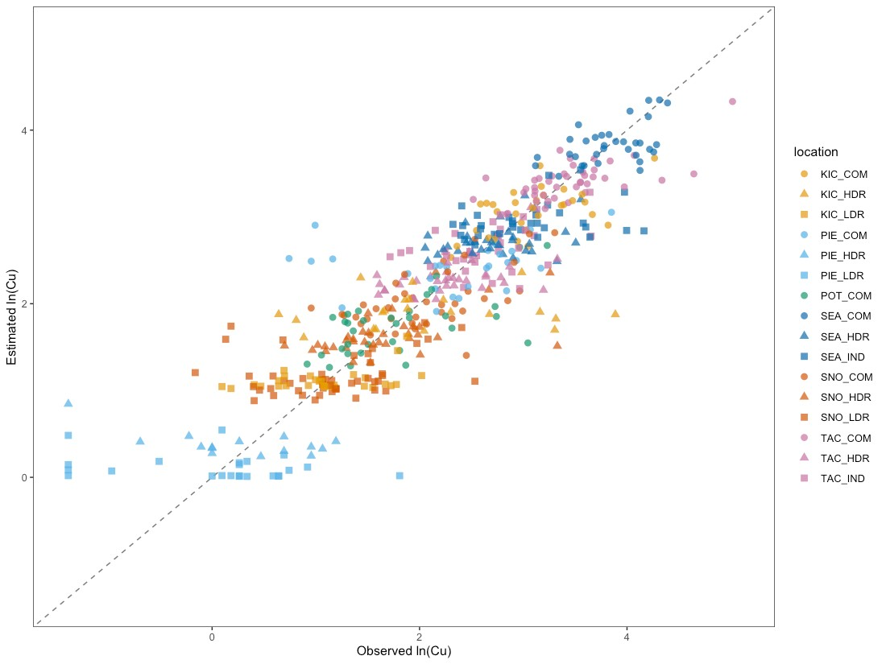
Figure 13. Estimated vs. observed plot for the Bayesian copper model, with point color corresponding to location. Individual points show how the observed value for ln(copper) (horizontal axis) compares to the mean estimated value from the Bayesian model (vertical axis). The diagonal dashed line shows the 1:1 relationship, where estimated=observed.

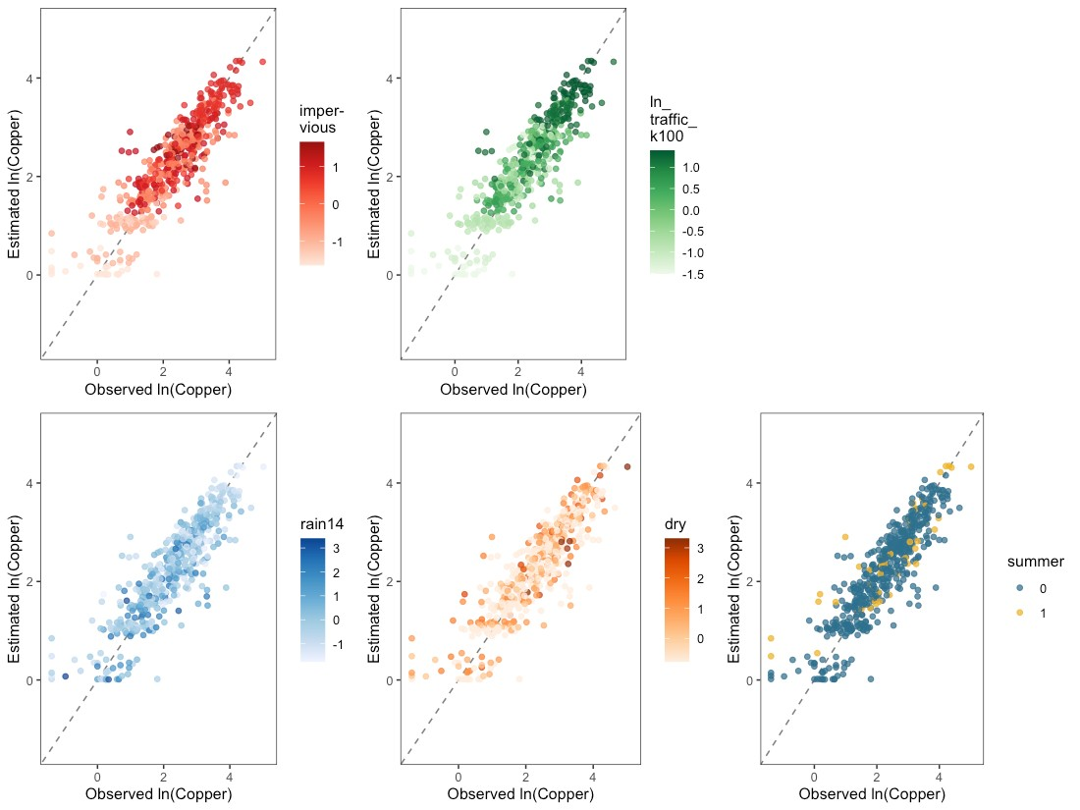
Figure 14. Estimated vs. observed plots for the Bayesian copper model, with colors showing the magnitude of one spatial predictor (impervious, ln_traffic_k100, rain14, dry or summer) at each data point. Individual points show how the observed value for ln(copper) compares to the mean estimated value from the Bayesian model. Diagonal dashed lines show the 1:1 relationship, where estimated=observed.

Copper concentration estimates rely on two spatial predictors: impervious and ln_traffic_k100, along with three spatio-temporal predictors: rain14, dry and summer. We can visualize the effect of one spatial landscape predictor at a time on expected copper concentrations by applying a range of values of the other spatial predictor and various observed combinations of precipitation and season. In Figure 15, expected mean copper concentrations as a function of impervious or ln_traffic_k100 are presented as colored credible interval bands, with median S8 Data by location plotted as black bars atop the credible intervals.
Credible intervals were calculated using the epred_draws function (tidybayes package; Kay, 2022) applied to a simulated dataset with all combinations of the following predictors:
- 20% of rain, dry & summer combinations randomly sampled from the S8 Data, to provide representative scenarios of rain and summer/ not summer conditions;
- eight equally-spaced impervious values between minimum and maximum impervious levels observed in the S8 Data;
- eight equally-spaced ln_traffic_k100 values between the minimum and maximum ln_traffic_k100 levels observed in the S8 Data.
Following computation of credible intervals, spatial predictors were unstandardized to generate the figure.
As discussed in Step 9 of Model Construction and Selection, credible intervals account for uncertainty around fixed effect parameters and around the variance parameters of the groups, but do not account for residual variance. This allows stormwater managers to assess the following:
- What is the likely range for mean copper at a heretofore unsampled watershed with a particular level of impervious (or ln_traffic_k100)?
This is in line with stormwater management best practices, which manage for the over-annual impact on water bodies rather than for extreme events.

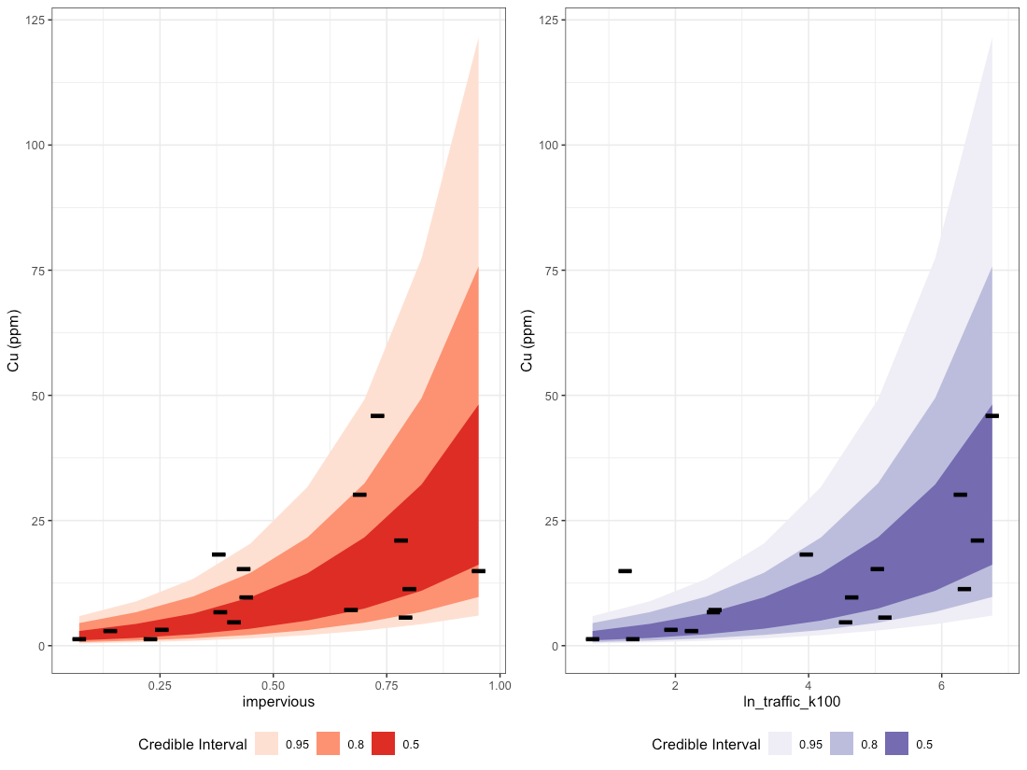
Figure 15. Credible intervals for total copper as a function of impervious (left plot) and ln_traffic_k100 (right plot). Bands of color represent 50%, 80% and 95% credible intervals, while black lines represent median S8 Data by location.

The Bayesian copper model has a population-level intercept $β_{0}=1.96$. As a random-intercept model, the location-specific intercept is allowed to vary by reporting agency (k), and by catchment location within each reporting agency (j|k), and sums to: $β_{0}+a_{k}+a_{j|k}$. Density plots for the location-specific intercept parameters are shown in Figure 16, along with the mean and 95% credible intervals for the population-level intercept. Variability around the population-level intercept for copper is relatively high (see the vertical dashed lines in Figure 16). Thirteen of the 16 catchments have location-specific intercepts that overlap well with the population-level intercept: the majority of their density plots are shaded blue (see e.g., TAC_HDR). One catchment has approximately half of the density plot overlapping with that of the population-level intercept (SEA_COM), while the remaining two catchments have location-specific intercepts that are quite different from that of the population (see SEA_IND and POT_COM). The deviation between location-specific intercepts and the population-level intercept gives some insight into how much variability may exist in y-intercept values at unsampled locations. Variability around the population-level intercept and around group-specific random effects (reporting agency and location) is also visible in the width of credible interval bands shown in Figure 15. Implementing more monitoring across diverse watershed types would be beneficial to providing more precise COC estimates and credible intervals.
The Stormwater Heatmap utilizes only the population-level intercept to estimate mean copper concentrations at unsampled locations; Figure 16 is provided as a visual for how much variability exists between locations, in terms of location-specific intercept.
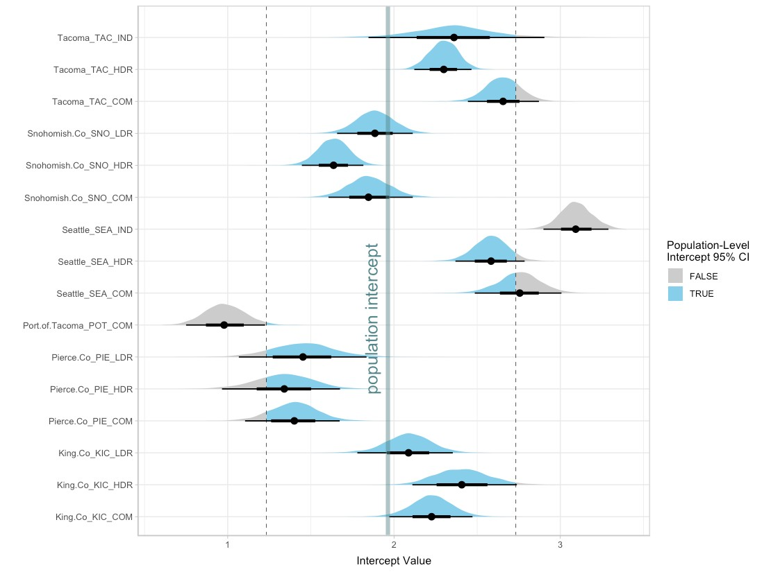
Figure 16. Density plots for the 16 location-specific intercept parameters, along with the median (thick vertical line) and 95% credible intervals (dashed vertical lines) for the population-level intercept. For each location, the mean intercept value is indicated with a black dot, and credible intervals are shown with thick (50% CI) and thin (95% CI) black horizontal lines. Density plots for each location are shaded blue for values that fall within the 95% CI for the population-level intercept, and gray for values that fall outside of the 95% CI for population-level intercept. Note that the population-level 95% CI does not incorporate variability around reporting agency $σ_{agency}$, or around location within each reporting agency $σ_{location}$; it is solely the 95% CI for the population-level intercept (i.e.: 95% of the time, the population-level intercept will fall between the given CI values).

In summary, the Stormwater Heatmap utilizes the spatial predictors impervious and ln_traffic_k100 to estimate the over-annual mean copper concentration. The equation used for visualizing the total copper layer is:
$$ln(Cu)=1.96+0.50*impervious+0.37*ln⁡_traffic_k100$$
See Applying Mixed Effects Equations to the Stormwater Heatmap at the end of this document for more information on how the Bayesian model is simplified to this equation.

Total Suspended Solids
Based on linear models of ln-transformed TSS versus individual predictors, the strong predictors identified for TSS include: totRES, grass, trees, roofs, impervious, nodev, ln_traffic_k100, sqrt_popn, sqrt_CO2_res, sqrt_CO2_com, sqrt_CO2_road, sqrt_CO2_transport, devAge and oldDev (Figure 17).

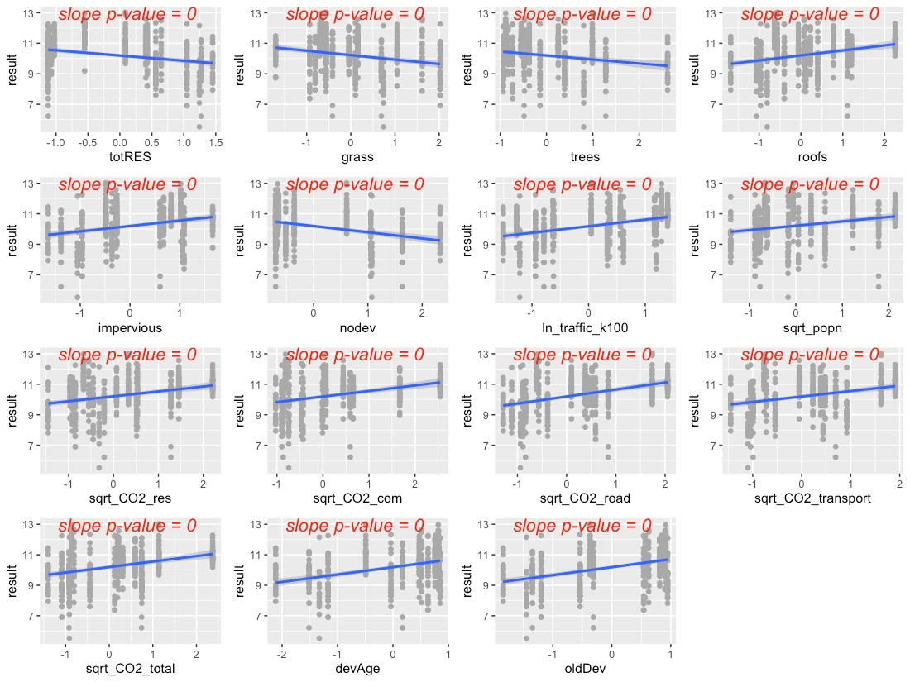
Figure 17. Strong predictors for TSS, showing linear model fit (blue line) for the relationship between ln-transformed TSS concentration and each predictor in turn.
The precipitation predictors used for TSS are 1-day cumulative precipitation and 21-day cumulative precipitation. Additionally, TSS concentrations in the S8 Data showed a relationship with spring, so this seasonal effect was added to the equation.
Residuals plotted against fitted values showed signs of slight heterogeneity (Figure 18, top left plot). Of the variance structures tested, the best fit allows residual variation to differ by location j.
$$sd(ϵ_{ijk})=σ_{j}$$

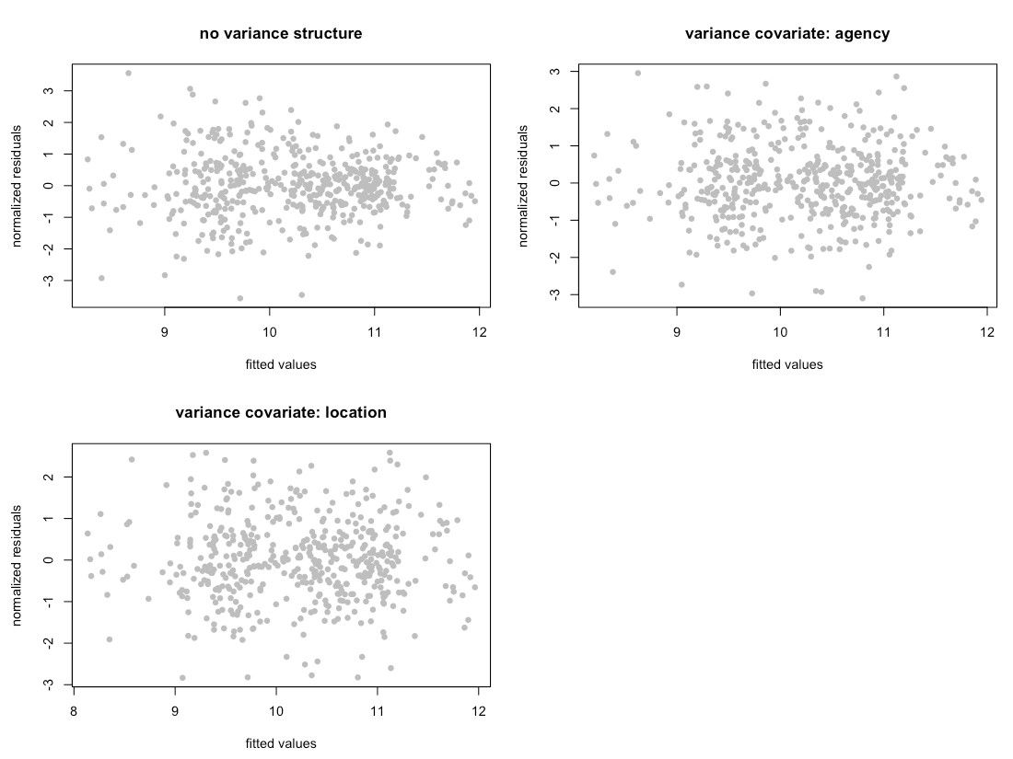
Figure 18. Normalized residuals from beyond-optimal model, with no variance structure (top left), with reporting agency as a variance covariate (top right) and with location as a variance covariate (bottom left). Location as the variance covariate provided the best model fit.

Frequentist Model Summary
The best model for TSS is a random-intercept model, where the intercept of the linear model is allowed to vary by reporting agency (k), and by location within each reporting agency (j|k). No signs of temporal or spatial auto-correlation were detected in auto-correlation plots or variograms.
Two possible models emerged to capture the fixed effects:
$$ln\left(TSS_{ijk}\right)=β_{0}+β_{1}*rai{n1}_{i}+β_{2}*{rain21}_{i}+β_{3}*spring+β_{4}*{oldDev}_{ijk}+β_{5}*{sqrt.CO2.road}_{ijk}+β_{6}*{rain1}_{i}*{oldDev}_{ijk}+a_{k}+a_{j|k}+ϵ_{ijk}$$
$$ln\left(TSS_{ijk}\right)=β_{0}+β_{1}*rai{n1}_{i}+β_{2}*{rain21}_{i}+β_{3}*spring+β_{4}*{oldDev}_{ijk}+β_{5}*{rain1}_{i}*{oldDev}_{ijk}+a_{k}+a_{j|k}+ϵ_{ijk}$$
The AIC score for these models (fitted with ML) was 1354.4 and 1355.6, respectively. We selected the first model as the most suitable for TSS, as it included a traffic-based predictor (sqrt_CO2_road), and roadways are an important contributor to TSS. Figure 19 shows the model fit for each individual predictor, plotted against data points. Correlation between the two predictors was acceptable (correlation coefficient = 0.4).

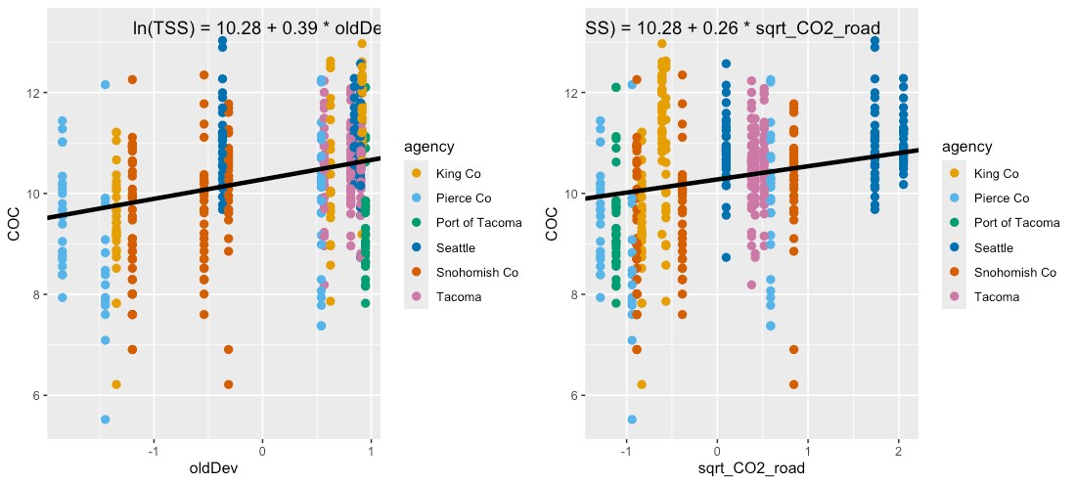
Figure 19. Single-predictor plots for TSS, showing fit of the Spatial Predictor Model to each predictor. Model fitting was performed using maximum likelihood (ML) estimation.

Comparisons between the Null Model, Categorical Land Use Model, and Spatial Predictor Model can be visualized through residuals (Figure 20) and comparative metrics such as AIC. The residual plots clearly show good fit (residuals close to zero) for the Categorical Land Use Model and for the Spatial Predictor Model.
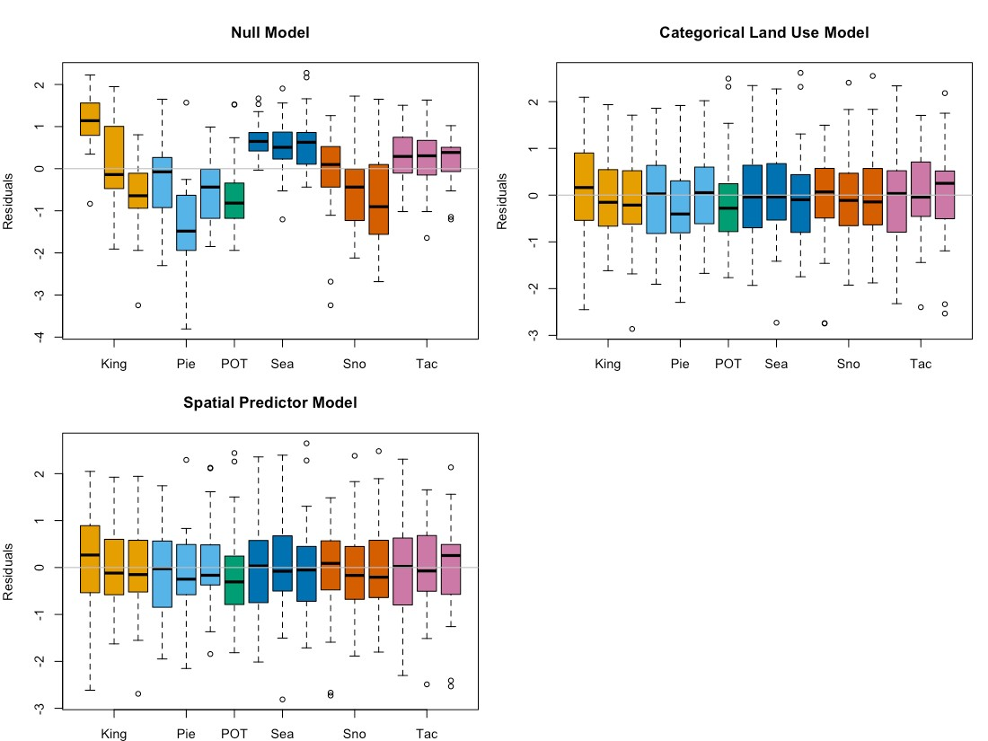
Figure 20. TSS model residuals for the Null Model, Categorical Land Use Model, and Spatial Predictor Model. Each bar represents one watershed, with colors representing reporting agencies. Model fitting was performed using maximum likelihood (ML) estimation.

Final frequentist model AIC values (fitted with REML) for the three models are: 1585.1 (Null Model), 1377.5 (Categorical Land Use Model) and 1377.0 (Spatial Predictor Model), with the Spatial Predictor Model showing slight improvement over the Categorical Land Use Model. Final coefficient values for all three frequentist models are shown in Figure 21. The larger variability around Categorical Land Use Model coefficients (shown in orange) indicates lower predictive power compared to the Spatial Predictor Model, because confidence intervals around TSS estimates will be large. We selected the Spatial Predictor Model to estimate COC loading in the Stormwater Heatmap’s data visualizations.

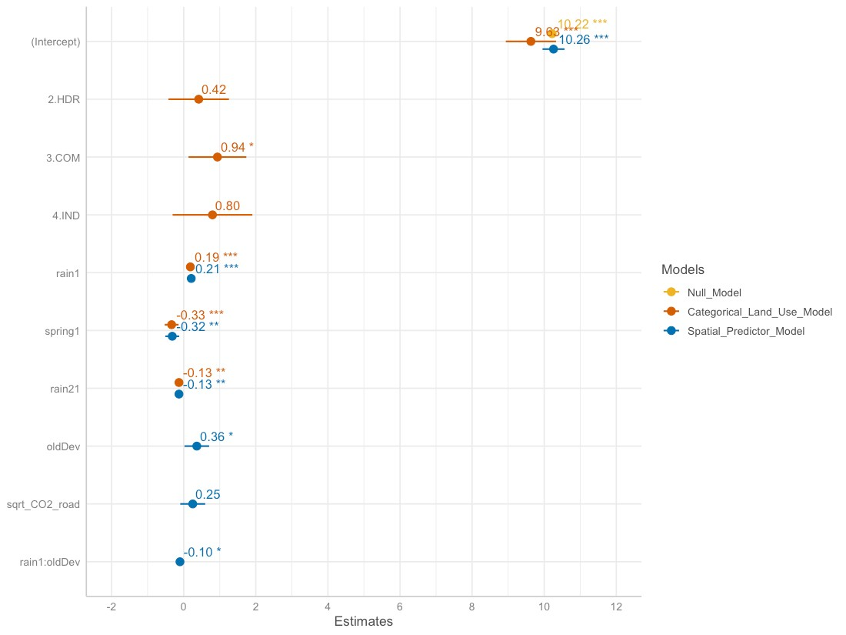
Figure 21. Model coefficients for the Null Model (goldenrod), Categorical Land Use Model (orange), and Spatial Predictor Model (blue). Final coefficient values for linear mixed effects models are based on fitting with restricted maximum likelihood (REML) estimation, and may differ slightly from those fitted using maximum likelihood (ML) estimation.

Bayesian Model Summary
The Bayesian model for TSS is:
$$ln\left(TSS_{ijk}\right)=β_{0}+β_{1}*rai{n1}_{i}+β_{2}*{rain21}_{i}+β_{3}*spring+β_{4}*{oldDev}_{ijk}+β_{5}*{sqrt.CO2.road}_{ijk}+β_{6}*{rain1}_{i}*{oldDev}_{ijk}+a_{k}+a_{j|k}+ϵ_{ijk}$$
where:
$$β_{0}=10.24; β_{1}=0.19; β_{2}=-0.12; β_{3}=-0.31; β_{4}=0.36; β_{5}=0.25; β_{6}=-0.11$$
$$a_{k}∼N(0,σ_{agency}); σ_{agency}=0.41$$
$$a_{j|k}∼N(0,σ_{location}); σ_{location}=0.50$$
$$ϵ_{ijk}∼t_{15.51}(0,σ_{j}); ln(σ_{j})=η+u_{j}; σ_{j}=e^{η}*e^{u_{j}}; η=-0.16;$$
$$u_{j}∼N(0,σ_{0}); σ_{0}=0.30$$
]Subscripts indicate sample (i), location (j) and reporting agency (k).
Random effects $a_{k}$ (agency-specific contribution to the intercept) and $a_{j|k}$ (location-specific contribution to the intercept) follow a normal (Gaussian) distribution, with mean equal to 0 and standard deviation equal to $σ_{agency}$ for agency-specific contribution to the intercept, and $σ_{location}$ for location-specific contribution to the intercept. The residual variance $ϵ_{ijk}$ represents remaining variation in the data that cannot be explained by the model variables. For the TSS model, residual variance follows a Student-t distribution, which is defined by three parameters: shape ($ν=15.51$), mean ($μ=0$), and scale ($σ=σ_{j}$). By imposing a variance structure with location (j) as the variance covariate, scale ($σ_{j}$) becomes a function of parameters $η$ and $u_{j}$, where $e^{η}$ represents population-level variability, and $e^{u_{j}}$ represents deviation of location j from the population-level variability. Finally, $u_{j}$ is normally distributed, with mean equal to 0 and standard deviation equal to $σ_{0}$.
Density plots for the 4000 sets of parameter estimates generated by the Bayesian model are provided in the left half of Figure 22, Figure 23, and Figure 24. The peaks show where the most likely values (along the x-axis) of a given parameter are concentrated. They also indicate how much variability exists around parameter estimates, shown by the shape of the curve (low and broad equals lots of variability; tall and narrow equals little variability). The y-axis on density plots represents the probability density function for the kernel density estimation, and can be disregarded for our purposes. Traces (right half of Figure 22, Figure 23, and Figure 24) indicate how well the parameter space was sampled in the four chains generated by the NUTS sampler (no U-turn sampling - an extension of Hamilton Monte Carlo) used when fitting brms models. Each chain generated 1000 sets of parameter estimates, for a total of 4000 sets of parameter estimates. For TSS, the traces indicate that the sampling algorithm did not get stuck in one region of the parameter space, and that the parameter space was well sampled.

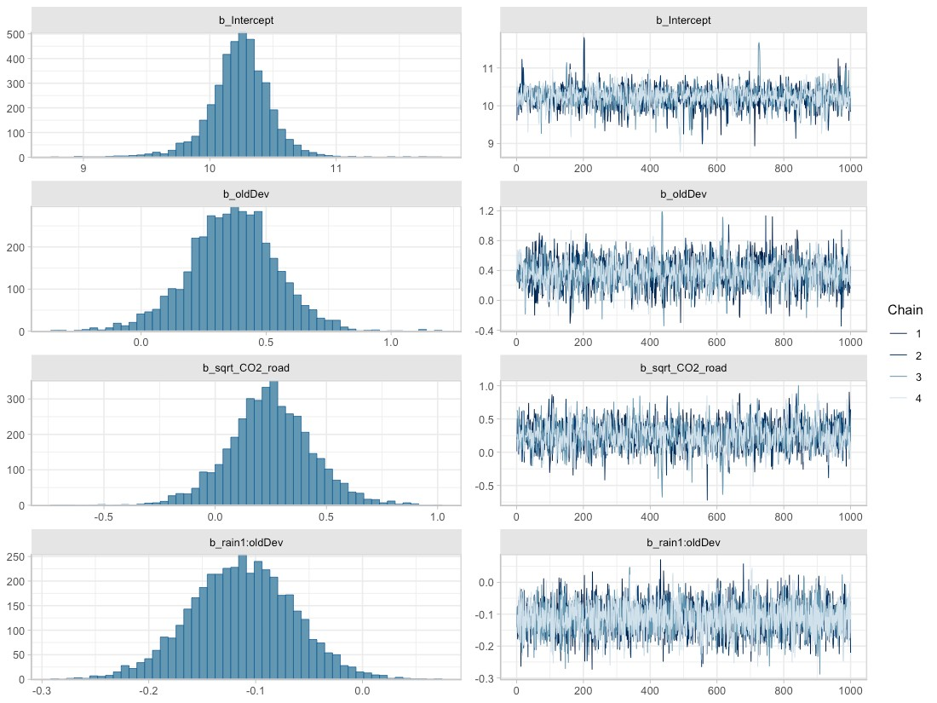
Figure 22. Posterior densities (left) and traces (right) for parameters associated with fixed effects, obtained from the best-fit Bayesian model for TSS.

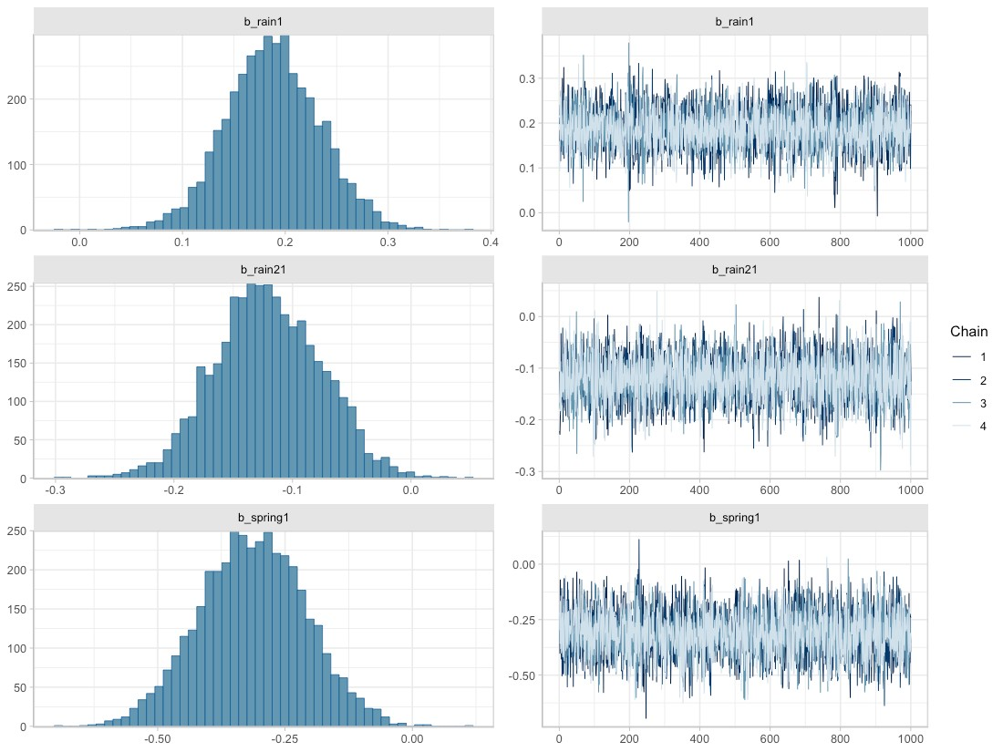
Figure 23. Posterior densities (left) and traces (right) for parameters associated with random effects, obtained from the best-fit Bayesian model for TSS.

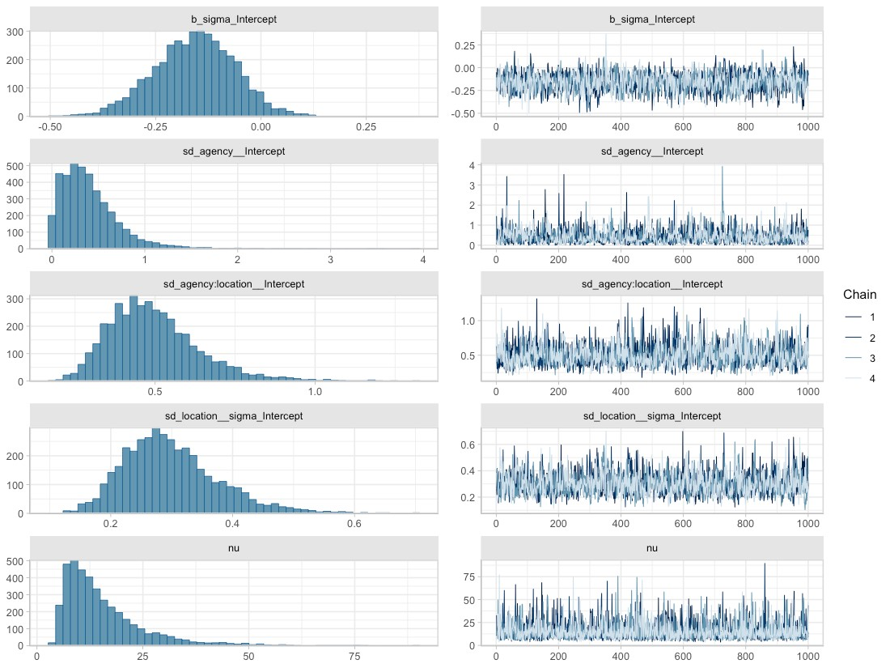
Figure 24. Posterior densities (left) and traces (right) for parameters associated with random effects, obtained from the best-fit Bayesian model for total copper. Here, b_sigma_intercept represents $η$ from the random effects equations, sd_agency__Intercept represents $σ_{agency}$, sd_agency:location__Intercept represents $σ_{location}$, sd_location__sigma_Intercept represents $σ_{0}$, and nu is the Greek letter $ν$, representing shape of the Student-t distribution.

Fit of the Bayesian TSS model to data can be assessed through RMSE (0.960) or RSR (0.777), or visualized in estimated versus observed plots (Figure 25 and Figure 26). We provide RSR as a measure of model precision, since RSR is a standardized form of RMSE. Moriasi et al. (2007) suggest that an RSR ≤ 0.70 indicates a satisfactory model, while an RSR > 0.7 indicates an unsatisfactory model. According to these guidelines, the TSS model (RSR=0.777) is unsatisfactory.
In Figure 25 and Figure 26, the estimated ln(TSS) values (vertical axis) are generated using the fitted function (brms package; Buerkner 2017), which applies the spatial predictors associated with each data point (location, rain1, rain21, spring, oldDev, sqrt_CO2_road) to all 4000 parameter sets that make up the Bayesian posterior. Mean estimated values are then plotted against observed ln(TSS) data (horizontal axis). Ideally, the points should form a swath along the 1:1 diagonal dashed line. This 1:1 line shows where estimated values exactly match the observed data.
For TSS, the estimated vs. observed plots show a slightly broader swath of observed TSS values in locations with lower values for the spatial predictors sqrt_CO2_road and oldDev (see pastel colors in the top two plots of Figure 26), and a slightly narrower swath of observed TSS values in locations with high values for these spatial predictors (see dark colors in the top two plots of Figure 26). The generally broad distribution of points around the 1:1 line indicates that the model is not capturing all contributors to TSS.
Spring, rain1 and rain21 do not appear to affect the Bayesian model’s fit to observed data (Figure 26, bottom panel).

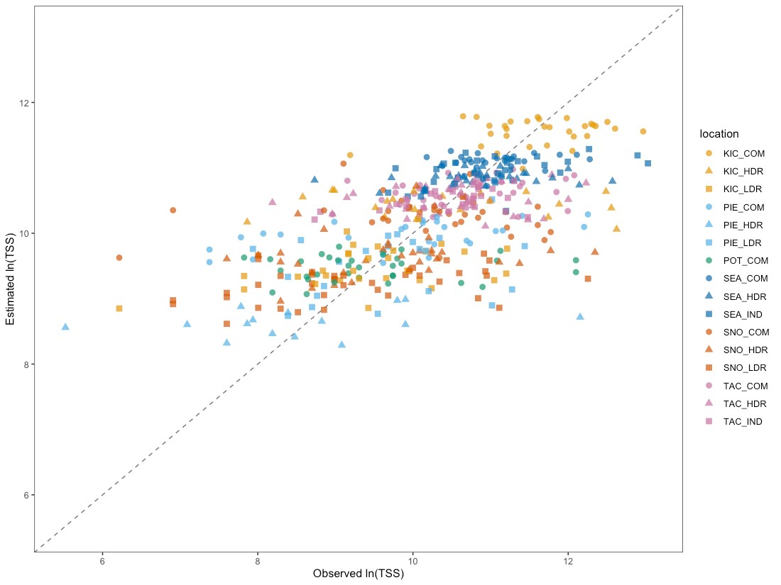
Figure 25. Estimated vs. observed plot for the Bayesian TSS model, with point color corresponding to location. Individual points show how the observed value for ln(TSS) (horizontal axis) compares to the mean estimated value from the Bayesian model (vertical axis). The diagonal dashed line shows the 1:1 relationship, where estimated=observed.

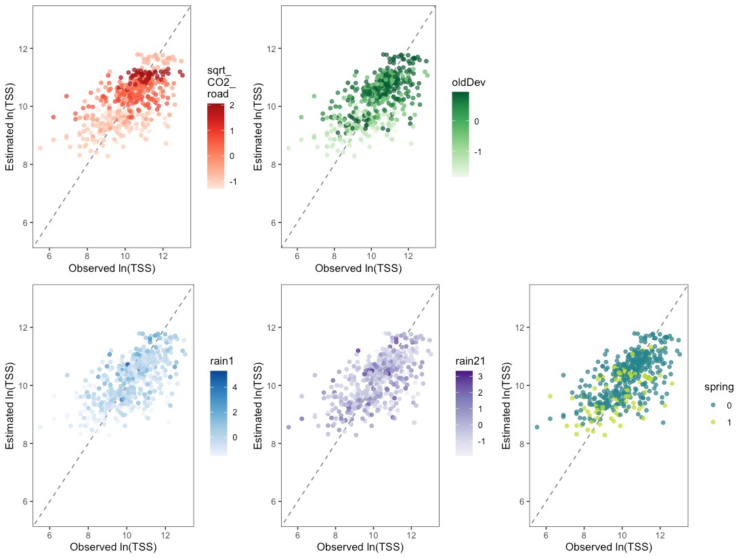
Figure 26. Estimated vs. observed plots for the Bayesian TSS model, with colors showing the magnitude of one spatial predictor (sqrt_CO2_road, oldDev, rain1, rain21 or spring) at each data point. Individual points show how the observed value for ln(TSS) compares to the mean estimated value from the Bayesian model. Diagonal dashed lines show the 1:1 relationship, where estimated=observed.

TSS concentration estimates rely on two spatial predictors: sqrt_CO2_road and oldDev, along with three spatio-temporal predictors: rain1, rain21 and spring. We can visualize the effect of one spatial landscape predictor at a time on expected TSS concentrations by applying a range of values of the other spatial predictor and various observed combinations of precipitation and season. In Figure 27, expected mean TSS concentrations as a function of sqrt_CO2_road or oldDev are presented as colored credible interval bands, with median S8 Data by location plotted as black bars atop the credible intervals.
Credible intervals were calculated using the epred_draws function (tidybayes package; Kay, 2022) applied to a simulated dataset with all combinations of the following predictors:
- 20% of rain & spring combinations randomly sampled from the S8 Data, to provide representative scenarios of rain and spring/ not spring conditions;
- eight equally-spaced sqrt_CO2_road values between minimum and maximum sqrt_CO2_road levels observed in the S8 Data;
- eight equally-spaced oldDev values between the minimum and maximum oldDev levels observed in the S8 Data.
Following computation of credible intervals, spatial predictors were unstandardized and back-transformed to generate the figure.
As discussed in Step 9 of Model Construction and Selection, credible intervals account for uncertainty around fixed effect parameters and around the variance parameters of the groups, but do not account for residual variance. This allows stormwater managers to assess the following:
- What is the likely range for mean TSS at a heretofore unsampled watershed with a particular level of sqrt_CO2_road (or oldDev)?
This is in line with stormwater management best practices, which manage for the over-annual impact on water bodies rather than for extreme events.
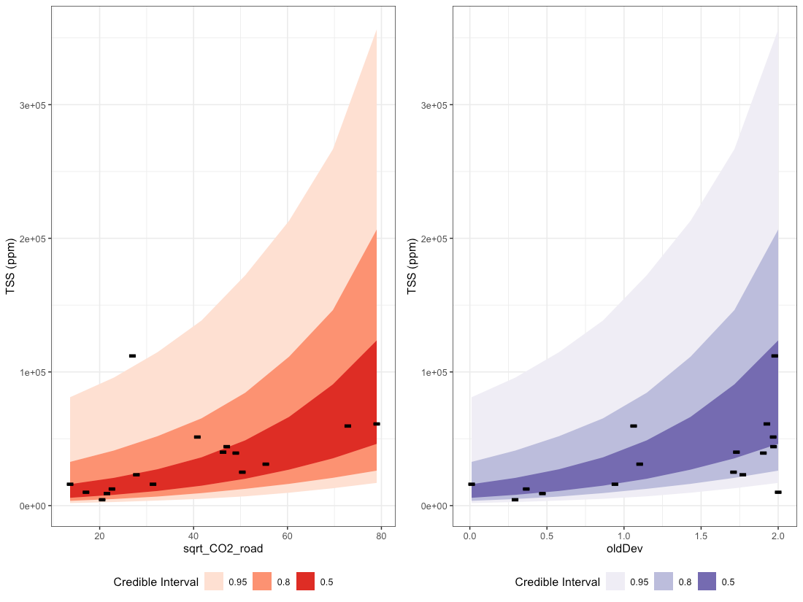
Figure 27. Credible intervals for TSS as a function of sqrt_CO2_road (left plot) and oldDev (right plot). Bands of color represent 50%, 80% and 95% credible intervals, while black lines represent median S8 Data by location.

The Bayesian TSS model has a population-level intercept $β_{0}=10.24$. As a random-intercept model, the location-specific intercept is allowed to vary by reporting agency (k), and by catchment location within each reporting agency (j|k), and sums to: $β_{0}+a_{k}+a_{j|k}$. Density plots for the location-specific intercept parameters are shown in Figure 28, along with the mean and 95% credible intervals for the population-level intercept.
Thirteen of the 16 catchments have location-specific intercepts that overlap well with the population-level intercept: the majority of their density plots are shaded blue (see e.g., TAC_IND). One catchment has approximately half of the density plot overlapping with that of the population-level intercept (PIE_COM), while the remaining two catchments have location-specific intercepts that are quite different from that of the population (see POT_COM and KIC_COM). The deviation between location-specific intercepts and the population-level intercept gives some insight into how much variability may exist in y-intercept values at unsampled locations. In the case of TSS, the y-intercept values for most locations align well with the population-level intercept.
The Stormwater Heatmap utilizes only the population-level intercept to estimate mean TSS concentrations at unsampled locations; Figure 28 is provided as a visual for how much variability exists between locations, in terms of location-specific intercept.
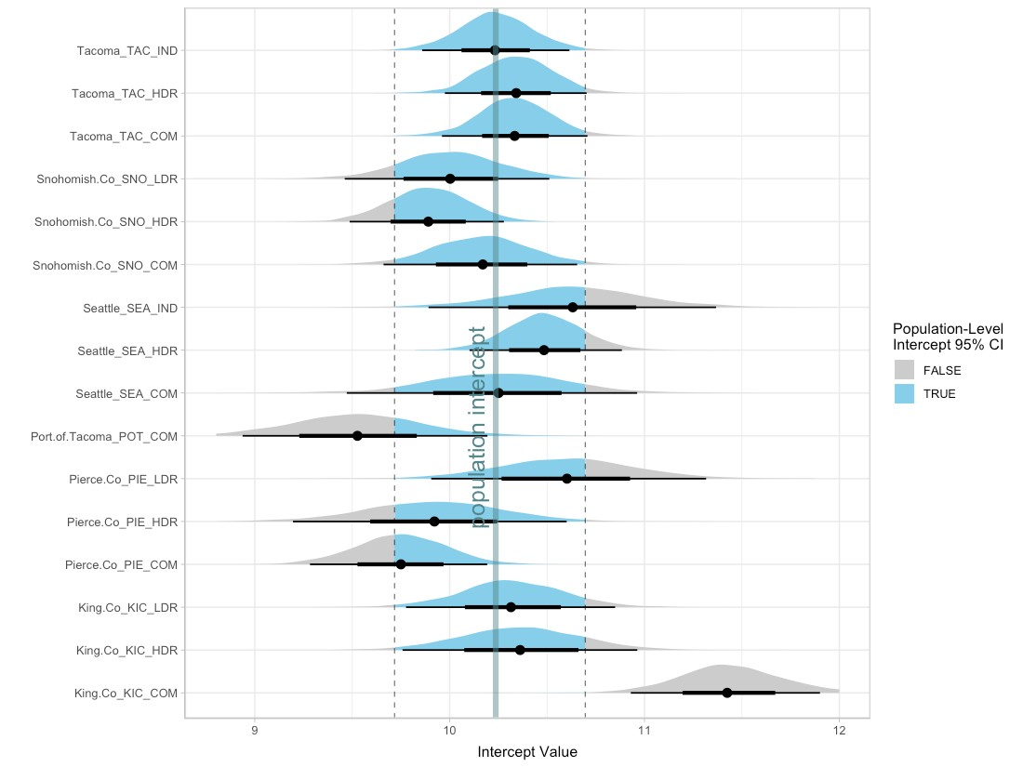
Figure 28. Density plots for the 16 location-specific intercept parameters, along with the median (thick vertical line) and 95% credible intervals (dashed vertical lines) for the population-level intercept. For each location, the mean intercept value is indicated with a black dot, and credible intervals are shown with thick (50% CI) and thin (95% CI) black horizontal lines. Density plots for each location are shaded blue for values that fall within the 95% CI for the population-level intercept, and gray for values that fall outside of the 95% CI for population-level intercept. Note that the population-level 95% CI does not incorporate variability around reporting agency $σ_{agency}$, or around location within each reporting agency $σ_{location}$; it is solely the 95% CI for the population-level intercept (i.e.: 95% of the time, the population-level intercept will fall between the given CI values).

In summary, the Stormwater Heatmap utilizes the spatial predictors sqrt_CO2_road and oldDev to estimate the over-annual mean TSS concentration. The equation used for visualizing the TSS layer is:
$$ln\left(TSS\right)=10.24+0.36*oldDev+0.25*sqrt.CO2.road$$
See Applying Mixed Effects Equations to the Stormwater Heatmap at the end of this document for more information on how the Bayesian model is simplified to this equation.

Total Phosphorus
Based on linear models of ln-transformed total phosphorus (hereafter referred to only as phosphorus) versus individual predictors, the strong predictors identified for phosphorus include: trees, roofs, impervious, nodev, ln_traffic_k100, sqrt_popn, sqrt_CO2_res, sqrt_CO2_road, sqrt_CO2_transport, sqrt_CO2_total, devAge and oldDev (Figure 29).
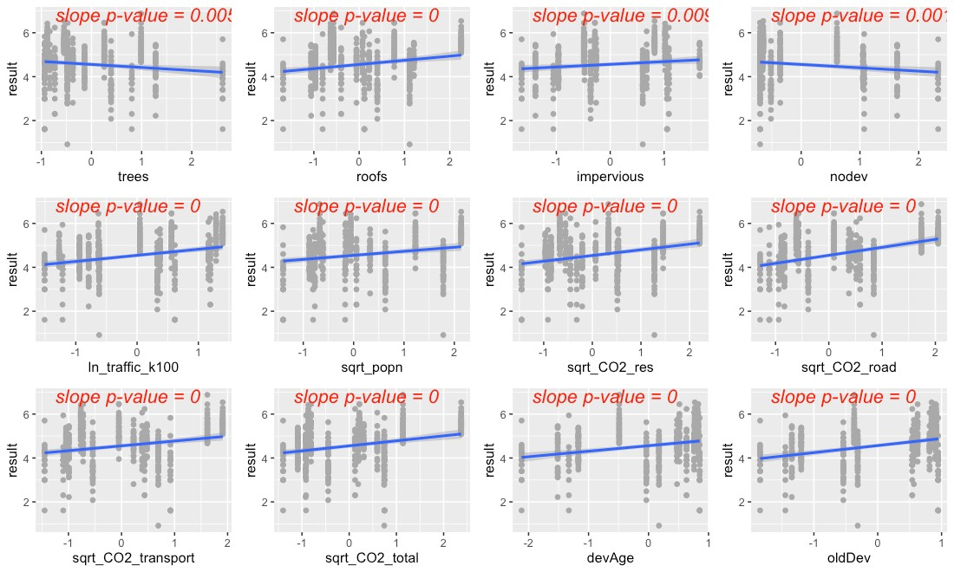
Figure 29. Strong predictors for phosphorus, showing linear model fit (blue line) for the relationship between ln-transformed phosphorus concentration and each predictor in turn.
The precipitation predictors used for phosphorus include standardized 14-day cumulative rainfall (rain14), and standardized 1-day cumulative rainfall (rain1). In addition, evidence of higher phosphorus concentrations during summer led us to add summer as a categorical predictor to the phosphorus model (where summer = 1 during July, August, September, and summer = 0 for all other months).
Residuals plotted against fitted values showed signs of slight heterogeneity (Figure 30, left plot). Of the variance structures tested, the best fit allows residual variation to differ by location j:
$$sd(ϵ_{ijk})=σ_{j}$$

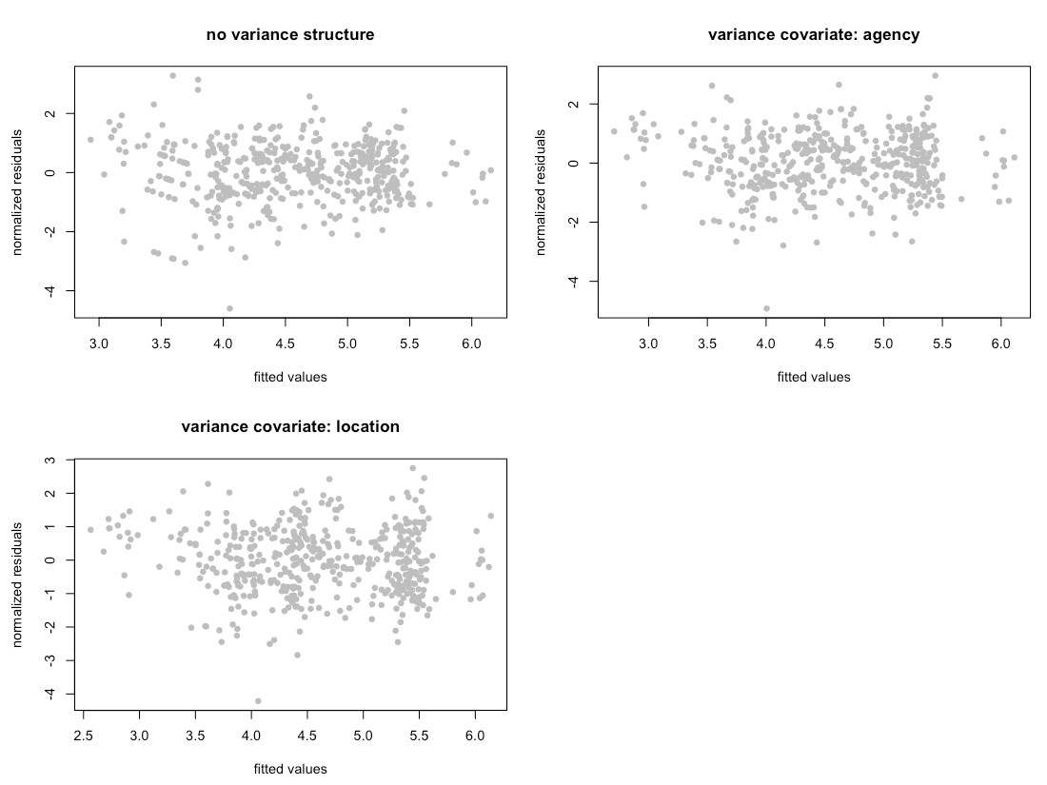
Figure 30. Normalized residuals from beyond-optimal model, with no variance structure (top left), with reporting agency as a variance covariate (top right) and with location as a variance covariate (bottom left). Location as the variance covariate provided the best model fit.

Frequentist Model Summary
The best model for phosphorus is a random-intercept model, where the intercept of the linear model is allowed to vary by reporting agency (k), and by location within each reporting agency (j|k). No signs of temporal or spatial auto-correlation were detected in auto-correlation plots or variograms.
Two possible models emerged to capture the fixed effects:
$$ln\left(P_{ijk}\right)=β_{0}+β_{1}*rai{n14}_{i}+β_{2}*{rain1}_{i}+β_{3}*summer_{i}+β_{4}*{oldDev}_{ijk}+β_{5}*{{rain14}_{i}*oldDev}_{ijk}+a_{k}+a_{j|k}+ϵ_{ijk}$$
$$ln\left(P_{ijk}\right)=β_{0}+β_{1}*rai{n14}_{i}+β_{2}*{rain1}_{i}+β_{3}*summer_{i}+β_{4}*{impervious}_{ijk}+a_{k}+a_{j|k}+ϵ_{ijk}$$
The AIC score for the first model was lower than that of the second model (AIC=911.9 vs. 914.8, when models were fitted with ML). We selected the first model, with oldDev as the single spatial predictor for its lower AIC value. Figure 31 shows the model fit plotted against S8 data.
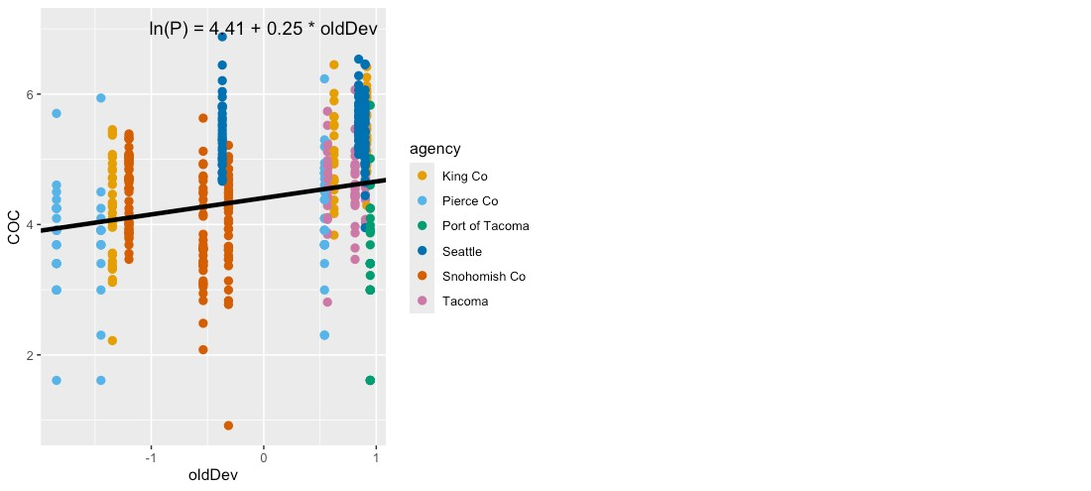
Figure 31. Single-predictor plots for phosphorus, showing fit of the Spatial Predictor Model to the single predictor. Model fitting was performed using maximum likelihood (ML) estimation.

Additionally, an interaction term between oldDev and rain14 was added to the model (Figure 32). When 14-day cumulative rainfall is low, areas that have high oldDev values (yellow to light-green) display a first flush effect which tapers off as cumulative rainfall increases. In contrast, areas with little development or only newer development (dark purple) have a more constant level of phosphorus in stormwater regardless of cumulative antecedent rainfall.

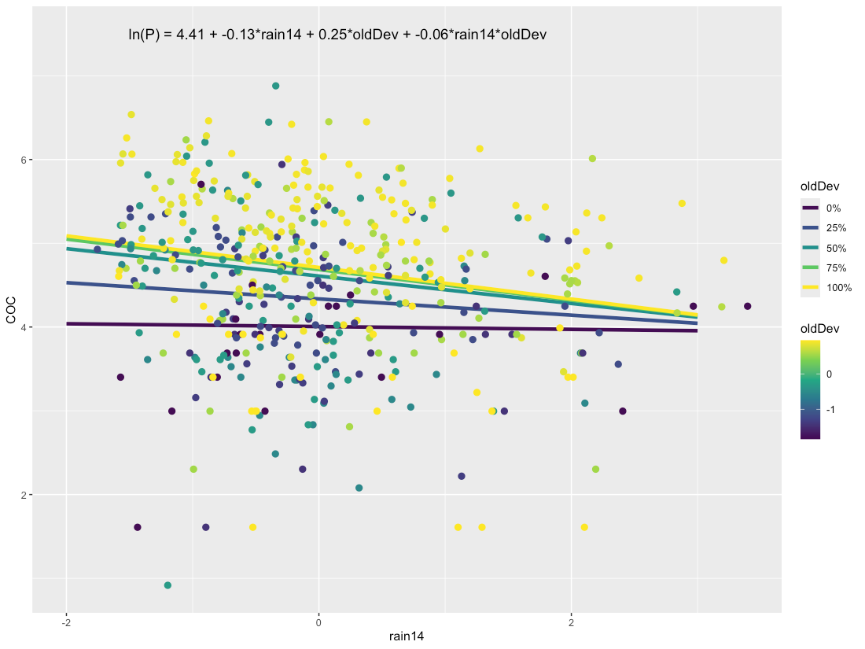
Figure 32. Interaction plot for phosphorous, showing the relationship between oldDev and rain14 (14-day cumulative rainfall).

Comparisons between the Null Model, Categorical Land Use Model, and Spatial Predictor Model can be visualized through residuals (Figure 33) and comparative metrics such as AIC. The residual plots clearly show good fit (residuals close to zero) for the Categorical Land Use Model and for the Spatial Predictor Model.
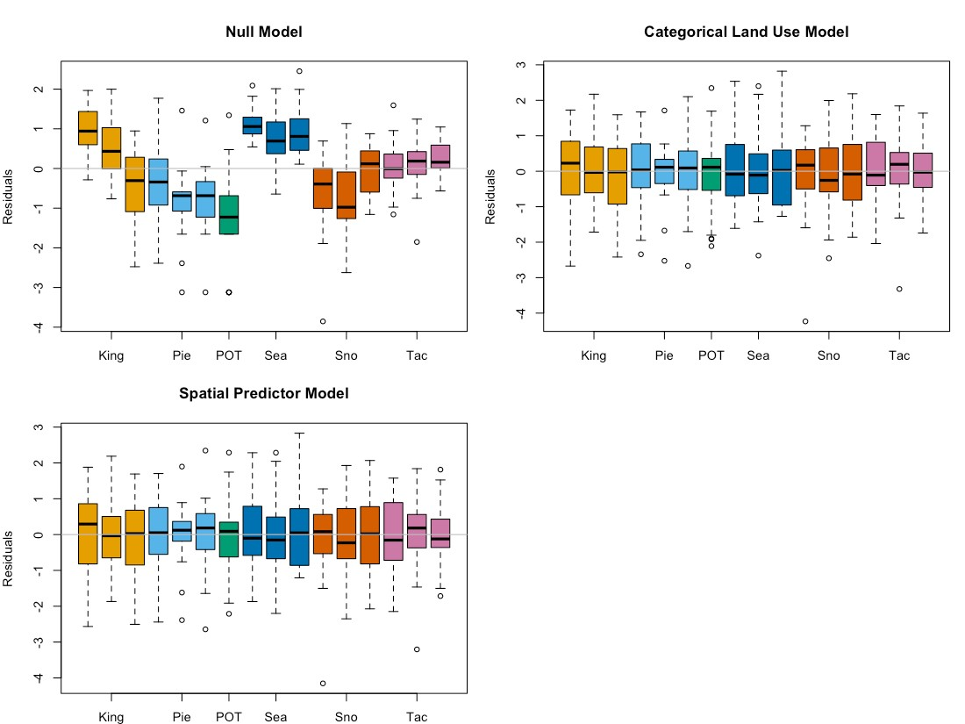
Figure 33. Phosphorus model residuals for the Null Model, Categorical Land Use Model and Spatial Predictor Model. Each bar represents one watershed, with colors representing agencies. Model fitting was performed using maximum likelihood (ML) estimation.

Final frequentist model AIC values (fitted with REML) for the four models are: 1278.6 (Null Model), 936.8 (Categorical Land Use Model), and 934.3 (Spatial Predictor Model). The Spatial Predictor Model shows an improvement over the Categorical Land Use Model. Final coefficient values for all four frequentist models are shown in Figure 34. The large variability in coefficients for the Categorical Land Use Model (shown in orange) indicates lower predictive power of this model. As a result, the Spatial Predictor model outperforms the currently used Categorical Land Use-type model both in terms of AIC, as well as in its potential for generating tighter precision intervals around estimates of phosphorus concentration.

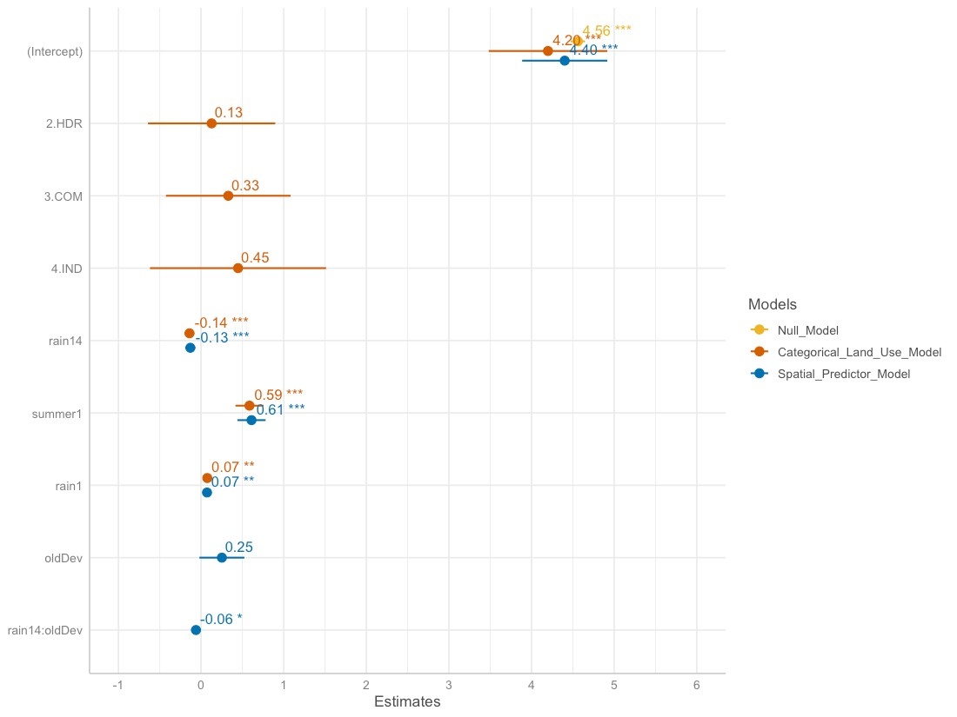
Figure 34. Frequentist model coefficients for the Null Model (goldenrod), Categorical Land Use Model (orange), and Spatial Predictor Model (blue). These coefficient values for linear mixed effects models are based on fitting with restricted maximum likelihood (REML) estimation, and may differ slightly from those fitted using maximum likelihood (ML) estimation.

Bayesian Model Summary
The Bayesian model for total phosphorous follows a Student-t distribution with the form:
$$ln\left(P_{ijk}\right)=β_{0}+β_{1}*rai{n14}_{i}+β_{2}*{rain1}_{i}+β_{3}*summer_{i}+β_{4}*{oldDev}_{ijk}+β_{5}*{{rain14}_{i}*oldDev}_{ijk}+a_{k}+a_{j|k}+ϵ_{ijk}$$
where:
$$β_{0}=4.41; β_{1}=-0.12; β_{2}=0.06; β_{3}=0.63; β_{4}=0.26; β_{5}=-0.07$$
$$a_{k}∼N(0,σ_{agency}); σ_{agency}=0.75$$
$$a_{j|k}∼N(0,σ_{location}); σ_{location}=0.39$$
$$ϵ_{ijk}∼t_{12.97}(0,σ_{j}); ln(σ_{j})=η+u_{j}; σ_{j}=e^{η}*e^{u_{j}}; η=-0.60;$$
$$u_{j}∼N(0,σ_{0}); σ_{0}=0.27$$
Subscripts indicate sample (i), location (j) and reporting agency (k).
Random effects $a_{k}$ (agency-specific contribution to the intercept) and $a_{j|k}$ (location-specific contribution to the intercept) follow a normal (Gaussian) distribution, with mean equal to 0 and standard deviation equal to $σ_{agency}$ for agency-specific contribution to the intercept, and $σ_{location}$ for location-specific contribution to the intercept. The residual variance $ϵ_{ijk}$ represents remaining variation in the data that cannot be explained by the model variables. For the total phosphorus model, residual variance follows a Student-t distribution, which is defined by three parameters: shape ($ν=12.97$) , mean ($μ=0$) and scale ($σ=σ_{j}$). By imposing a variance structure with location (j) as the variance covariate, scale ($σ_{j}$) becomes a function of parameters $η$ and $u_{j}$, where $e^{η}$ represents population-level variability, and $e^{u_{j}}$ represents deviation of location j from the population-level variability. Finally, $u_{j}$ is normally distributed, with mean equal to 0 and standard deviation equal to $σ_{0}$.
Density plots for the 4000 sets of parameter estimates generated by the Bayesian model are provided in the left half of Figure 35, Figure 36, and Figure 37. The peaks show where the most likely values (along the x-axis) of a given parameter are concentrated. They also indicate how much variability exists around parameter estimates, shown by the shape of the curve (low and broad equals lots of variability; tall and narrow equals little variability). The y-axis on density plots represents the probability density function for the kernel density estimation, and can be disregarded for our purposes. Traces (right half of Figure 35, Figure 36, and Figure 37) indicate how well the parameter space was sampled in the four chains generated by the NUTS sampler (no U-turn sampling - an extension of Hamilton Monte Carlo) used when fitting brms models. Each chain generated 1000 sets of parameter estimates, for a total of 4000 sets of parameter estimates. For total phosphorus, the traces indicate that the sampling algorithm did not get stuck in one region of the parameter space, and that the parameter space was well sampled.

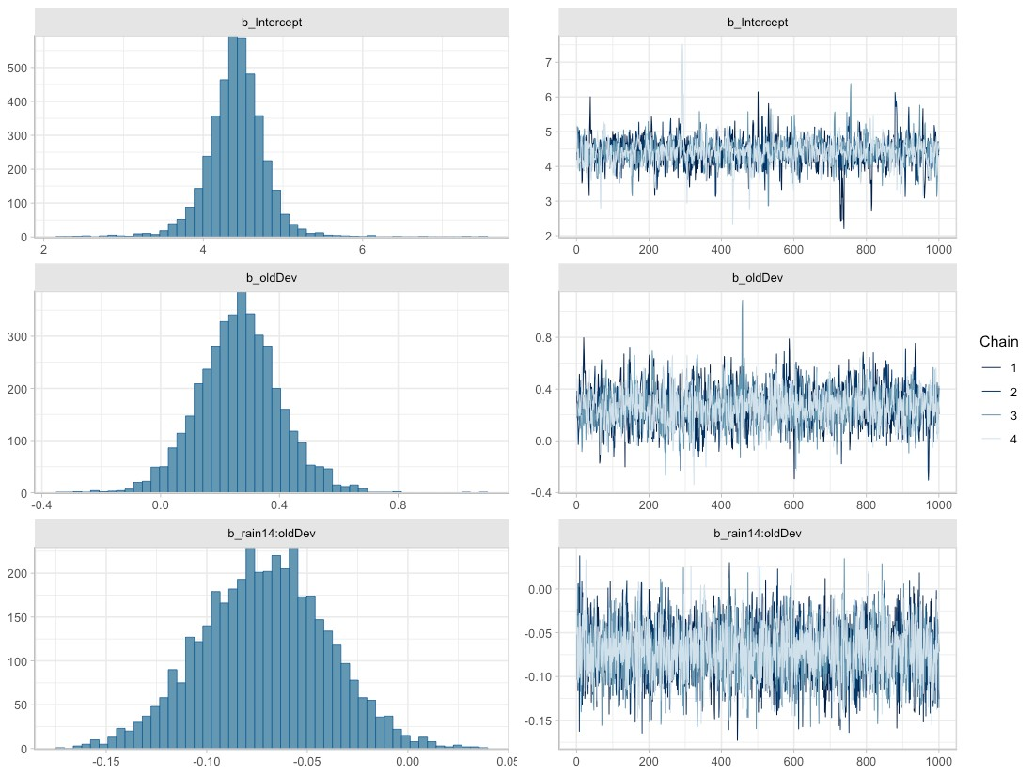
Figure 35. Posterior densities (left) and traces (right) for parameters associated with fixed effects, obtained from the best-fit Bayesian model for total phosphorus.

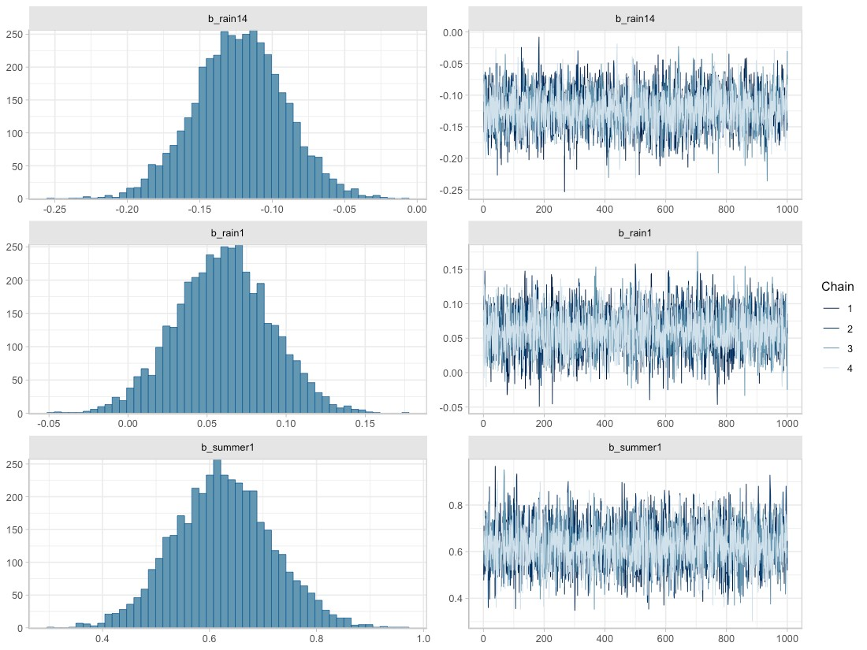
Figure 36. Posterior densities (left) and traces (right) for parameters associated with random effects, obtained from the best-fit Bayesian model for total phosphorus.

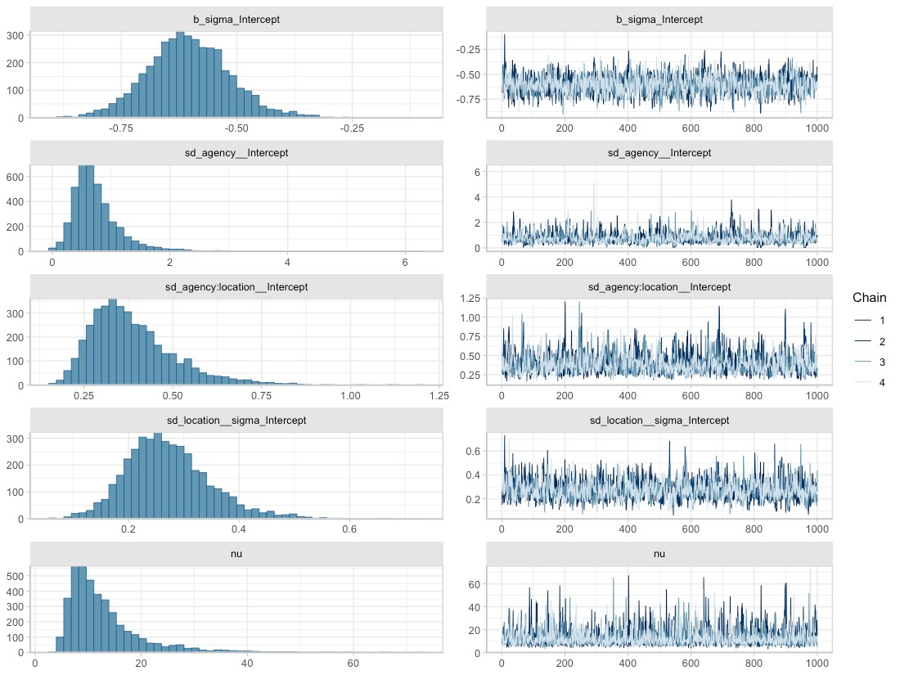
Figure 37. Posterior densities (left) and traces (right) for parameters associated with random effects, obtained from the best-fit Bayesian model for total copper. Here, b_sigma_intercept represents $η$ from the random effects equations, sd_agency__Intercept represents $σ_{agency}$, sd_agency:location__Intercept represents $σ_{location}$, sd_location__sigma_Intercept represents $σ_{0}$, and nu is the Greek letter $ν$, representing shape of the Student-t distribution.

Fit of the Bayesian phosphorus model to data can be assessed through RMSE (0.621) or RSR (0.656), or visualized in estimated versus observed plots (Figure 38 and Figure 39). We provide RSR as a measure of model precision, since RSR is a standardized form of RMSE. Singh et al. (2004) recommends that an RSR ≤ 0.50 indicates a well suited model, while Moriasi et al. (2007) elaborates on this recommendation, suggesting that an RSR ≤ 0.50 indicates a very good model, an RSR ≤ 0.60 indicates a good model, an RSR ≤ 0.70 indicates a satisfactory model, and RSR > 0.7 indicates an unsatisfactory model. According to these guidelines, the phosphorus model (RSR=0.656) is a satisfactory model.
In Figure 38 and Figure 39, the estimated ln(phosphorus) values (vertical axis) are generated using the fitted function (brms package; Buerkner 2017), which applies the spatial predictors associated with each data point (location, rain14, rain1, summer, oldDev) to all 4000 parameter sets that make up the Bayesian posterior. Mean estimated values are then plotted against observed ln(phosphorus) data (horizontal axis). Ideally, the points should form a swath along the 1:1 diagonal dashed line. This 1:1 line shows where estimated values exactly match the observed data. For phosphorus, the estimated vs. observed plots show slightly better model fit at higher phosphorus concentrations (Figure 38), evident because points in the upper right quadrant are slightly closer to the 1:1 line than points in the lower left quadrant.
None of the predictors display a consistent effect on the Bayesian model’s fit to observed data (Figure 39).

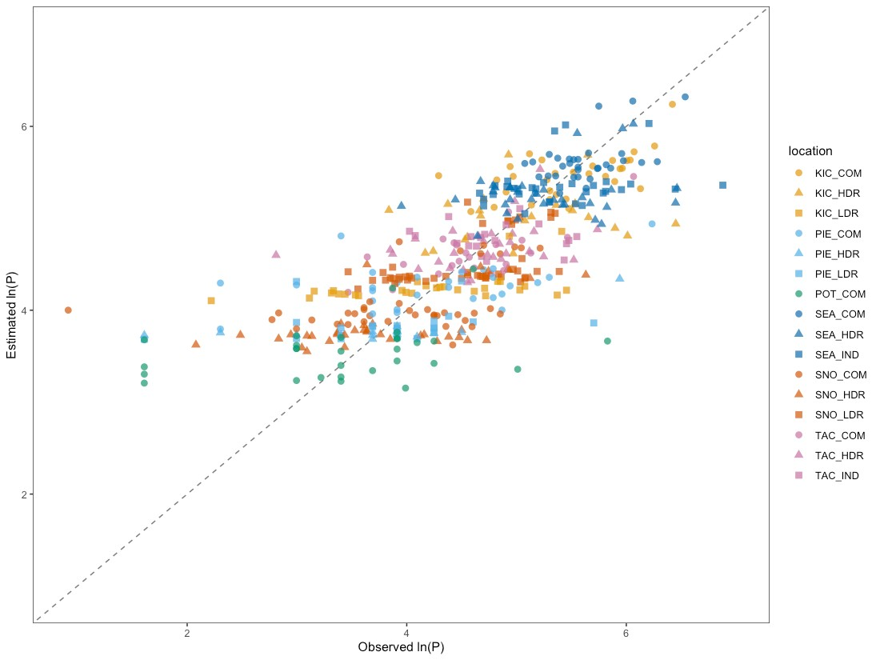
Figure 38. Estimated vs. observed plot for the Bayesian total phosphorous model, with point color corresponding to location. Individual points show how the observed value for ln(phosphorous) (horizontal axis) compares to the mean estimated value from the Bayesian model (vertical axis). The diagonal dashed line shows the 1:1 relationship, where estimated = observed.

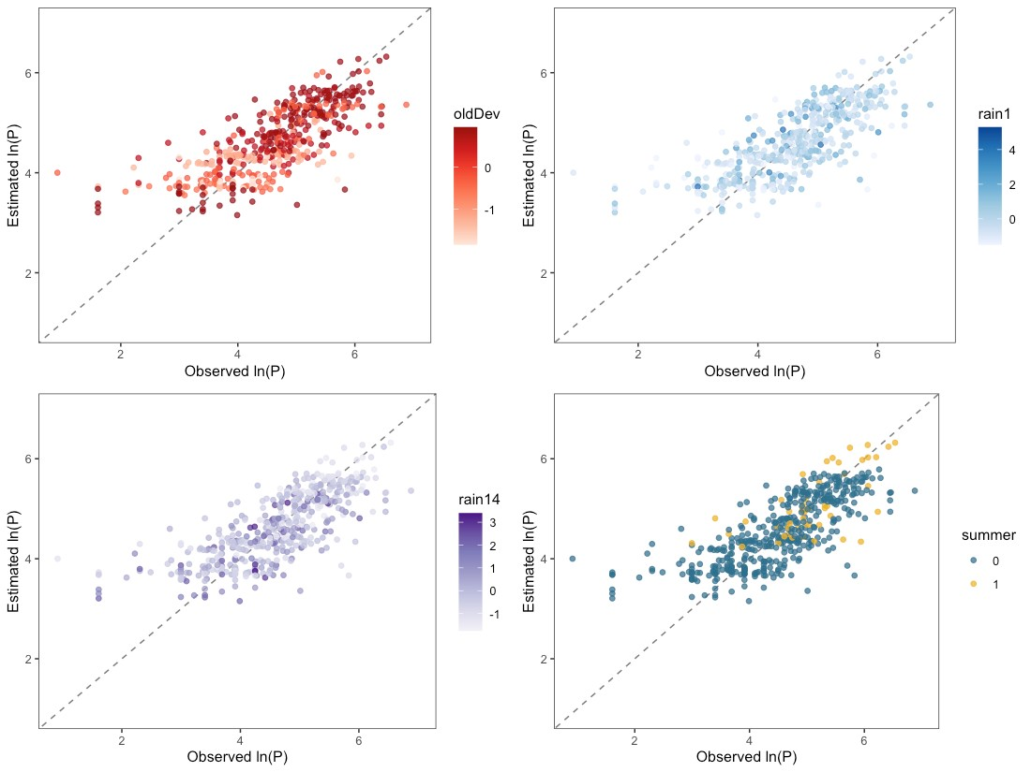
Figure 39. Estimated vs. observed plots for the Bayesian total phosphorus model, with colors showing the magnitude of one spatial predictor (oldDev, rain1, rain14 or summer) at each data point. Individual points show how the observed value for ln(phosphorus) compares to the mean estimated value from the Bayesian model. Diagonal dashed lines show the 1:1 relationship, where estimated=observed.

Phosphorus concentration estimates rely on the spatial predictor oldDev, along with three spatio-temporal predictors: rain14, rain1 and summer. Figure 40 visualizes the effect of oldDev on expected phosphorus concentrations as colored credible interval bands, with median S8 Data by location plotted as black bars atop the credible intervals. In order to generate Figure 40, we integrated over the range of values in the S8 Data for rainfall and season to produce 50%, 80% and 95% credible interval bands.
Credible intervals were calculated using the epred_draws function (tidybayes package; Kay, 2022) applied to a simulated dataset with all combinations of the following predictors:
- 20% of rain, dry & summer combinations randomly sampled from the S8 Data, to provide representative scenarios of rain and summer/ not summer conditions;
- eight equally-spaced oldDev values between minimum and maximum oldDev levels observed in the S8 Data;
Following computation of credible intervals, the spatial predictor oldDev was unstandardized to generate the figure.
As discussed in Step 9 of Model Construction and Selection, credible intervals account for uncertainty around fixed effect parameters and around the variance parameters of the groups, but do not account for residual variance. This allows stormwater managers to assess the following:
- What is the likely range for mean total phosphorus at a heretofore unsampled watershed with a particular level of oldDev?
This is in line with stormwater management best practices, which manage for the over-annual impact on water bodies rather than for extreme events.
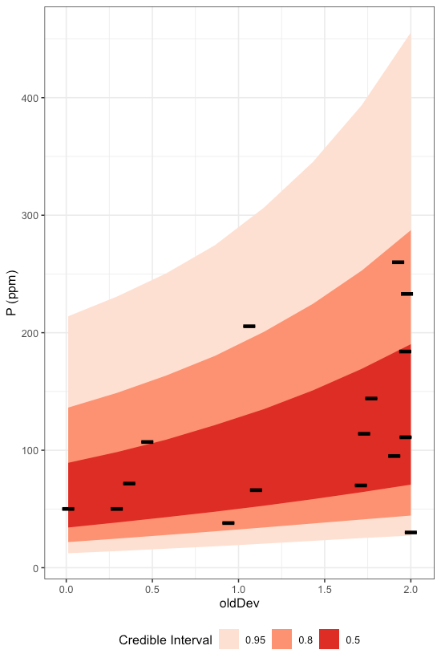
Figure 40. Credible intervals for total phosphorus as a function of oldDev. Bands of color represent 50%, 80% and 95% credible intervals, while black lines represent median S8 Data by location.

The Bayesian total phosphorus model has a population-level intercept $β_{0}=4.41$. As a random-intercept model, the location-specific intercept is allowed to vary by reporting agency (k), and by catchment location within each reporting agency (j|k), and sums to: $β_{0}+a_{k}+a_{j|k}$. Density plots for the location-specific intercept parameters are shown in Figure 41, along with the mean and 95% credible intervals for the population-level intercept.
Twelve of the 16 catchments have location-specific intercepts that overlap well with the population-level intercept: the majority of their density plots are shaded blue (see e.g., TAC_IND). The remaining four catchments have location-specific intercepts that are quite different from that of the population. The deviation between location-specific intercepts and the population-level intercept gives some insight into how much variability may exist in y-intercept values at unsampled locations. Based on the S8 Data, we might expect about a quarter of unsampled locations to differ substantially from the model in terms of the y-intercept.
The Stormwater Heatmap utilizes only the population-level intercept to estimate mean phosphorus concentrations at unsampled locations; Figure 41 is provided as a visual for how much variability exists between locations, in terms of location-specific intercept.

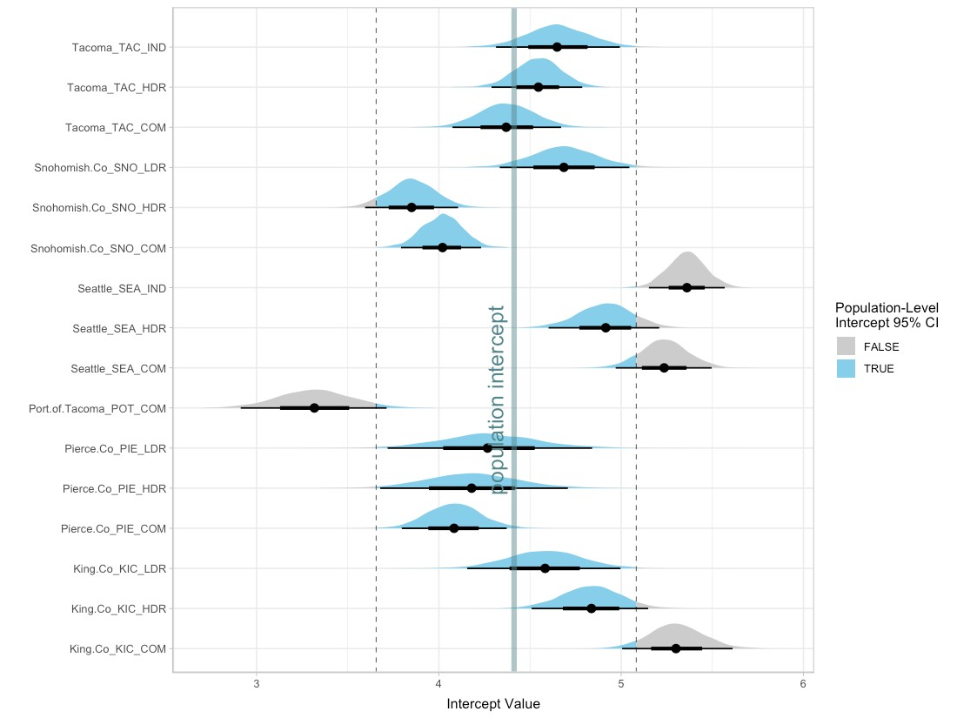
Figure 41. Density plots for the 16 location-specific intercept parameters, along with the median (thick vertical line) and 95% credible intervals (dashed vertical lines) for the population-level intercept. For each location, the mean intercept value is indicated with a black dot, and credible intervals are shown with thick (50% CI) and thin (95% CI) black horizontal lines. Density plots for each location are shaded blue for values that fall within the 95% CI for the population-level intercept, and gray for values that fall outside of the 95% CI for population-level intercept. Note that the population-level 95% CI does not incorporate variability around reporting agency $σ_{agency}$, or around location within each reporting agency $σ_{location}$; it is solely the 95% CI for the population-level intercept (i.e.: 95% of the time, the population-level intercept will fall between the given CI values).

The Stormwater Heatmap utilizes the spatial predictor oldDev to estimate the over-annual mean total phosphorus concentration. The equation used for visualizing the total phosphorus layer is:
$$ln(P)=4.41+0.26*oldDev$$
See Applying Mixed Effects Equations to the Stormwater Heatmap at the end of this document for more information on how the Bayesian model is simplified to this equation.

Total Zinc
Based on linear models of ln-transformed total zinc versus individual predictors, the strong predictors identified for total zinc include: totRES, intURB_IND, grass, trees, roofs, impervious, nodev, ln_traffic_k100, pm25_na, partSA, sqrt_CO2_com, sqrt_CO2_road, sqrt_CO2_nonroad, sqrt_CO2_transport, sqrt_CO2_total, devAge, oldDev, roof_intURB_IND, and roof_totRES (Figure 42).

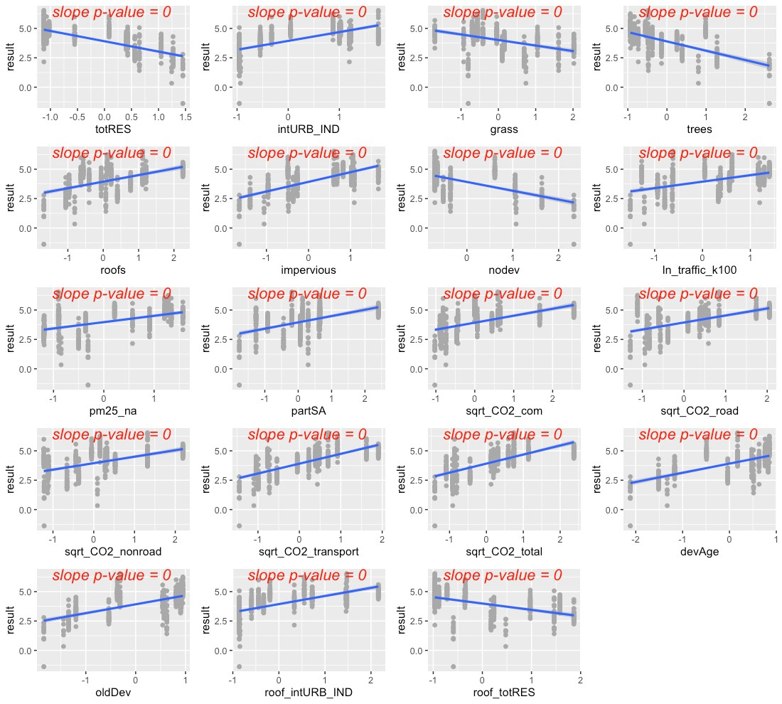
Figure 42. Strong predictors for total zinc, showing linear model fit (blue line) for the relationship between ln-transformed total zinc concentration and each predictor in turn.
The precipitation predictor used for total zinc was 14-day cumulative precipitation. In addition, evidence of higher total zinc concentrations during summer led us to add summer as a categorical predictor to the total zinc model (where summer = 1 during July, August, and September, and summer= 0 for all other months).
Residuals plotted against fitted values showed a pattern, indicating a chance of slight heteroskedasticity (Figure 43, top left). Of the variance structures tested, the best fit allows residual variation to differ by location j.
$$sd(ϵ_{j})=σ_{j}$$

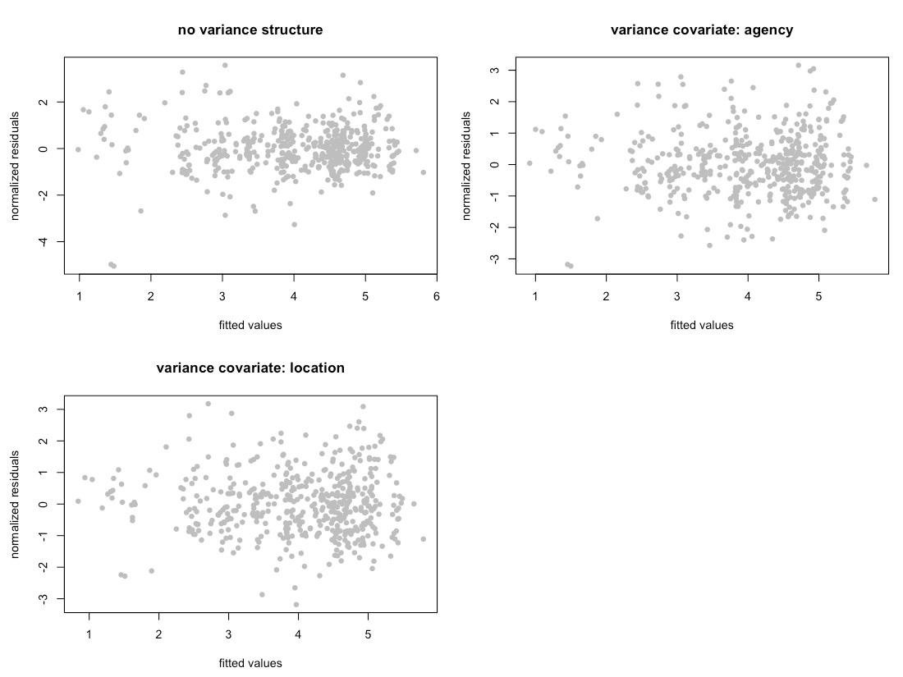
Figure 43. Normalized residuals from beyond-optimal model, with no variance structure (top left), with reporting agency as a variance covariate (top right), and with location as a variance covariate (bottom left). Location as the variance covariate provided the best model fit.

Frequentist Model Summary
The best model for total zinc is a random-intercept model, where the intercept of the linear model is allowed to vary by reporting agency (k), as well as by location within each reporting agency (j|k). No signs of temporal or spatial auto-correlation were detected in auto-correlation plots or variograms.
We explored a variety of models for total zinc. Two possible models emerged to capture the fixed effects:
$$ln(Zn_{ijk})=β_{0}+β_{1}*rai{n14}_{i}+β_{2}*summer_{i}+β_{3}*{impervious}_{ijk}+β_{4}*sqrt_CO_{2}_transport_{ijk}+β_{5}*rai{n14}_{i}*ol{dDev}_{ijk}+a_{k}+a_{j|k}+ϵ_{ijk}$$
$$ln(Zn_{ijk})=β_{0}+β_{1}*rai{n14}_{i}+β_{2}*summer_{i}+β_{3}*{oldDev}_{ijk}+β_{4}*sqrt_CO_{2}_transport_{ijk}+β_{5}*rai{n14}_{i}*ol{dDev}_{ijk}+a_{k}+a_{j|k}+ϵ_{ijk}$$
The first model’s AIC score was slightly lower than that of the second model (AIC=774.3 vs 779.9, when fitted with ML). However, we preferred the model with oldDev and sqrt_CO2_transport, as it more clearly points to sources of zinc (galvanized metals, vehicle tire wear). Figure 44 shows the model fit for each individual predictor, plotted against data points. Correlation between the two predictors was acceptable (correlation = 0.5).

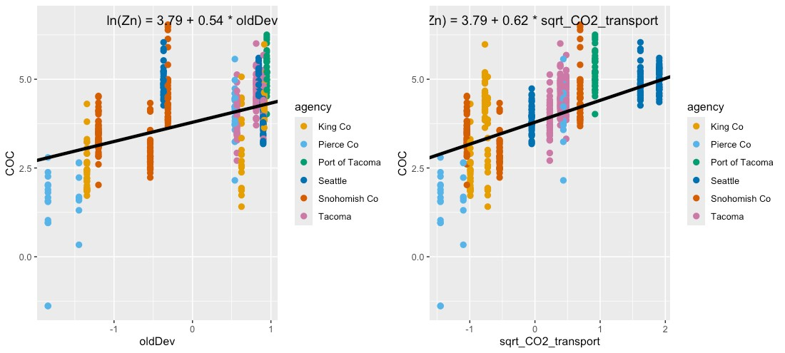
Figure 44. Single-predictor plots for total zinc, showing fit of the Spatial Predictor Model to the not_greenBE and sqrt_CO2_transport predictors. Model fitting was performed using maximum likelihood (ML) estimation.

Figure 45 shows the interaction between rain14 and oldDev. When 14-day cumulative rainfall is low, areas with high oldDev (yellow to light-green) display a first flush effect which tapers off as cumulative rainfall increases. In contrast, areas with little development or only new development (dark purple) have a more constant level of zinc in stormwater regardless of cumulative antecedent rainfall.

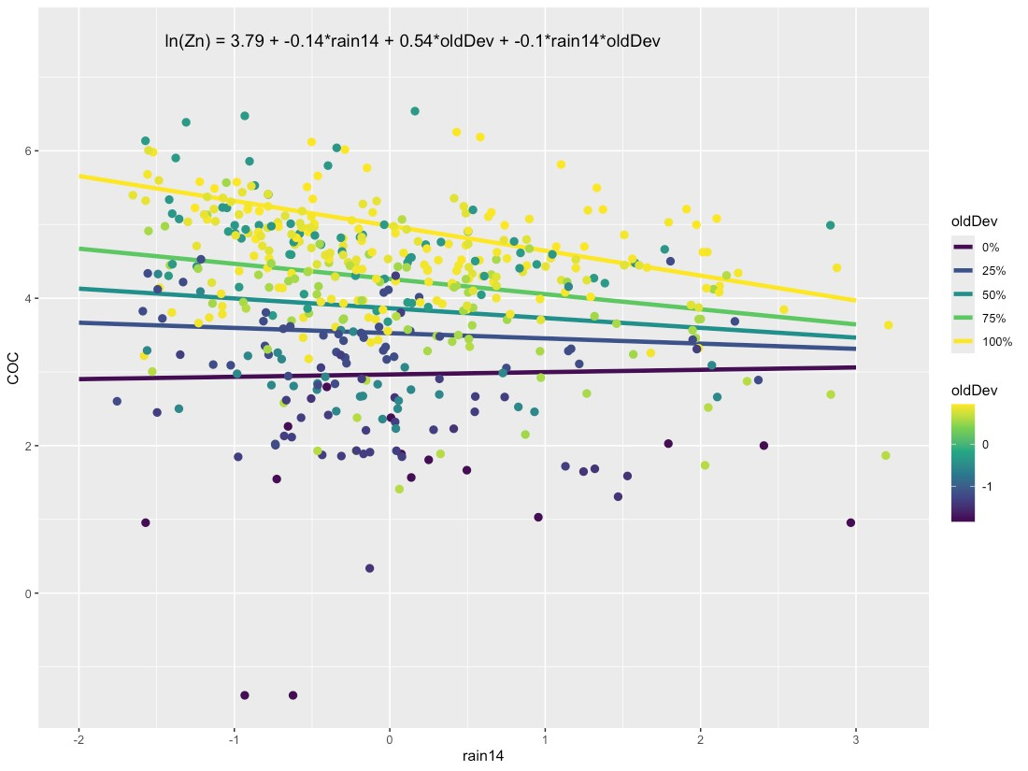
Figure 45. Plot showing for zinc, showing the relationship between oldDev and rain14 (14-day cumulative rainfall).

Model fitting was performed using maximum likelihood (ML) estimation. Comparisons between the Null Model, Categorical Land Use Model, and Spatial Predictor Model can be visualized through residuals (Figure 46) and comparative metrics such as AIC. The residual plots clearly show good fit (residuals close to zero) for the Categorical Land Use Model and for the Spatial Predictor Model.

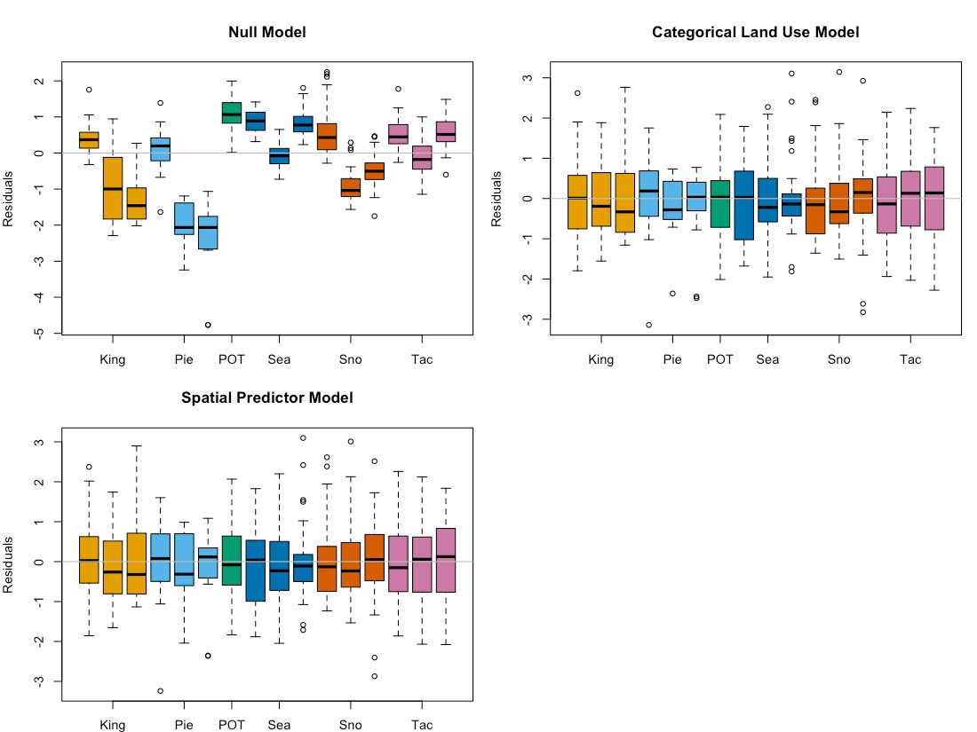
Figure 46. Total zinc model residuals for the Null Model, Categorical Land Use Model, and Spatial Predictor Model. Each bar represents one watershed, with colors representing agencies. Model fitting was performed using maximum likelihood (ML) estimation.

Final frequentist model AIC values (fitted with REML) for the three models are: 1490.5 (Null Model), 804.2 (Categorical Land Use Model), and 800.3 (Spatial Predictor Model), with the Spatial Predictor Model showing a significant improvement over the Categorical Land Use Model. Final coefficient values for all three frequentist models are shown in Figure 47. The large variability in model coefficients for the Categorical Land Use Model (shown in orange) indicates low predictive power, because confidence intervals on predictions will be large. As a result, the Spatial Predictor model outperforms the currently used Categorical Land Use-type model both in terms of AIC, as well as in its potential for generating tighter precision intervals around estimates of copper concentration. We selected this improved method of estimating COC loading for inclusion in the Stormwater Heatmap’s data visualizations.

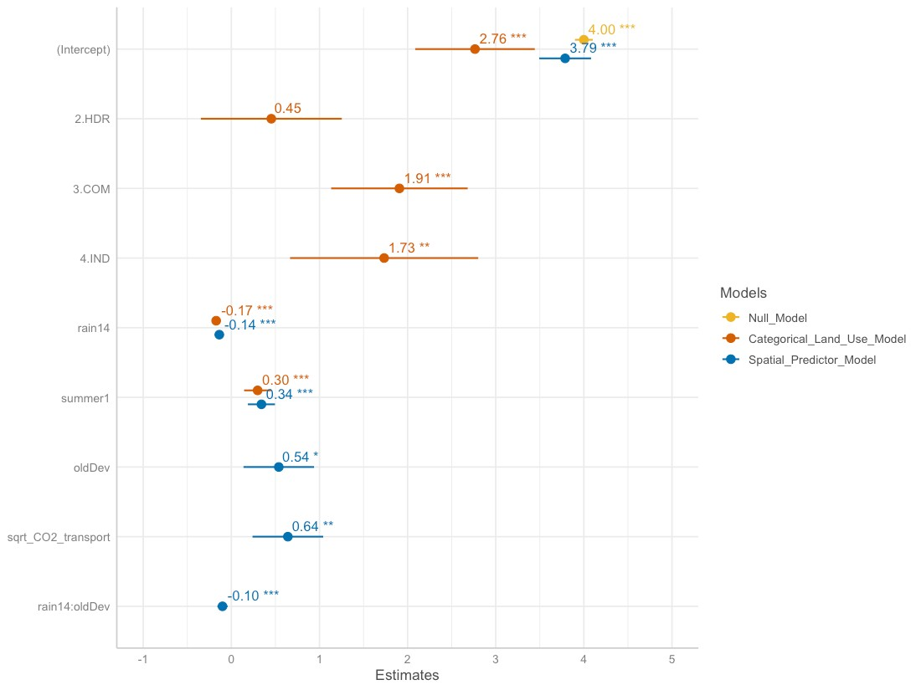
Figure 47. Frequentist model coefficients for the Null Model (goldenrod), Categorical Land Use Model (orange), and Spatial Predictor Model (blue). Final coefficient values for linear mixed effects models are based on fitting with REML, and may differ slightly from coefficient values based on fitting with ML.

Bayesian Model Summary
The Bayesian model for total zinc follows a Student-t distribution with the form:
$$ln(Zn_{ijk})=β_{0}+β_{1}*rai{n14}_{i}+β_{2}*summer_{i}+β_{3}*{oldDev}_{ijk}+β_{4}*sqrt_CO_{2}_transport_{ijk}+β_{5}*rai{n14}_{i}*ol{dDev}_{ijk}+a_{k}+a_{j|k}+ϵ_{ijk}$$
where:
$$β_{0}=3.78; β_{1}=-0.14; β_{2}=0.35; β_{3}=0.53; β_{4}=0.64; β_{5}=-0.09$$
$$a_{k}∼N(0,σ_{agency}); σ_{agency}=0.31$$
$$a_{j|k}∼N(0,σ_{location}); σ_{location}=0.55$$
$$ϵ_{ijk}∼t_{12.41}(0,σ_{j}); ln(σ_{j})=η+u_{j}; σ_{j}=e^{η}*e^{u_{j}}; η=-0.74;$$
$$u_{j}∼N(0,σ_{0}); σ_{0}=0.37$$
Subscripts indicate sample (i), location (j) and reporting agency (k).
Random effects $a_{k}$ (agency-specific contribution to the intercept) and $a_{j|k}$ (location-specific contribution to the intercept) follow a normal (Gaussian) distribution, with mean equal to 0 and standard deviation equal to $σ_{agency}$ for agency-specific contribution to the intercept, and $σ_{location}$ for location-specific contribution to the intercept. The residual variance $ϵ_{ijk}$ represents remaining variation in the data that cannot be explained by the model variables. For the total zinc model, residual variance follows a Student-t distribution, which is defined by three parameters: shape ($ν=12.41$) , mean ($μ=0$) and scale ($σ=σ_{j}$). By imposing a variance structure with location (j) as the variance covariate, scale ($σ_{j}$) becomes a function of parameters $η$ and $u_{j}$, where $e^{η}$ represents population-level variability, and $e^{u_{j}}$ represents deviation of location j from the population-level variability. Finally, $u_{j}$ is normally distributed, with mean equal to 0 and standard deviation equal to $σ_{0}$.
Density plots for the 4000 sets of parameter estimates generated by the Bayesian model are provided in the left half of Figure 48, Figure 49, and Figure 50. The peaks show where the most likely values (along the x-axis) of a given parameter are concentrated. They also indicate how much variability exists around parameter estimates, shown by the shape of the curve (low and broad equals lots of variability; tall and narrow equals little variability). The y-axis on density plots represents the probability density function for the kernel density estimation, and can be disregarded for our purposes. Traces (right half of Figure 48, Figure 49, and Figure 50) indicate how well the parameter space was sampled in the four chains generated by the NUTS sampler (no U-turn sampling - an extension of Hamilton Monte Carlo) used when fitting brms models. Each chain generated 1000 sets of parameter estimates, for a total of 4000 sets of parameter estimates. For total zinc, the traces indicate that the sampling algorithm did not get stuck in one region of the parameter space, and that the parameter space was well sampled.

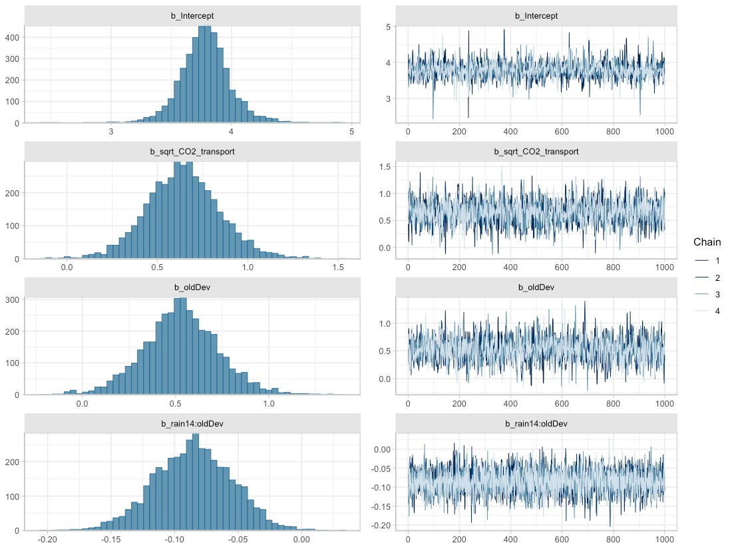
Figure 48. Posterior densities (left) and traces (right) for parameters associated with fixed effects, obtained from the best-fit Bayesian model for total zinc.
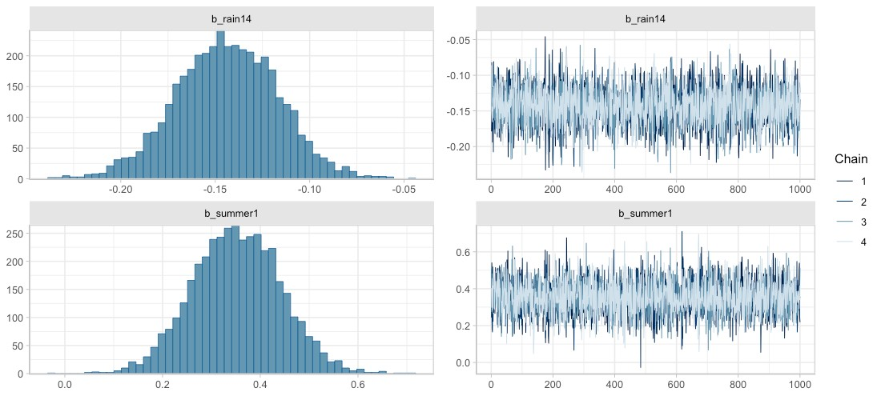
Figure 49. Posterior densities (left) and traces (right) for parameters associated with fixed effects, obtained from the best-fit Bayesian model for total zinc.
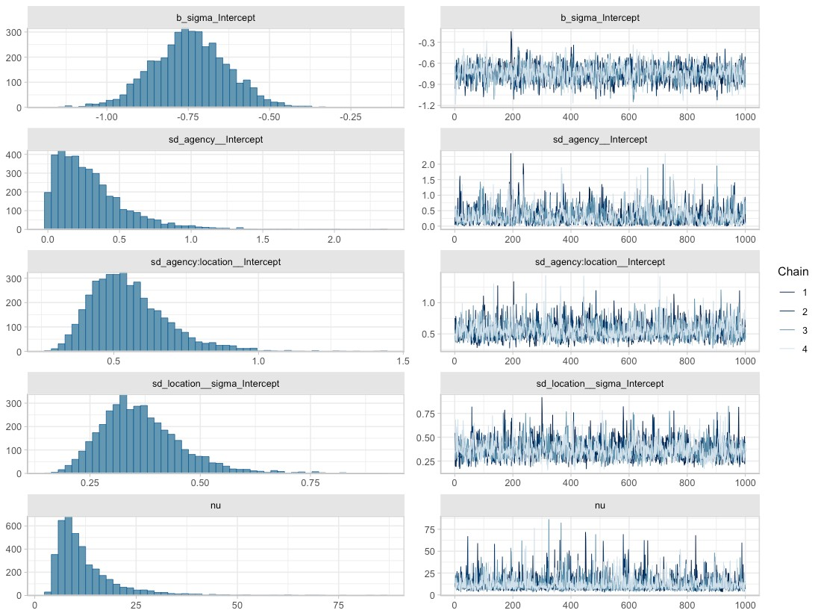
Figure 50. Posterior densities (left) and traces (right) for parameters associated with random effects, obtained from the best-fit Bayesian model for total zinc. Here, b_sigma_intercept represents $η$ from the random effects equations, sd_agency__Intercept represents $σ_{agency}$, sd_agency:location__Intercept represents $σ_{location}$, sd_location__sigma_Intercept represents $σ_{0}$, and nu is the Greek letter $ν$, representing shape of the Student-t distribution.

Fit of the Bayesian total zinc model to data can be assessed through the precision metrics RMSE (0.553) or RSR (0.489), or visualized in estimated versus observed plots (Figure 51 and Figure 52). We provide RSR as a measure of model precision, since RSR is a standardized form of RMSE. Singh et al. (2004) recommends that an RSR ≤ 0.50 indicates a well suited model, while Moriasi et al. (2007) elaborates on this recommendation, suggesting that an RSR ≤ 0.50 indicates a very good model, an RSR ≤ 0.60 indicates a good model, an RSR ≤ 0.70 indicates a satisfactory model, and RSR > 0.7 indicates an unsatisfactory model. According to these guidelines, the total zinc model (RSR=0.489) is very good model.
In Figure 51 and Figure 52, the estimated ln(total zinc) values (vertical axis) are generated using the fitted function (brms package; Buerkner 2017), which applies the spatial predictors associated with each data point (location, rain14, summer, oldDev and sqrt_CO2_transport) to all 4000 parameter sets that make up the Bayesian posterior. Mean estimated values are then plotted against observed ln(total zinc) data (horizontal axis). Ideally, the points should form a swath along the 1:1 diagonal dashed line. This 1:1 line shows where estimated values exactly match the observed data. For total zinc, the estimated vs. observed plots show good model fit to data over all observed zinc concentrations. Several locations show higher within-location variability (e.g., KIC_LDR, KIC_HDR, PIE_LDR in Figure 52), but no pattern emerges indicating better model fit at higher or lower zinc concentrations.
The spatial or temporal predictors do not display a consistent effect on the Bayesian model’s fit to observed data (Figure 52).

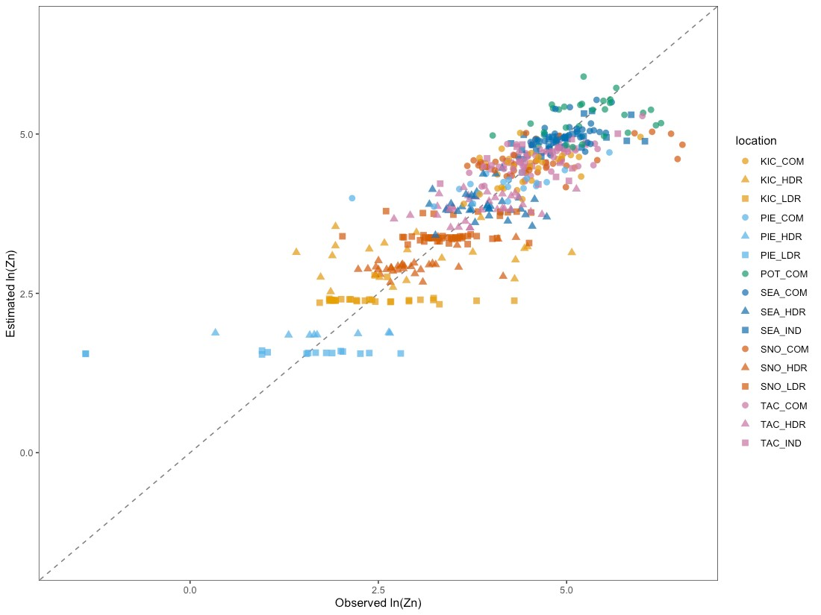
Figure 51. Estimated vs. observed plot for the Bayesian total zinc model, with point color corresponding to location. Individual points show how the observed value for ln(total zinc) (horizontal axis) compares to the mean estimated value from the Bayesian model (vertical axis). The diagonal dashed line shows the 1:1 relationship, where estimated=observed.

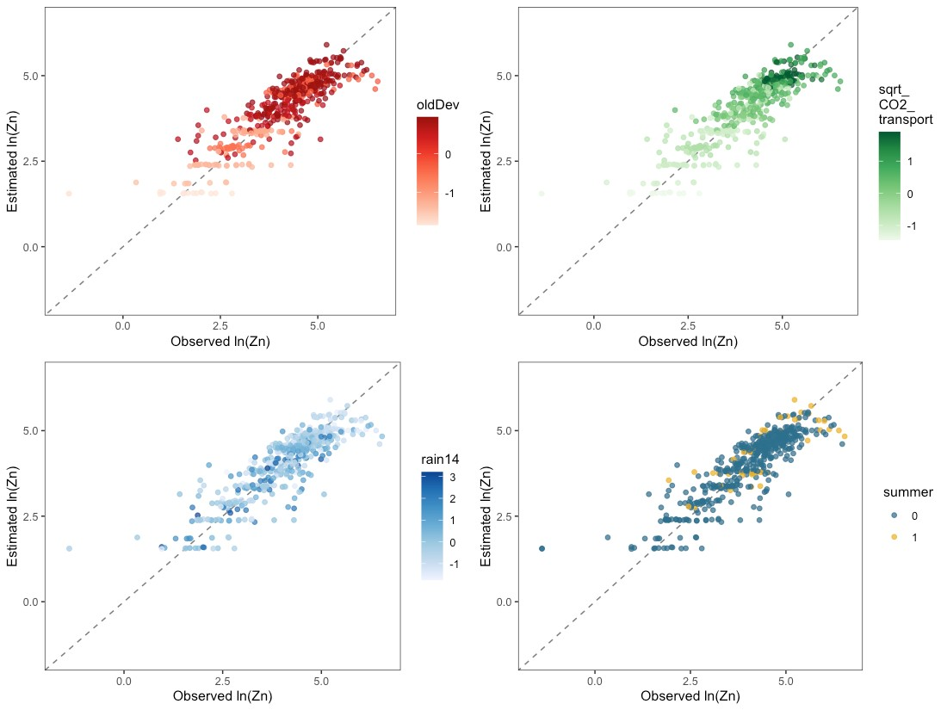
Figure 52. Estimated vs. observed plots for the Bayesian total zinc model, with colors showing the magnitude of one spatial predictor (oldDev, sqrt_CO2_transport, rain14 or summer) at each data point. Individual points show how the observed value for ln(total zinc) compares to the mean estimated value from the Bayesian model. Diagonal dashed lines show the 1:1 relationship, where estimated=observed.

Total zinc concentration estimates rely on two spatial predictors: oldDev and sqrt_CO2_transport, along with two spatio-temporal predictors: rain14 and summer. We can visualize the effect of one spatial landscape predictor at a time on expected total zinc concentrations by applying a range of values of the other spatial predictor and various observed combinations of precipitation and season. In Figure 53, expected mean zinc concentrations as a function of oldDev or CO2_transport are presented as colored credible interval bands, with median S8 Data by location plotted as black bars atop the credible intervals.
Credible intervals were calculated using the epred_draws function (tidybayes package; Kay, 2022) applied to a simulated dataset with all combinations of the following predictors:
- 20% of rain, dry & summer combinations randomly sampled from the S8 Data, to provide representative scenarios of rain and summer/ not summer conditions;
- eight equally-spaced oldDev values between minimum and maximum oldDev levels observed in the S8 Data;
- eight equally-spaced sqrt_CO2_transport values between the minimum and maximum sqrt_CO2_transport levels observed in the S8 Data.
Following computation of credible intervals, the spatial predictors were unstandardized to generate the figure.
As discussed in Step 9 of Model Construction and Selection, credible intervals account for uncertainty around fixed effect parameters and around the variance parameters of the groups, but do not account for residual variance. This allows stormwater managers to assess the following:
- What is the likely range for mean total zinc at a heretofore unsampled watershed with a particular level of oldDev (or sqrt_CO2_transport)?
This is in line with stormwater management best practices, which manage for the over-annual impact on water bodies rather than for extreme events.
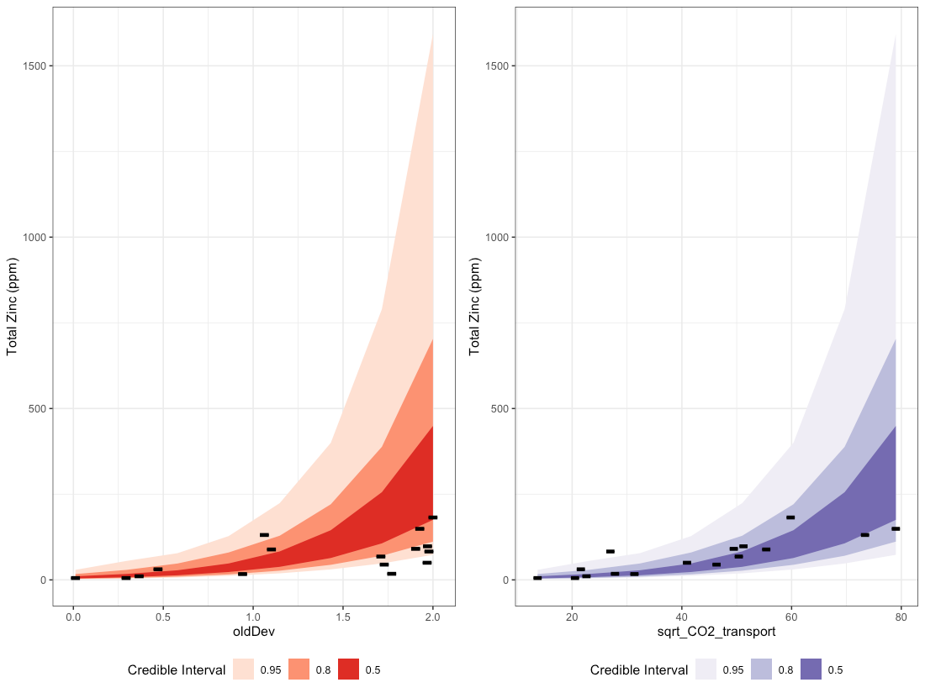
Figure 53. Credible intervals for total zinc as a function of oldDev (left plot) and sqrt_CO2_transport (right plot). Bands of color represent 50%, 80% and 95% credible intervals, while black lines represent median S8 Data by location.

The Bayesian total zinc model has a population-level intercept $β_{0}=3.78$. As a random-intercept model, the location-specific intercept is allowed to vary by reporting agency (k), and by catchment location within each reporting agency (j|k), and sums to: $β_{0}+a_{k}+a_{j|k}$. Density plots for the location-specific intercept parameters are shown in Figure 54 along with the mean and 95% credible intervals for the population-level intercept. Eight of the 16 catchments have location-specific intercepts that overlap well with the population-level intercept: the majority of their density plots are shaded blue (see e.g., TAC_IND). Four additional catchments have approximately half of their density plot overlapping with that of the population-level intercept (e.g., SNO_COM). The remaining four catchments have location-specific intercepts that are quite different from that of the population.
The deviation between location-specific intercepts and the population-level intercept gives some insight into how much variability may exist in y-intercept values at unsampled locations. For total zinc, half of the sampled watershed catchments overlap well with the population-level intercept. Variability around the population-level intercept and around group-specific random effects (reporting agency and location) is also visible in the width of credible interval bands shown in Figure 53.
The Stormwater Heatmap utilizes only the population-level intercept to estimate mean total zinc concentrations at unsampled locations; Figure 54 is provided as a visual for how much variability exists between locations, in terms of location-specific intercept.

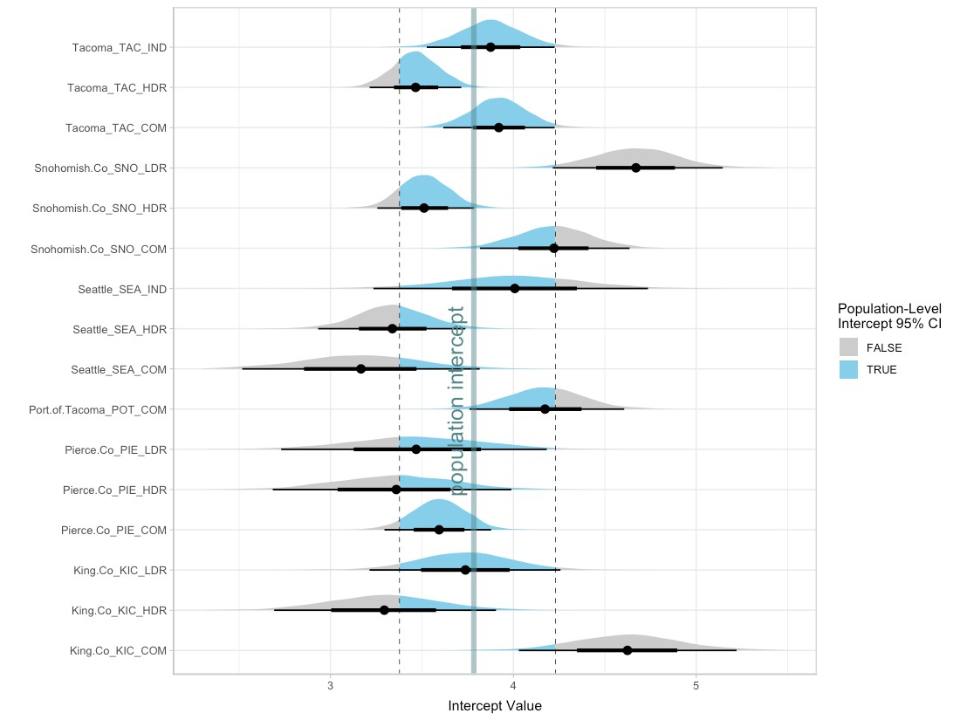
Figure 54. Density plots for the 16 location-specific intercept parameters, along with the median (thick vertical line) and 95% credible intervals (dashed vertical lines) for the population-level intercept. For each location, the mean intercept value is indicated with a black dot, and credible intervals are shown with thick (50% CI) and thin (95% CI) black horizontal lines. Density plots for each location are shaded blue for values that fall within the 95% CI for the population-level intercept, and gray for values that fall outside of the 95% CI for population-level intercept. Note that the population-level 95% CI does not incorporate variability around reporting agency $σ_{agency}$, or around location within each reporting agency $σ_{location}$; it is solely the 95% CI for the population-level intercept (i.e.: 95% of the time, the population-level intercept will fall between the given CI values).

In summary, the Stormwater Heatmap utilizes the spatial predictors oldDev and sqrt_CO2_transport to estimate the over-annual mean total zinc concentration. The equation used for visualizing the total zinc layer is:
$$ln(Zn)=3.78+0.53*oldDev+0.64*sqrt_CO2_transport$$
See Applying Mixed Effects Equations to the Stormwater Heatmap at the end of this document for more information on how the Bayesian model is simplified to this equation.

Total Kjeldahl Nitrogen
Out of 440 total Kjeldahl nitrogen (TKN) samples, 49 samples (11.1%) were flagged as non-detects, with a variety of detection limits ranging from 100 to 500. The majority of non-detect samples came from three agencies: Pierce County, Port of Tacoma, and Snohomish County (Figure 55). High detection limits in Pierce County and Port of Tacoma strongly truncated the lower half of these data sets. One non-detect sample from TAC_HDR was flagged by the laboratory as estimated, with an estimated value of 255. For the purposes of our analysis, we assume that this estimated sample value is correct. The two samples with the lowest detection limits (one each from TAC_COM and TAC_IND) appear to be anomalous with the rest of the data for these two catchments. We assumed that these were mislabeled sample blanks and removed them from the analysis.
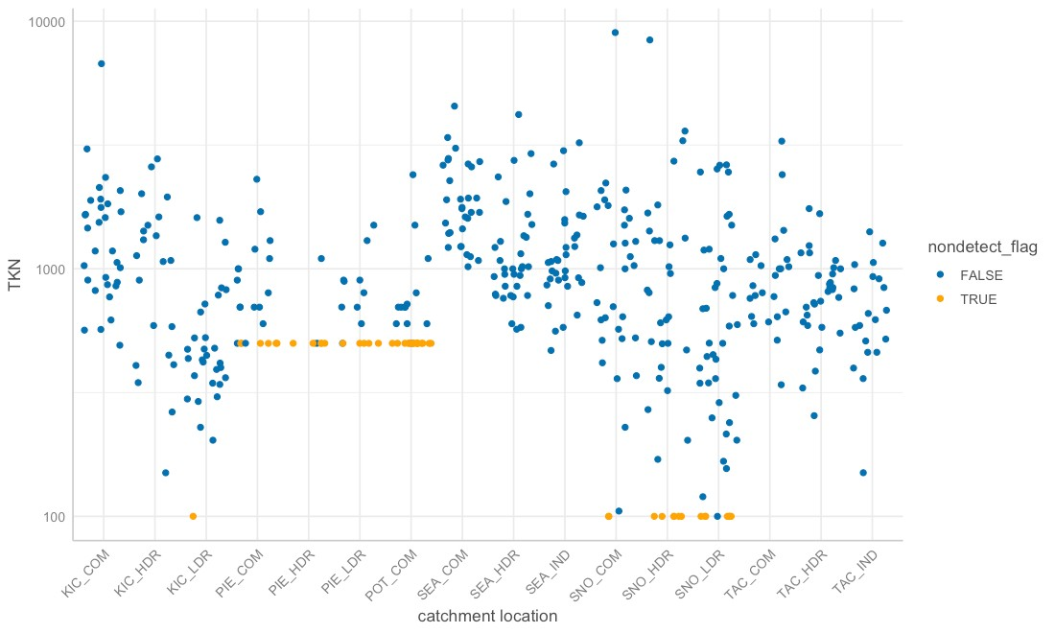
Figure 55. Concentrations of total Kjeldahl nitrogen in samples collected by catchment location. Blue dots indicate detected values, while orange dots indicate the detection limit for samples flagged as non-detect.

Although the EPA allows substitution of (0.5 x detection limit) for censored values when less than 15% of samples are non-detect (USEPA, 2009), substitution can add a pattern to the data that is different than the pattern of the data itself (Helsel, 2012). As a result, we performed regression on order statistics (ROS) at each location using the NADA package (Lee, 2020). ROS uses the uncensored and censored values to model the likely data distribution, then draws from the distribution to generate modeled values for the censored data. Because we ran ROS on a location-by-location basis, we do not anticipate the introduction of extraneous patterns that affect the spatial predictors. Rainfall and seasonality patterns could potentially be affected for the 40 data points that were generated through ROS; however, because nearly 90% of data were not censored, this effect should be relatively small. Figure 56 shows the modeled concentrations of TKN in orange. Frequentist statistics were performed using the modeled values generated by ROS, in place of censored data. Bayesian statistics were performed using a censored data package function the model fitting algorithm (see Bayesian Model Statistics section below).

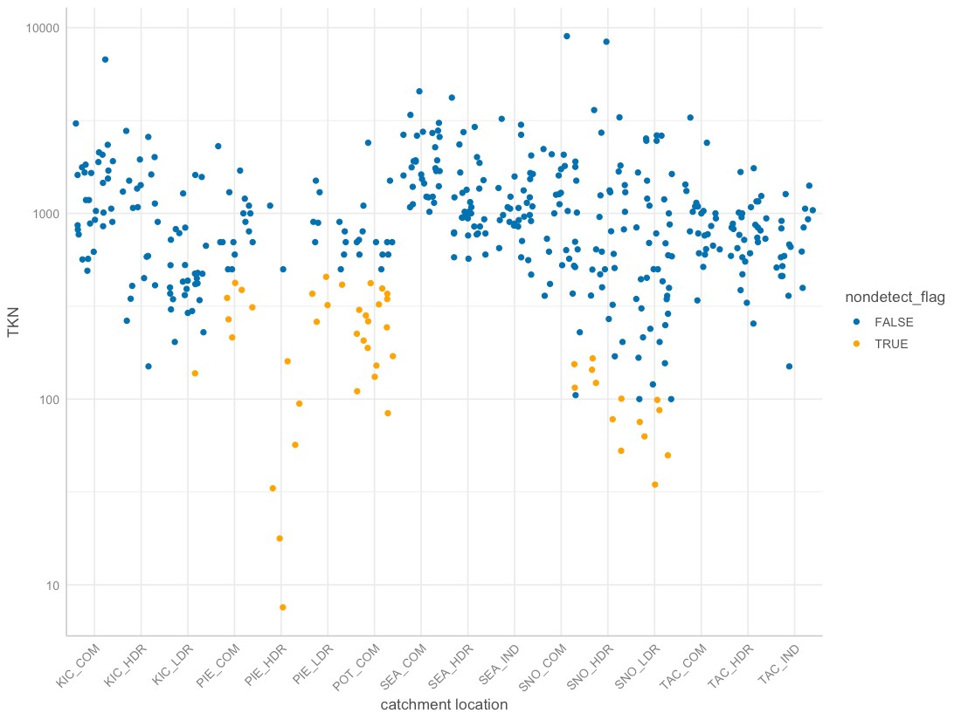
Figure 56. Actual (blue) and modeled (orange) concentrations of total Kjeldahl nitrogen in samples collected by catchment location. Modeled values were generated by regression on order statistics, to replace the detection limit on censored data.

Based on linear models of ln-transformed TKN versus individual predictors, the strong predictors identified for TKN include: totRES, grass, paved, roofs, impervious, nodev, ln_traffic_k100, sqrt_popn, sqrt_CO2_res, sqrt_CO2_com, sqrt_CO2_road, sqrt_CO2_nonroad, sqrt_CO2_transport, sqrt_CO2_total, devAge, oldDev and roof_intURB_IND (Figure 57).

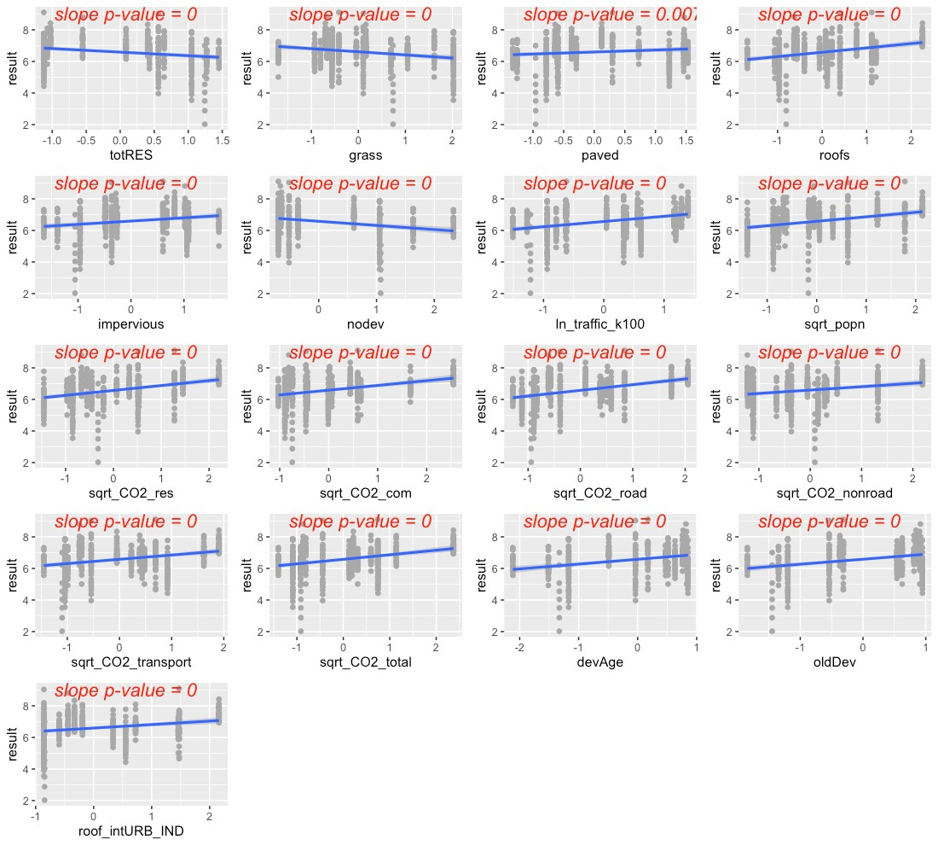
Figure 57. Strong predictors for total Kjeldahl nitrogen (TKN), showing linear model fit (blue line) for the relationship between ln-transformed TKN concentration and each predictor in turn.

The precipitation predictors used for TKN were 14-day cumulative precipitation (rain14) and 1-day cumulative precipitation (rain1). In addition, evidence of higher TKN concentrations during summer led us to add summer as a categorical predictor to the TKN model (where summer = 1 during July, August, September, and summer = 0 for all other months).
Residuals plotted against fitted values showed signs of slight heterogeneity (Figure 58, top left plot). Of the variance structures tested during the frequentist model fitting, the best fit allows residual variation to differ by location j. (Note that during the Bayesian fitting, the best fit allows residual variation to differ by reporting agency k, which is ultimately used in the Bayesian model.)
$$sd(ϵ_{j})=σ_{j}$$
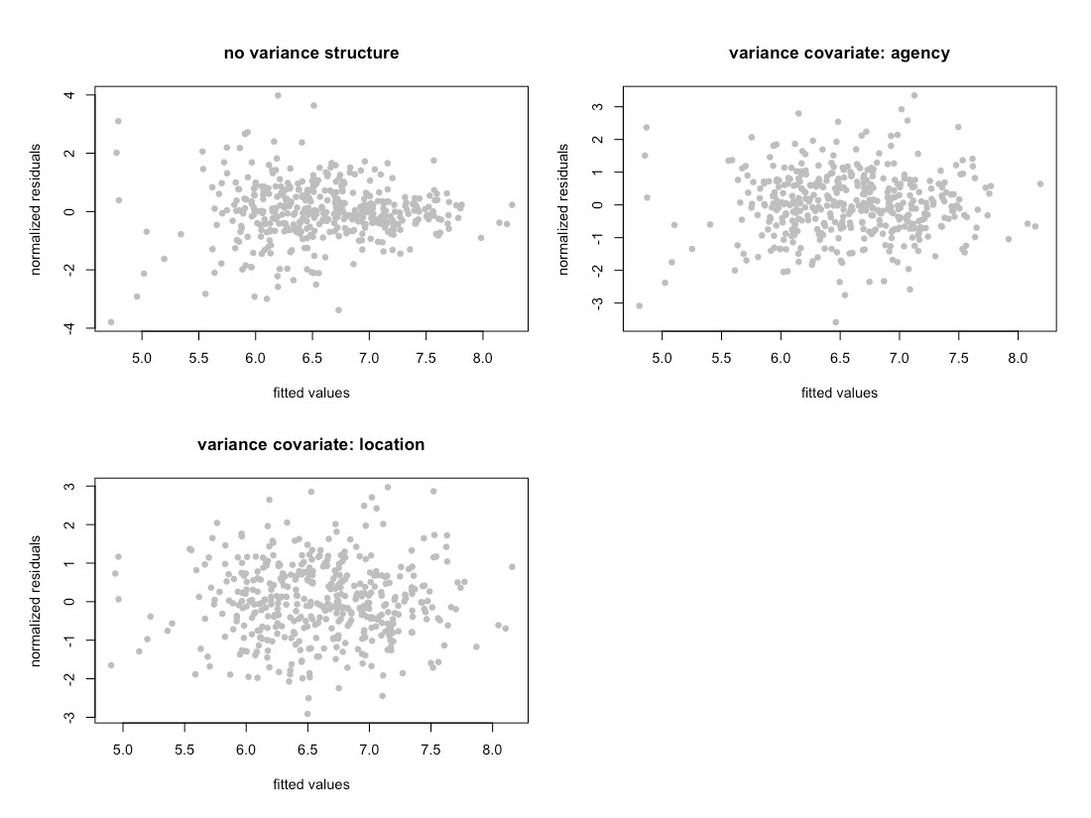
Figure 58. Normalized residuals from beyond-optimal model, with no variance structure (top left), with reporting agency as a variance covariate (top right), and with location as a variance covariate (bottom left). Location as the variance covariate provided the best model fit during the frequentist fitting.

Frequentist Model Summary
The best model for TKN is a random-intercept model, where the intercept of the linear model is allowed to vary by reporting agency (k), as well as by location within each reporting agency (j|k). No signs of temporal or spatial auto-correlation were detected in auto-correlation plots or variograms.
Two models emerged to capture the fixed effects:
$$ln\left({TKN}_{ijk}\right)=β_{0}+β_{1}*rai{n14}_{i}+β_{2}*{rain1}_{i}+β_{3}*summer_{i}+β_{4}*{oldDev}_{ijk}+β_{5}*sqr{t.CO2.res}_{ijk}+β_{6}*{{rain1}_{i}*oldDev}_{ijk}+a_{k}+a_{j|k}+ϵ_{ijk}$$
$$ln\left({TKN}_{ijk}\right)=β_{0}+β_{1}*rai{n14}_{i}+β_{2}*{rain1}_{i}+β_{3}*summer_{i}+β_{4}*{paved}_{ijk}+β_{5}*sqr{t.CO2.res}_{ijk}+β_{6}*{{rain1}_{i}*paved}_{ijk}+a_{k}+a_{j|k}+ϵ_{ijk}$$

The AIC scores for these models were 835.6 and 839.4, respectively, when models were fitted using ML. We selected the first model, with spatial predictors oldDev + sqrt_CO2_res. While both models fit the data reasonably well, we thought that old development would be more likely to have leaky sewers that contribute TKN to stormwater runoff. Figure 59 shows the model fit for each individual predictor, plotted against data points. Correlation between the two predictors was low (correlation coefficient = 0.2).

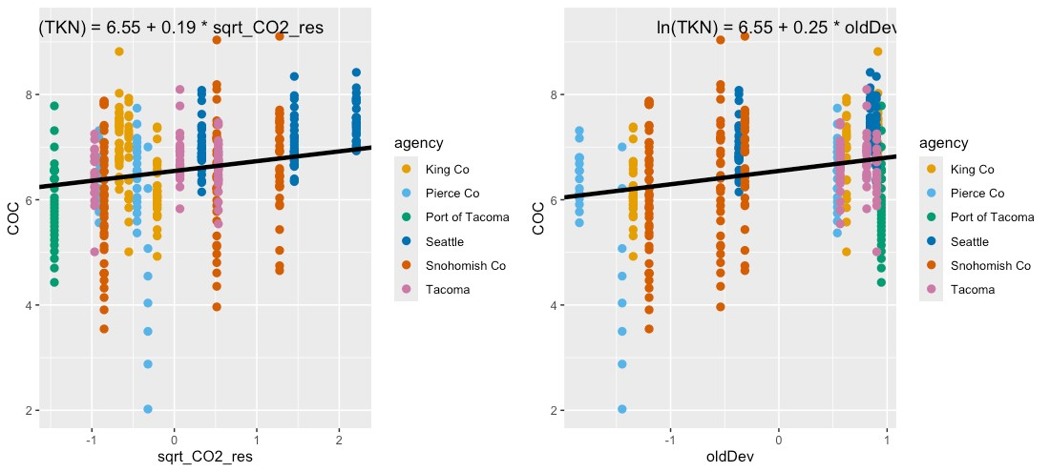
Figure 59. Single-predictor plots for total Kjeldahl nitrogen, showing fit of the Spatial Predictor Model to each predictor. Model fitting was performed using maximum likelihood (ML) estimation.

The interaction between rain1 and oldDev is shown in Figure 60. When the 1-day rainfall is low intensity, areas with low oldDev (either undeveloped or newly developed, shown in dark purple) result in little TKN washing into stormwater outfalls. However, as rainfall intensity increases, these areas contribute more heavily to TKN washing into outfalls. In contrast, aeas with high oldDev have a more constant level of TKN in stormwater regardless of rainfall intensity.

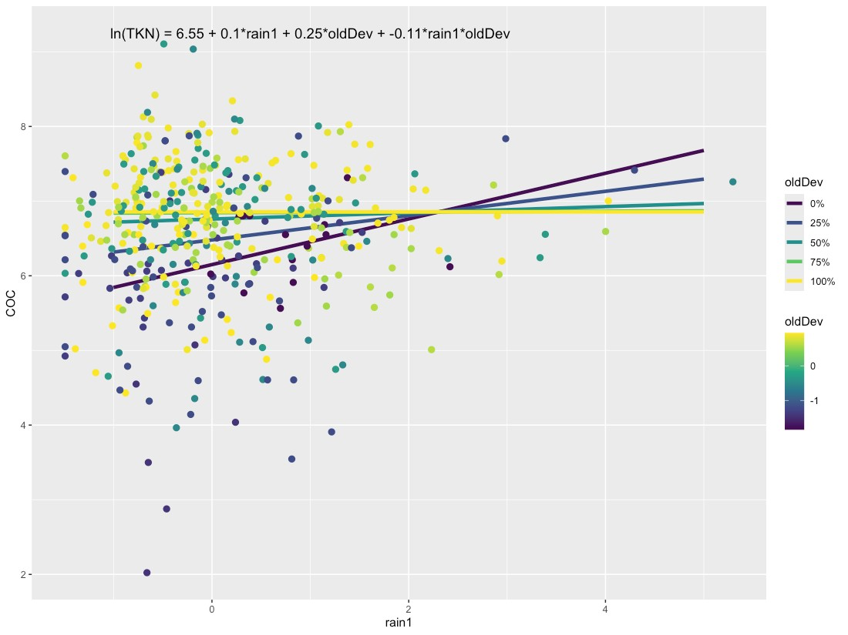
Figure 60. Interaction plot for TKN, showing the relationship between oldDev and rain1 (1-day cumulative rainfall).

Comparisons between the Null Model, Categorical Land Use Model, and Spatial Predictor Model can be visualized through residuals (Figure 61) and comparative metrics such as AIC. The residual plots clearly show good fit (residuals close to zero) for the Categorical Land Use Model and for the Spatial Predictor Model.

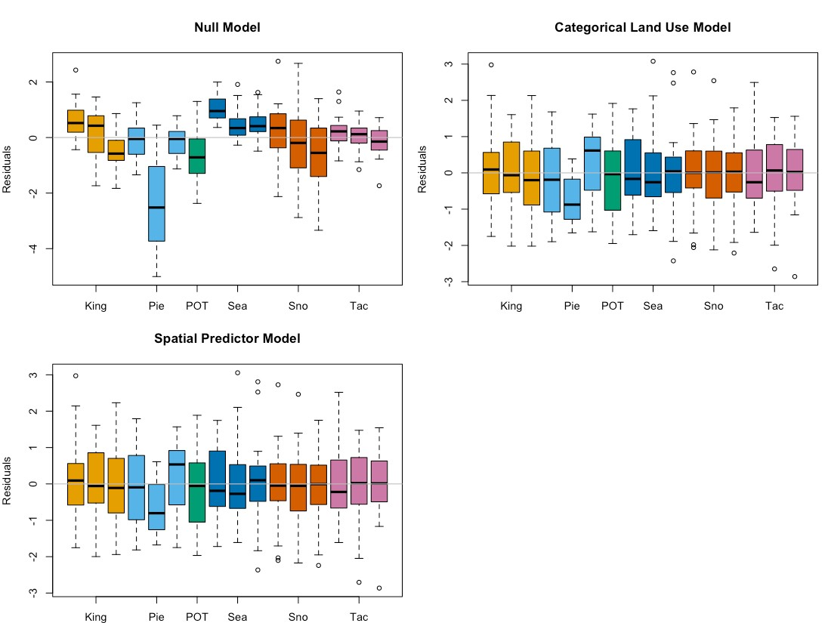
Figure 61. Total Kjeldahl nitrogen model residuals for the Null Model, Categorical Land Use Model, and Spatial Predictor Model. Each bar represents one watershed, with colors representing agencies. Model fitting was performed using maximum likelihood (ML) estimation.

Final frequentist model AIC values (fitted with REML) for the three models are: 1177.6 (Null Model), 868.5 (Categorical Land Use Model) and 863.6 (Spatial Predictor Model), with the Spatial Predictor Model showing a significant improvement over the Categorical Land Use Model. Final coefficient values for all three frequentist models are shown in Figure 62. The relatively large variability in model coefficients for the Categorical Land Use Model (shown in orange) indicates lower predictive power, because confidence intervals around TKN estimates will be large. We selected the Spatial Predictor Model to estimate COC loading in the Stormwater Heatmap’s data visualizations for its clear improvement in AIC value, and the increase in predictive power over the Categorical Land Use Model.

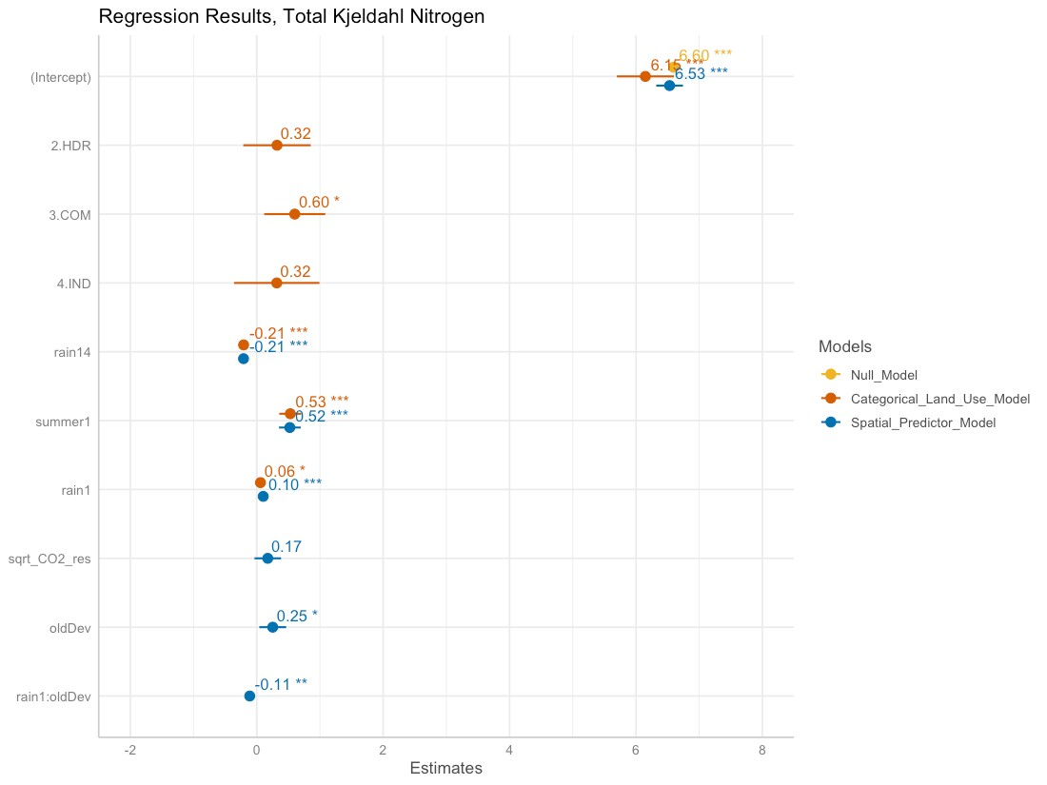
Figure 62. Model coefficients for the Null Model (goldenrod), Categorical Land Use Model (orange), and Spatial Predictor Model (blue). Final coefficient values for linear mixed effects models are based on fitting with restricted maximum likelihood (REML) estimation, and may differ slightly from those fitted using maximum likelihood (ML) estimation.

Bayesian Model Summary
The Bayesian model for TKN was constructed using the censored data function within the brms package (Buerkner, 2017). The best fit model follows a Student-t distribution with the form:
$$ln\left({TKN}_{ijk}\right)=β_{0}+β_{1}*rai{n14}_{i}+β_{2}*{rain1}_{i}+β_{3}*summer_{i}+β_{4}*{oldDev}_{ijk}+β_{5}*sqr{t.CO2.res}_{ijk}+β_{6}*{{rain1}_{i}*oldDev}_{ijk}+a_{k}+a_{j|k}+ϵ_{ijk}$$
where:
$$β_{0}=6.54; β_{1}=-0.18; β_{2}=0.10; β_{3}=0.58; β_{4}=0.25; β_{5}=0.14; β_{6}=-0.11$$
$$a_{k}∼N(0,σ_{agency}); σ_{agency}=0.25$$
$$a_{j|k}∼N(0,σ_{location}); σ_{location}=0.27$$
$$ϵ_{ijk}∼t_{7.70}(0,σ_{k}); ln(σ_{k})=η+u_{k}; σ_{k}=e^{η}*e^{u_{k}}; η=-0.70;$$
$$u_{k}∼N(0,σ_{0}); σ_{0}=0.58$$
Subscripts indicate sample (i), location (j) and reporting agency (k).
Unlike the frequentist fitting, the best variance structure for the Bayesian fitting used agency as a variance covariate. Random effects $a_{k}$ (agency-specific contribution to the intercept) and $a_{j|k}$ (location-specific contribution to the intercept) follow a normal (Gaussian) distribution, with mean equal to 0 and standard deviation equal to $σ_{agency}$ for agency-specific contribution to the intercept, and $σ_{location}$ for location-specific contribution to the intercept. The residual variance $ϵ_{ijk}$ represents remaining variation in the data that cannot be explained by the model variables. For the TKN model, residual variance follows a Student-t distribution, which is defined by three parameters: shape ($ν=7.70$) , mean ($μ=0$) and scale ($σ=σ_{j}$). By imposing a variance structure with reporting agency (k) as the variance covariate, scale ($σ_{k}$) becomes a function of parameters $η$ and $u_{k}$, where $e^{η}$ represents population-level variability, and $e^{u_{k}}$ represents deviation of reporting agency k from the population-level variability. Finally, $u_{k}$ is normally distributed, with mean equal to 0 and standard deviation equal to $σ_{0}$.
Density plots for the 4000 sets of parameter estimates generated by the Bayesian model are provided in the left half of Figure 63, Figure 64, and Figure 65. The peaks show where the most likely values (along the x-axis) of a given parameter are concentrated. They also indicate how much variability exists around parameter estimates, shown by the shape of the curve (low and broad equals lots of variability; tall and narrow equals little variability). The y-axis on density plots represents the probability density function for the kernel density estimation, and can be disregarded for our purposes. Traces (right half of Figure 63, Figure 64, and Figure 65) indicate how well the parameter space was sampled in the four chains generated by the NUTS sampler (no U-turn sampling - an extension of Hamilton Monte Carlo) used when fitting brms models. Each chain generated 1000 sets of parameter estimates, for a total of 4000 sets of parameter estimates. For TKN, the traces indicate that the sampling algorithm did not get stuck in one region of the parameter space, and that the parameter space was well sampled.

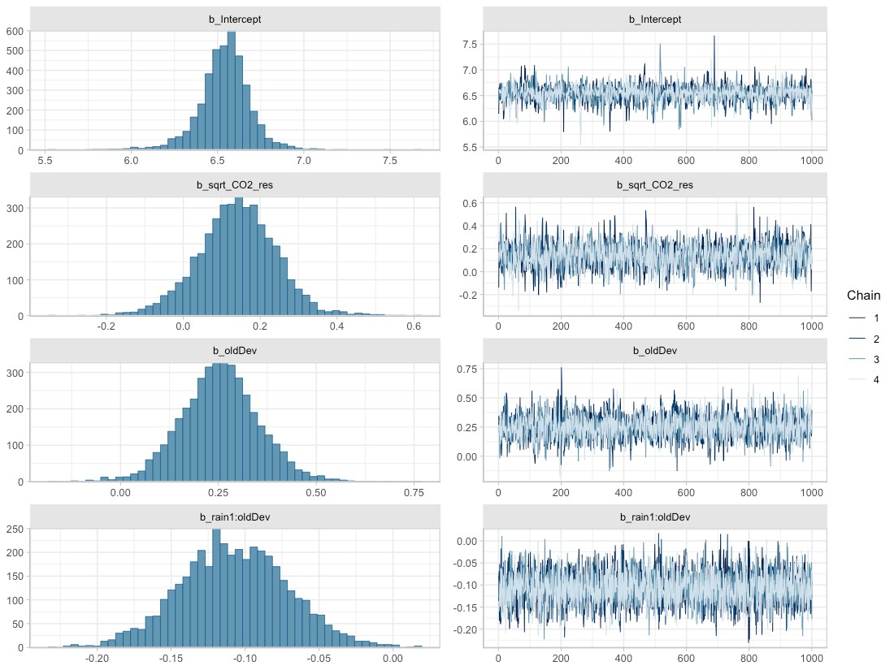
Figure 63. Posterior densities (left) and traces (right) for parameters associated with fixed effects, obtained from the best-fit Bayesian model for total Kjeldahl nitrogen.

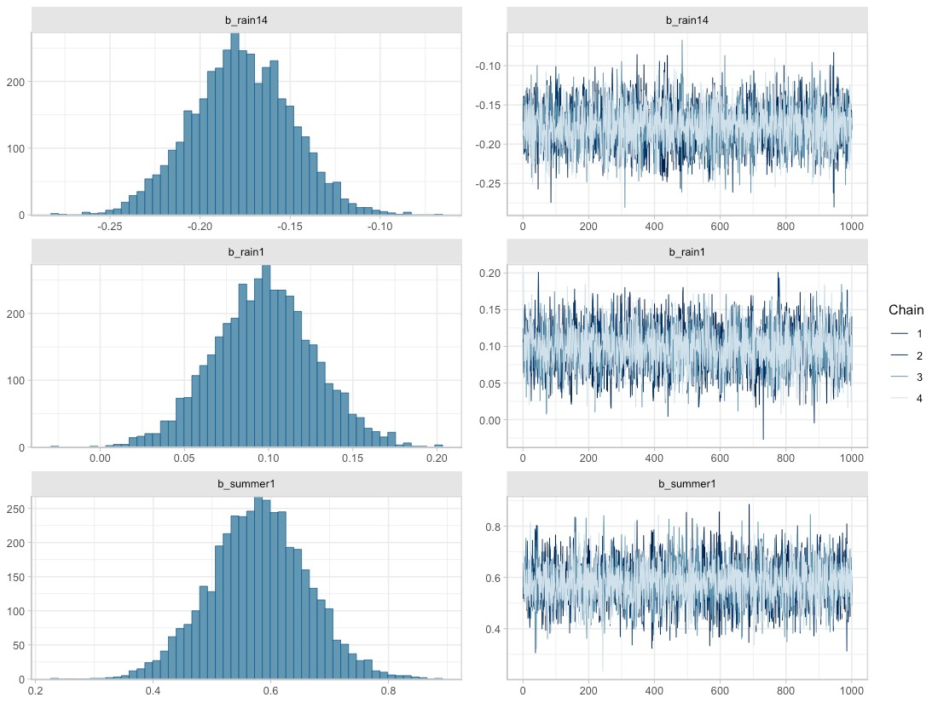
Figure 64. Posterior densities (left) and traces (right) for parameters associated with fixed effects, obtained from the best-fit Bayesian model for total Kjeldahl nitrogen.

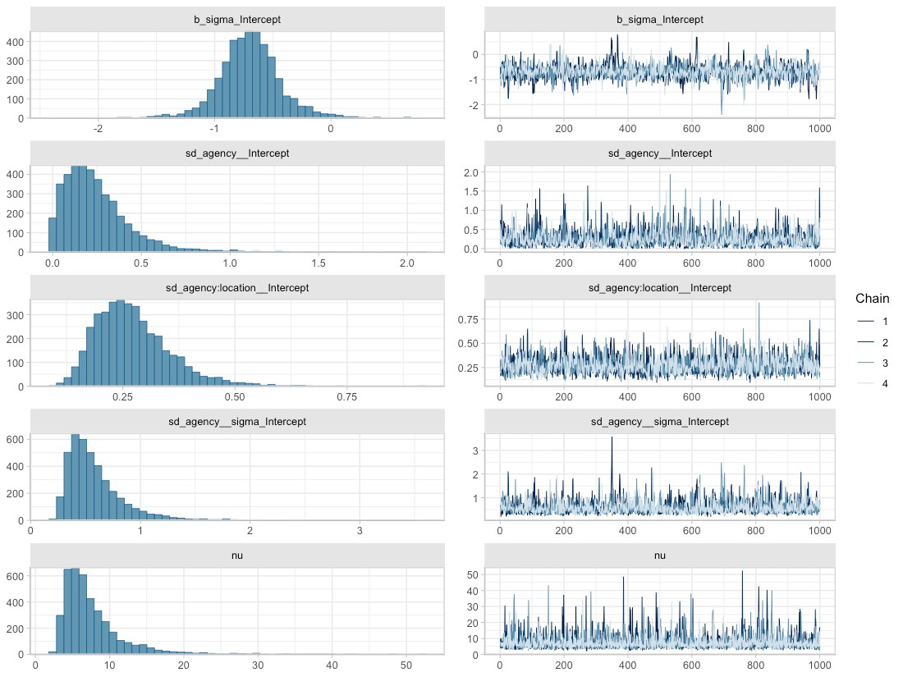
Figure 65. Posterior densities (left) and traces (right) for parameters associated with random effects, obtained from the best-fit Bayesian model for total Kjeldahl nitrogen. Here, b_sigma_intercept represents $η$ from the random effects equations, sd_agency__Intercept represents $σ_{agency}$, sd_agency:location__Intercept represents $σ_{location}$, sd_agency__sigma_Intercept represents $σ_{0}$, and nu is the Greek letter $ν$, representing shape of the Student-t distribution.

Fit of the Bayesian TKN model to data can be assessed through the precision metrics RMSE (0.624) or RSR (0.682), or visualized in estimated versus observed plots (Figure 66 and Figure 67). We provide RSR as a measure of model precision, since RSR is a standardized form of RMSE. Moriasi et al. (2007) suggest that an RSR ≤ 0.70 indicates a satisfactory model, while RSR > 0.7 indicates an unsatisfactory model. According to these guidelines, the TKN model (RSR=0.682) is a satisfactory model.
In Figure 66 and Figure 67, the estimated ln(TKN) values (vertical axis) are generated using the fitted function (brms package; Buerkner 2017), which applies the spatial predictors associated with each data point (location, rain14, rain1, summer, oldDev, sqrt_CO2_res) to all 4000 parameter sets that make up the Bayesian posterior. Mean estimated values are then plotted against observed ln(TKN) data (horizontal axis). Ideally, the plotted points should form a swath along the 1:1 diagonal dashed line. This 1:1 line shows where estimated values exactly match the observed data.
For TKN, the estimated vs. observed plots show reasonable model fit over all observed TKN concentrations, although the model seems to estimate censored data values higher than their detection limits (see semi-transparent points in Figure 66). Several catchment locations had high variability in TKN concentration (e.g., SNO_COM, SNO_HDR and SNO_LDR). While these catchments had relatively low values for sqrt_CO2_res and oldDev (Figure 67, top panels), the data do not offer a compelling indication that low sqrt_CO2_res or oldDev are correlated with high variability in observed TKN.
Summer, and rain14 and rain1 do not display a consistent effect on the Bayesian model’s fit to observed data (Figure 67, bottom panels).
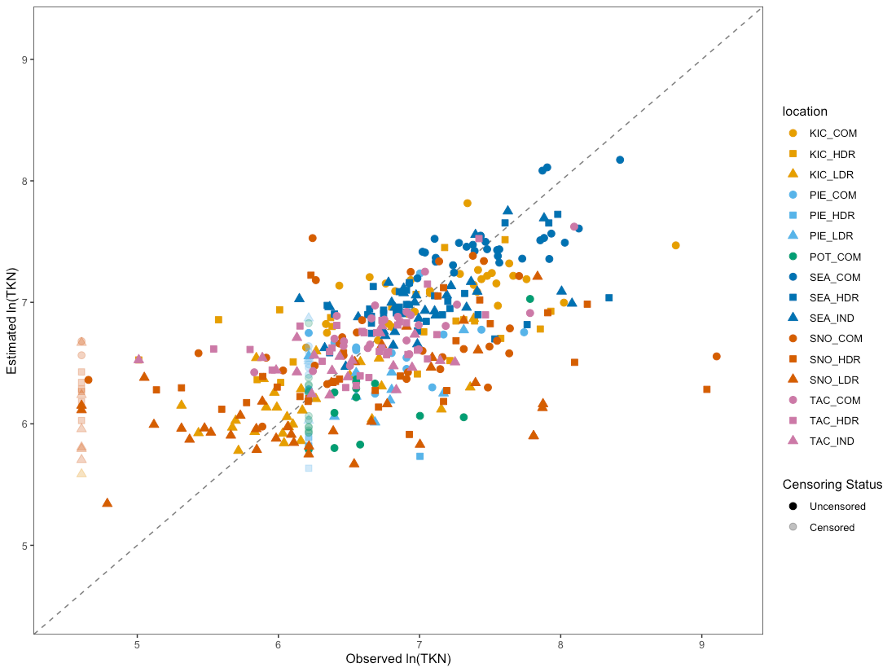
Figure 66. Estimated vs. observed plot for the Bayesian TKN model, with point color corresponding to location, and point transparency corresponding to whether data were censored (semi-transparent) or not. Censored data are shown at their detection limit. Individual points show how the observed value for ln(TKN) (horizontal axis) compares to the mean estimated value from the Bayesian model (vertical axis). The diagonal dashed line shows the 1:1 relationship, where estimated=observed.

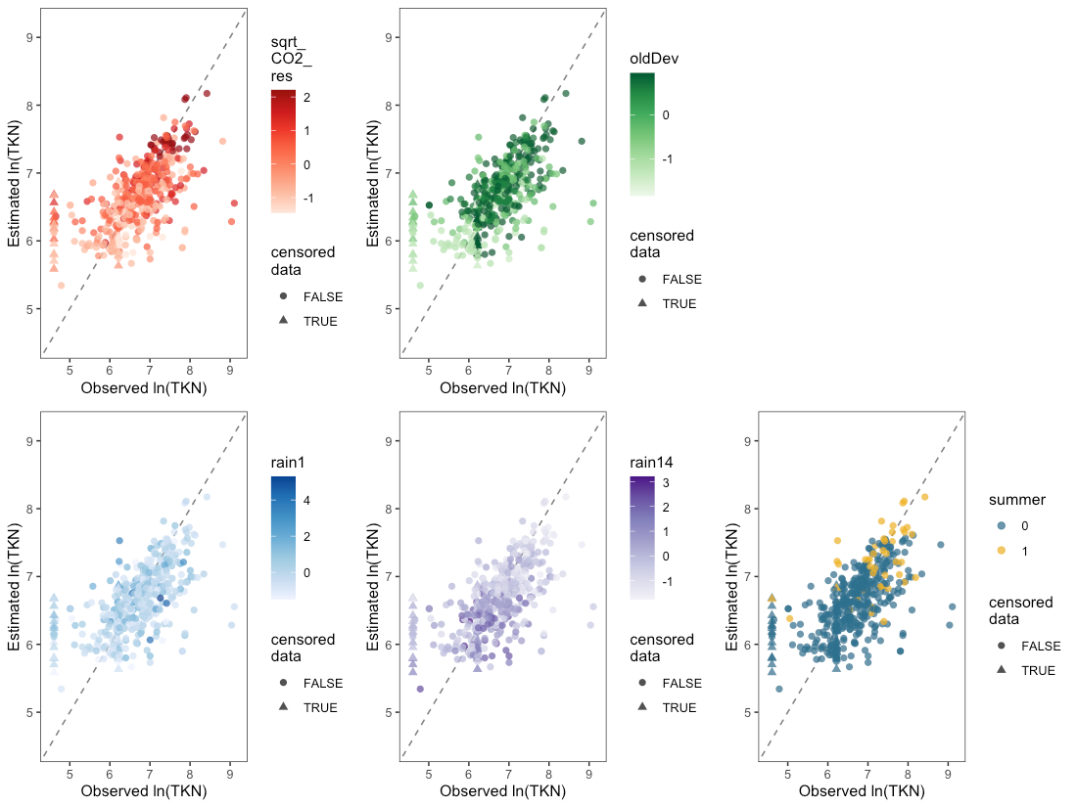
Figure 67. Estimated vs. observed plots for the Bayesian TKN model, with colors showing the magnitude of one spatial predictor (sqrt_CO2_res, oldDev, rain1, rain14 or summer) at each data point, and point style corresponding to whether data were censored (triangles) or not (circles). Censored data are shown at their detection limit. Individual points show how the observed value for ln(TKN) compares to the mean estimated value from the Bayesian model. Diagonal dashed lines show the 1:1 relationship, where estimated=observed.

TKN concentration estimates rely on two spatial predictors: sqrt_CO2_res and oldDev, along with three spatio-temporal predictors: rain14, rain1 and summer. We can visualize the effect of one spatial landscape predictor at a time on expected TKN concentrations by applying a range of values of the other spatial predictor and various combinations of precipitation and season. In Figure 68, expected mean TKN concentrations as a function of sqrt_CO2_res or oldDev are presented as colored credible interval bands, with median S8 Data by location plotted as black bars atop the credible intervals.

Credible intervals were calculated using the epred_draws function (tidybayes package; Kay, 2022) applied to a simulated dataset with all combinations of the following predictors:
- 20% of rain, dry & summer combinations randomly sampled from the S8 Data, to provide representative scenarios of rain and summer/ not summer conditions;
- eight equally-spaced sqrt_CO2_res values between minimum and maximum sqrt_CO2_res levels observed in the S8 Data;
- eight equally-spaced oldDev values between the minimum and maximum oldDev levels observed in the S8 Data.
Following computation of credible intervals, spatial predictors were unstandardized to generate the figure.
As discussed in Step 9 of Model Construction and Selection, credible intervals account for uncertainty around fixed effect parameters and around the variance parameters of the groups, but do not account for residual variance. This allows stormwater managers to assess the following:
- What is the likely range for mean TKN at a heretofore unsampled watershed with a particular level of sqrt_CO2_res (or oldDev)?
This is in line with stormwater management best practices, which manage for the over-annual impact on water bodies rather than for extreme events.
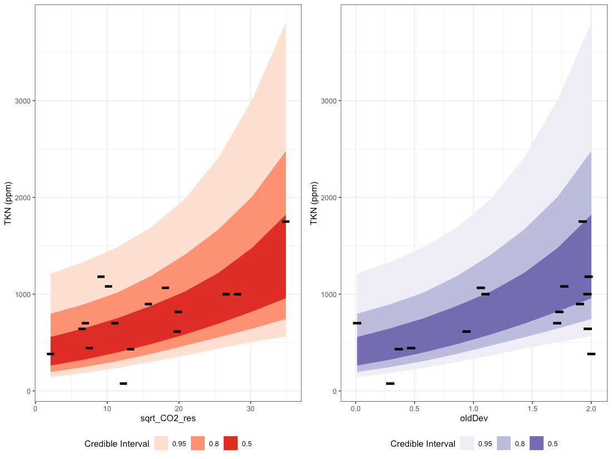
Figure 68. Credible intervals for total Kjeldahl nitrogen as a function of sqrt_CO2_res (left plot) and oldDev (right plot). Bands of color represent 50%, 80% and 95% credible intervals, while black lines represent median S8 Data by location.

The Bayesian TKN model has a population-level intercept $β_{0}=6.54$. As a random-intercept model, the location-specific intercept is allowed to vary by reporting agency (k), and by catchment location within each reporting agency (j|k), and sums to: $β_{0}+a_{k}+a_{j|k}$. Density plots for the location-specific intercept parameters are shown in Figure 69, along with the mean and 95% credible intervals for the population-level intercept.
Eleven of the 16 catchments have location-specific intercepts that overlap well with the population-level intercept: the majority of their density plots are shaded blue (see e.g., TAC_IND). Three catchments have approximately half of their density plot overlapping with that of the population-level intercept (e.g., SEA_COM), and the remaining two catchments have density plots that are quite different from the population-level intercept. The deviation between location-specific intercepts and the population-level intercept gives some insight into how much variability may exist in y-intercept values at unsampled locations. For TKN, most sampled catchments have a y-intercept value that is relatively consistent with that of the population.
The Stormwater Heatmap utilizes only the population-level intercept to estimate mean TKN concentrations at unsampled locations; Figure 69 is provided as a visual for how much variability exists between locations, in terms of location-specific intercept.
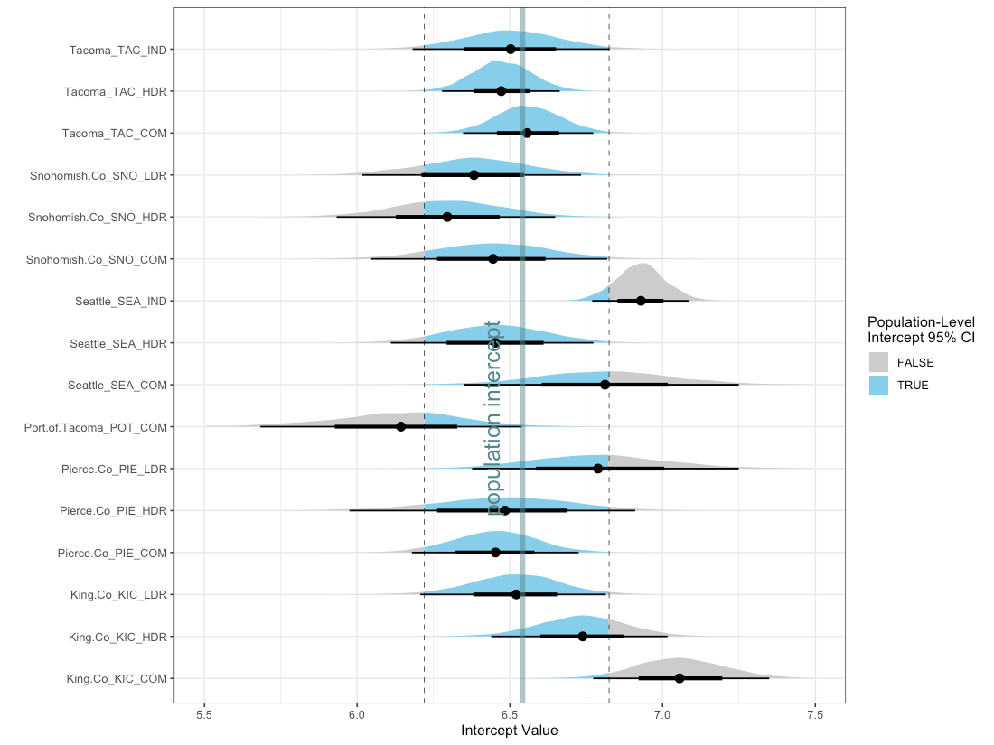
Figure 69. Density plots for the 16 location-specific intercept parameters, along with the median (thick vertical line) and 95% credible intervals (dashed vertical lines) for the population-level intercept. For each location, the mean intercept value is indicated with a black dot, and credible intervals are shown with thick (50% CI) and thin (95% CI) black horizontal lines. Density plots for each location are shaded blue for values that fall within the 95% CI for the population-level intercept, and gray for values that fall outside of the 95% CI for population-level intercept. Note that the population-level 95% CI does not incorporate variability around reporting agency $σ_{agency}$, or around location within each reporting agency $σ_{location}$; it is solely the 95% CI for the population-level intercept (i.e.: 95% of the time, the population-level intercept will fall between the given CI values).

In summary, the Stormwater Heatmap utilizes the spatial predictors sqrt_CO2_res and oldDev to estimate the over-annual mean TKN concentration. The equation used for visualizing the total Kjeldahl nitrogen layer is:
$$ln(TKN)=6.54+0.14*sqrt_CO2_res+0.25*oldDev$$
See Applying Mixed Effects Equations to the Stormwater Heatmap at the end of this document for more information on how the Bayesian model is simplified to this equation.

Model Sensitivity Analysis
We evaluated the model sensitivity to three aspects of the model: 1.) influential data points, 2.) variance structure (no variance covariate, agency as variance covariate, and location as variance covariate), and 3.) structure of the random effects (location only vs. location nested within agency). Alternate models were constructed and compared to the best fit model to evaluate the percent change to landscape predictor parameters. This indicated how sensitive the models were to model structure and influential data points.
We assessed for the presence of influential data points using Cook’s distance, calculated using the HLMdiag package in R (Loy & Hofmann, 2014). Table 4.4 shows the percent difference in landscape predictor coefficients when influential data points were removed for each COC. The effect of influential data points on the models was minimal, with the greatest effect shown for phosphorus: 4.4% change to the oldDev coefficient when three influential data points were removed.
Table 5. Effect of removing influential data points on landscape predictor coefficients and on the global intercept. Columns titled global intercept, impervious, ln_traffic_k100, oldDev, sqrt_CO2_road, sqrt_CO2_transport and sqrt_CO2_res indicate the percent change to these values in models that exclude influential data points, compared to models that include influential data points.
COC | # of data points removed | global intercept | impervious | ln_ traffic_k100 | oldDev | sqrt_CO2_  road | sqrt_CO2_  transport | sqrt_CO2_res
Total Copper | 1 | 0.1% | 0.1% | 0.5%
Total Suspended Solids | 2 | 0% |  |  | 1.8% | 2.2%
Total Phosphorus | 3 | 0.2% |  |  | 4.4%
Total Zinc | 5 | 0.1% |  |  | 2.0% |  | 0.8%
Total Kjeldahl Nitrogen | 2 | 0% |  |  | 3.5% |  |  | 2.9%

We measured the sensitivity of the models to variance structures by running models for each COC with three different variance structures (no variance covariate, agency as variance covariate, location as variance covariate). Landscape predictor and global intercept coefficients generated by these models were compared to those of the best fit model for each COC, to obtain the percent difference in coefficients (Table 6). Substituting different variance structures into the equations had a modest impact for TKN (9.2% change in oldDev covariate) and TSS (7.2% change in sqrt_CO2_road covariate).
Table 6. Effects of changing the model variance structure on landscape predictor coefficients and on the global intercept. The best fit variance covariate and comparison covariate columns indicate which variance covariate is used in the best fit model and the covariate structure that is being tested as a comparison. Columns titled global intercept, impervious, ln_traffic_k100, oldDev, sqrt_CO2_road, sqrt_CO2_transport and sqrt_CO2_res indicate the percent change to these values in models where the variance structure has been changed.
COC | best fit variance covariate | comparison covariate | global intercept | imperv-ious | Ln_traffic_k100 | oldDev | sqrt_CO2_  road | sqrt_CO2_  transport | sqrt_CO2_  res
Total Copper | location | none | 0.3% | 1.5% | 0%
Total Copper | location | agency | 0.3% | 0.3% | 0.4%
Total Suspended Solids | location | none | 0.2% |  |  | 1.7% | 7.2%
Total Suspended Solids | location | agency | 0.1% |  |  | 0.2% | 3.6%
Total Phosphorus | location | none | 0.5% |  |  | 2.1%
Total Phosphorus | location | agency | 0.3% |  |  | 2.2%
Total Zinc | location | none | 0.2% |  |  | 4.8% |  | 0.4%
Total Zinc | location | agency | 0% |  |  | 3.7% |  | 0.1%
Total Kjeldahl Nitrogen | agency | none | 0.5% |  |  | 9.2% |  |  | 3.2%
Total Kjeldahl Nitrogen | agency | location | 0% |  |  | 1.7% |  |  | 1.8%

Lastly, we evaluated how sensitive the SWHM models are to the choice of using a nested structure for the random effects (location nested within agency) rather than a non-nested structure, with location as the sole random effect. We ran models using location as the sole random effects, comparing the landscape predictor and global intercept coefficients to those from the best fit (nested random effects) models, to obtain the percent difference in coefficients for each COC (Table 7). Altering the random effects structure had a larger impact on coefficients than did the previous sensitivity analyses (removing influential outliers or changing variance structure). The greatest percent change was for total phosphorus, where removing the nested structure of the data led to a 36.5% change in the coefficient for oldDev.
Table 7. Effect of changing the random effects stucture (from location nested within agency to not nested) on landscape predictor coefficients and the global intercept. Columns titled global intercept, impervious, ln_traffic_k100, oldDev, sqrt_CO2_road, sqrt_CO2_transport and sqrt_CO2_res indicate the percent change to these values in models where the random effect of location is NOT nested within agency.
COC | global intercept | impervious | ln_  traffic_  k100 | oldDev | sqrt_CO2_  road | sqrt_CO2_  transport | sqrt_CO2_  res
Total Copper | 5.7% | 8.1% | 43.7%
Total Suspended Solids | 0.2% |  |  | 5.6% | 14.0%
Total Phosphorus | 1.9% |  |  | 36.5%
Total Zinc | 0% |  |  | 3.5% |  | 2.9%
Total Kjeldahl Nitrogen | 0.5% |  |  | 0.6% |  |  | 23.3%

Model Validation with External Data
We performed model validation using nine independent data sets (“validation data”) to determine whether the model results are representative of locations outside of the 16 catchments used to fit and calibrate the models. This is an important step for ensuring that our chemical of concern models can be applied to areas across the Puget Sound region.
The validation process involved several steps:

Step 1: Identify suitable data
We searched for projects where data were collected in a similar way to the S8 data used for model fitting. The S8 data were collected from stormwater outfalls as flow-composite samples during storms with predicted cumulative rainfall equal to or exceeding 0.25 inches. Ideal validation data would share these sample characteristics. Because of the low number of suitable studies with flow-composite samples, we also included outfalls with grab samples that were collected on three or more occasions over time. Initially, we treated the grab sampled outfalls differently in the model validation process, as variability around grab sample results can be substantially higher than variability around composite samples. However, as we did not see evidence of higher variability in the grab-sampled catchments that we had identified, we ultimately combined grab-sampled outfalls with those sampled using flow-composite methodology.

Step 2: Prepare spatial predictors for validation catchments
We obtained or traced spatial polygons for each validation catchments. We applied these polygons to the spatial data layers used as predictors, and calculated the mean spatial predictor values for each validation catchment.
Mean spatial predictor values for each catchment were standardized using the spatial predictor means and standard deviations from the S8 fitting dataset. Standardized spatial predictors were capped at +/- 3 to prevent extrapolation of model equations beyond the extent of the fitting data.

Step 3: Prepare the validation data
We removed validation data that were collected on days when the Daymet daily surface weather dataset (Thornton et al, 2022) estimated cumulative daily rainfall at 0mm.
We also used Cleaveland dotplots of the ln-transformed stormwater validation data to identify and remove outliers. Two high outliers were removed for zinc (both at OF235), one high outlier was removed for TKN (at SR9-MP17.92), one high outlier (at SS4) and two low outliers were removed for TSS (one at OF235, one at OF237A), and one high outlier was removed for phosphorus (at SR9-MP17.92). The two low outliers for TSS occurred on days with very low rainfall (Daymet precipitation < 1mm).

Step 4: Obtain prediction intervals and fitted values for validation catchments
Using the posterior_predict and fitted function in the brms package (Buerkner, 2017), we applied the Bayesian water quality models to the spatio-temporal predictors (landscape predictors, season, Daymet cumulative rainfall, antecedent dry days and season) from the validation catchments to obtain prediction intervals and fitted values. Prediction intervals predict in what range a future individual observation will fall. With the nested model structure for random effects (location nested within agency), prediction intervals are able to make predictions about future samples both for known agencies and unknown (new) agencies. This makes them ideal for comparison to validation data. In the case of the Tacoma S8C validation dataset, these data were collected by a known agency with an agency-specific intercept (City of Tacoma), so the prediction intervals are tighter for Tacoma S8C validation data than for validation data from unknown agencies.
Fitted values provide a direct comparison between individual samples collected from validation catchments and model estimates for that location and weather conditions (rainfall, season).

Step 5: Compare validation data to model predictions
We plotted the validation data against prediction intervals and fitted values to visually assess whether validation data fall within a margin of the model predictions. The following tools were used for visual assessment:
- Graphical evaluation of validation data plotted atop prediction interval bands. We were looking to see if the medians of the validation data generally fit within the 50% or 80% prediction intervals. This would allow us to conclude that the model is representative of the Puget Sound basin.
- Graphical evaluation of validation data plotted against model predictions (observed versus estimated plots). We were looking for validation data to fall relatively close to the 1:1 observed vs. estimated line.
- Graphical observation of explanatory reasons for divergence between model predictions and validation data.

Validation Datasets
All validation data were collected between 2006 and 2022. Four composite data sets and three grab sample data sets were utilized for model validation, for a total of 24 catchments (Table 8). The sampled catchments span a relatively wide range of the Puget Sound region, with different land use characteristics (Figure 70). Seventeen catchments are located in urban areas, while seven are located in medium- to low-density residential areas outside of the Seattle-Tacoma urban corridor. Of the seventeen urban catchments, nine are on high-use roadways (MLK Street Sweeping project, Washington State DOT project). Three of the catchments also appear in the S8 fitting data (OF235, OF237B and OF245), and were resampled by the city of Tacoma for their S8C study.
Table 8. Sample locations for validation data, including sample type (composite or grab), location description, and whether the samples were tested for COCs of interest (Cu=total copper, Zn=total zinc, TSS=total suspended solids, P=total phosphorus, TKN=total Kjeldahl nitrogen).
Project | Sample Type | Location Description | Sample Names | Sampling Dates | Cu | Zn | TSS | P | TKN
MLK Street Sweeping | composite | busy urban street | SS2  SS3  SS4  SS5 | Oct 2014 – Sep 2016 | X | X | X | X | X
Ship Canal Bridge Test Facility | composite | highway | I5 Bridge | Oct 2016 – May 2022 | X | X | X | X | X
Tacoma S8C | composite | urban/ industrial | OF230  OF235  OF237A  OF237B  OF243  OF245  OF254 | Aug 2014 – Oct 2019 | X | X | X | X
Washington State DOT | composite | highway | I5_MP197.27  I5_MP197.35  I5_MP210.71  I5_MP210.85  SR9_MP17.92 | May 2012 – Sep 2014 | X | X | X | X | X
Coupeville | grab | residential | BoatLaunch  CoupevilleWharf  FrontAndMain  PerkinsBluff | Nov 2008 – May 2009 | X | X
Garden Ed | grab | residential | W1  W2 | Nov 2006 – Aug 2007 |  |  | X | X
Lahti Drive | grab | residential | LahtiSwale | Jun 2011 – Apr 2014 |  |  | X | X

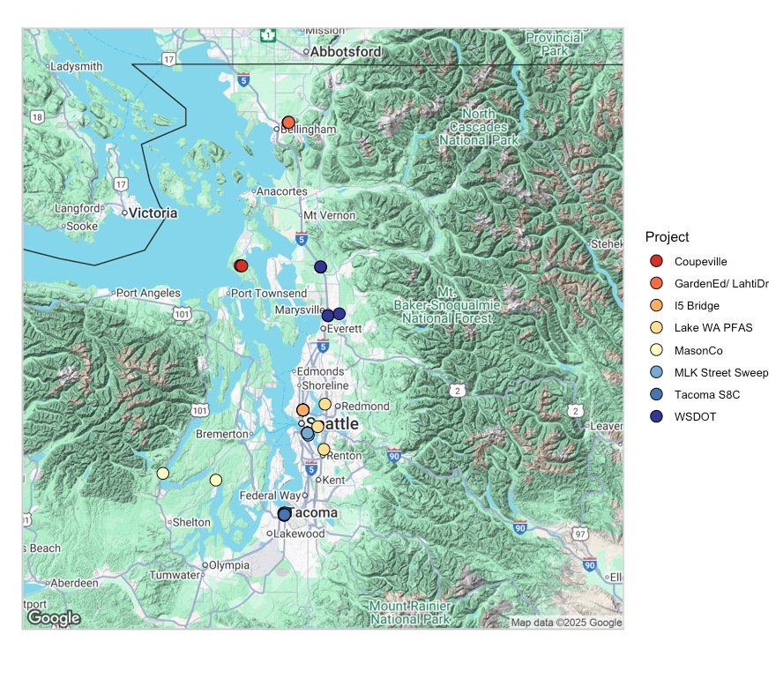
Figure 70. Locations of test data outfalls used in model validation. Garden Ed and Lahti Drive outfalls are proximally located and are combined into one point on the map.

Validation Catchments - Spatial Predictors
One way of assessing the similarity of the model validation catchments to the S8 model fitting catchments is to compare the standardized spatial predictor values for the fitting vs validation catchments. Standardized spatial predictor values for the validation catchments were similar to those of the fitting catchments for all spatial landscape predictors, with ln_traffic_k100 levels higher than the S8 catchments (Figure 71). The S8 fitting data did not have any purely roadway catchments, whereas nine of the validation catchments (those from the MLK Street Sweeping and WA State DOT projects) are paved roadway with high levels of traffic.
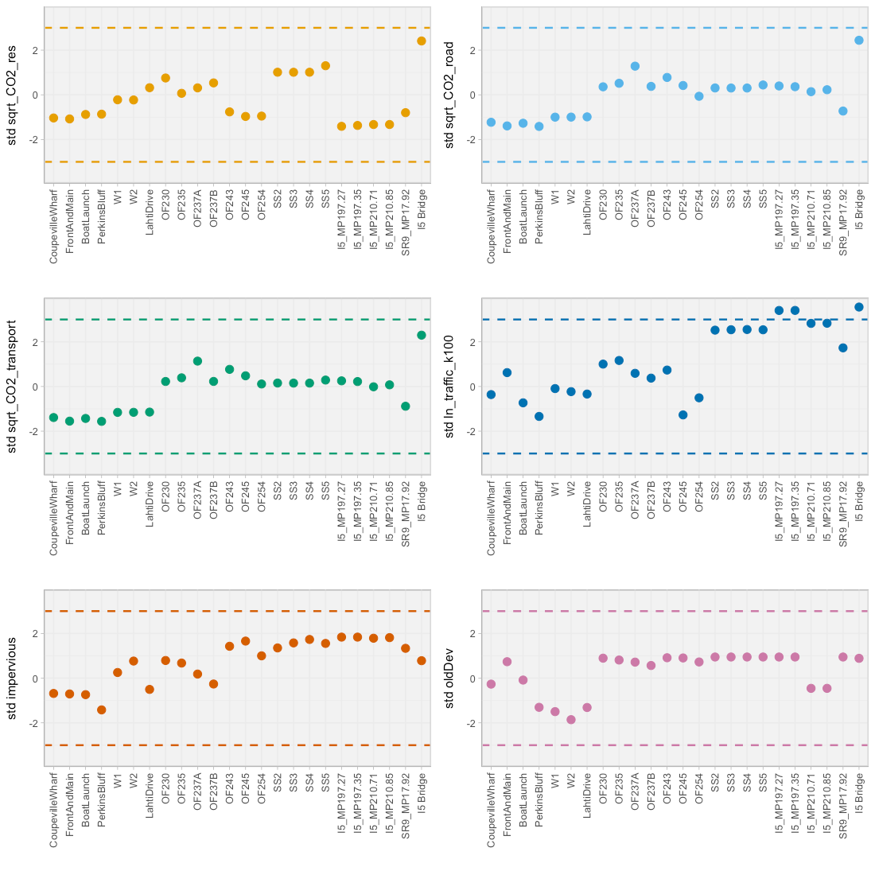
Figure 71. Standardized spatial predictor values at the validation catchments. Dashed lines at y=-3 and y=3 show the values at which predictors were capped.

As discussed above in “Step 2: Prepare spatial predictors for validation catchments”, all standardized spatial predictors for the validation catchments were capped at +/- 3 to keep model predictions within the range represented by the fitting data. It is possible that some landscape predictors are only linear over a certain range of values, and it is important that we constrain our predictions to the range where we have data.

Validation Results

Total Copper
Five of the eight model validation projects (21 catchments total) analyzed stormwater samples for total copper. These copper data are plotted atop prediction intervals for their catchments (Figure 72). Prediction intervals show the range into which future samples might fall. In general, our copper model tended to over-estimate copper concentrations in the validation catchments, with the exception of several highway sites (catchments beginning with I5) and the sites in Coupeville (BoatLaunch, CoupevilleWharf, FrontAndMain, PerkinsBluff): the majority of samples from these catchments fell within the 50% prediction intervals.
Tacoma S8C outfalls (samples beginning with OF) have somewhat narrower prediction intervals because the agency (the random effect) has a known agency-specific intercept from the model fitting process.

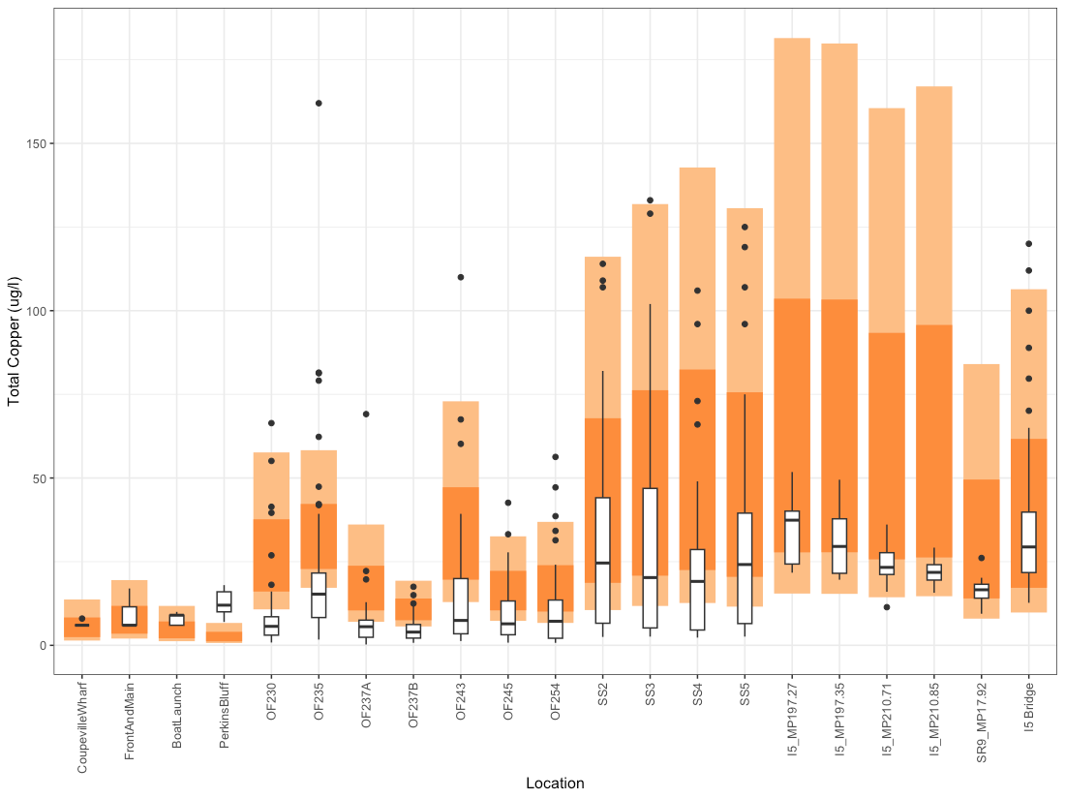
Figure 72. Box and whisker plots for copper validation data, shown atop model-generated prediction intervals. Dark orange bands represent the 50% prediction intervals, where 50% of future data points would be expected to lie, and light orange bands represent 80% prediction intervals.

Estimated vs. observed plots show the model estimated values for each catchment plotted against observed validation data. Figure 73 shows all observed data points and their model estimated values. Figure 74 shows a series of estimated vs. observed plots where colors indicate the spatio-temporal predictor values associated with each catchment and sample. Lastly, Figure 75 shows the median estimated value vs. the median observed value as a summary of the data for each catchment. Ideally, data points should lie close to the 1:1 line indicating that model estimates are close to the observed values. For copper, many data points have higher estimated values than the actual observed values.
Several samples from the Tacoma outfalls (OF235, OF237A, OF243) had estimated values substantially higher than their observed values (see upper left, Figure 73). These samples were collected in the summer during very low rainfall events (Figure 74, bottom panels). Two explanations exist for this overestimation. It is possible that the rain and summer coefficients in our copper model are not suitably addressing low rainfall/ summer conditions. It is also possible that the level of rainfall was too low to convey copper particles to the stormwater outfall, resulting in less polluted water entering the outfall during these sampling events.
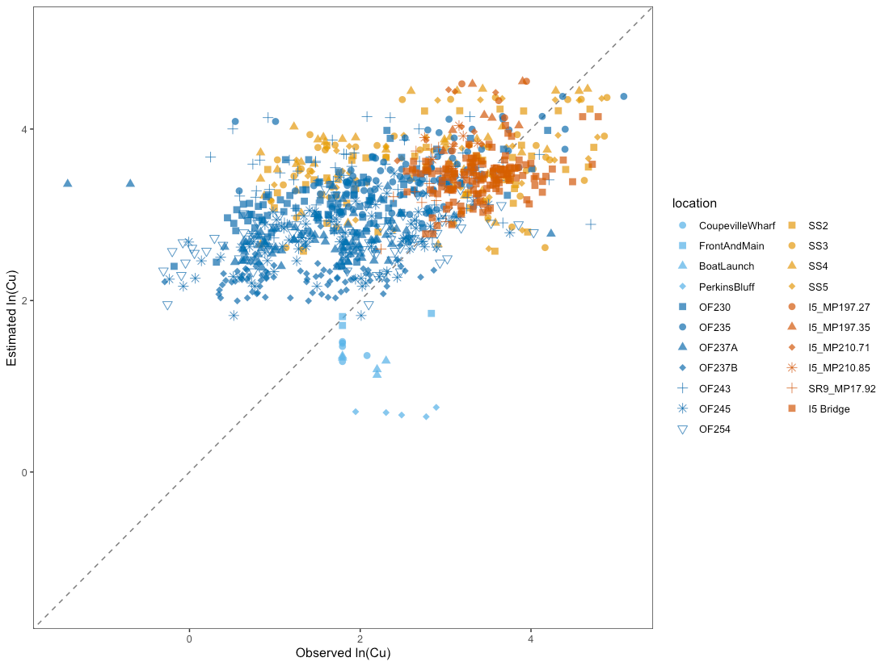
Figure 73. Estimated vs. observed plot for the copper validation data, with point color and shape corresponding to catchment location. Individual points show how the observed value for ln(copper) from model validation catchments (horizontal axis) compares to the mean estimated value from the Bayesian model for those same catchments (vertical axis). The diagonal dashed line shows the 1:1 relationship, where estimated=observed.
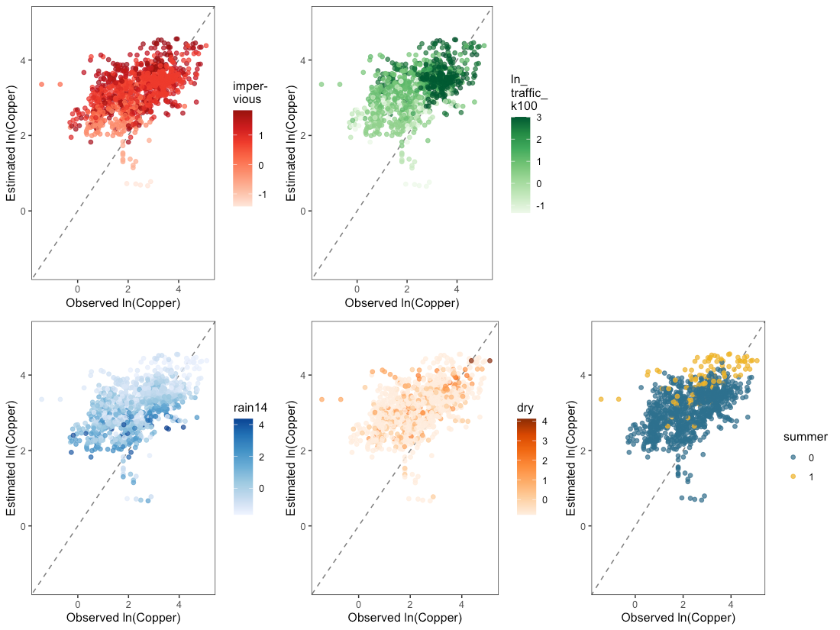
Figure 74. Estimated vs. observed plots for the copper validation data, with colors showing the magnitude of one spatial or temporal predictor (impervious, ln_traffic_k100, rain14, dry, summer) at each data point. Individual points show how the observed values for ln(copper) at the model validation catchments compare to the mean estimated values from the Bayesian model for the same catchments. Diagonal dashed lines show the 1:1 relationship, where estimated=observed.
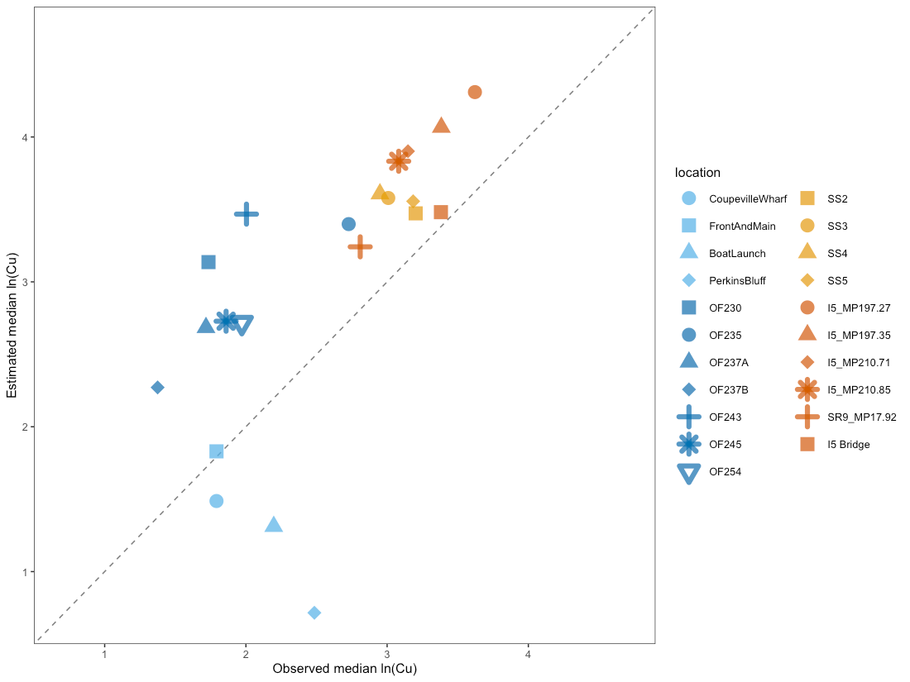
Figure 75. Median estimated vs. median observed plots for total copper at validation catchments. The diagonal dashed line shows the 1:1 relationship, where estimated=observed.

Total Suspended Solids
Five of the eight model validation projects (19 catchments total) analyzed stormwater samples for total suspended solids. These TSS data are plotted atop prediction intervals for their catchments (Figure 76). Prediction intervals show the range into which future samples might fall. In general, the 50% prediction intervals (dark orange, Figure 76) overlap well with validation data.
Tacoma S8C outfalls (samples beginning with OF) have somewhat narrower prediction intervals because the agency (the random effect) has a known agency-specific intercept from the model fitting process.
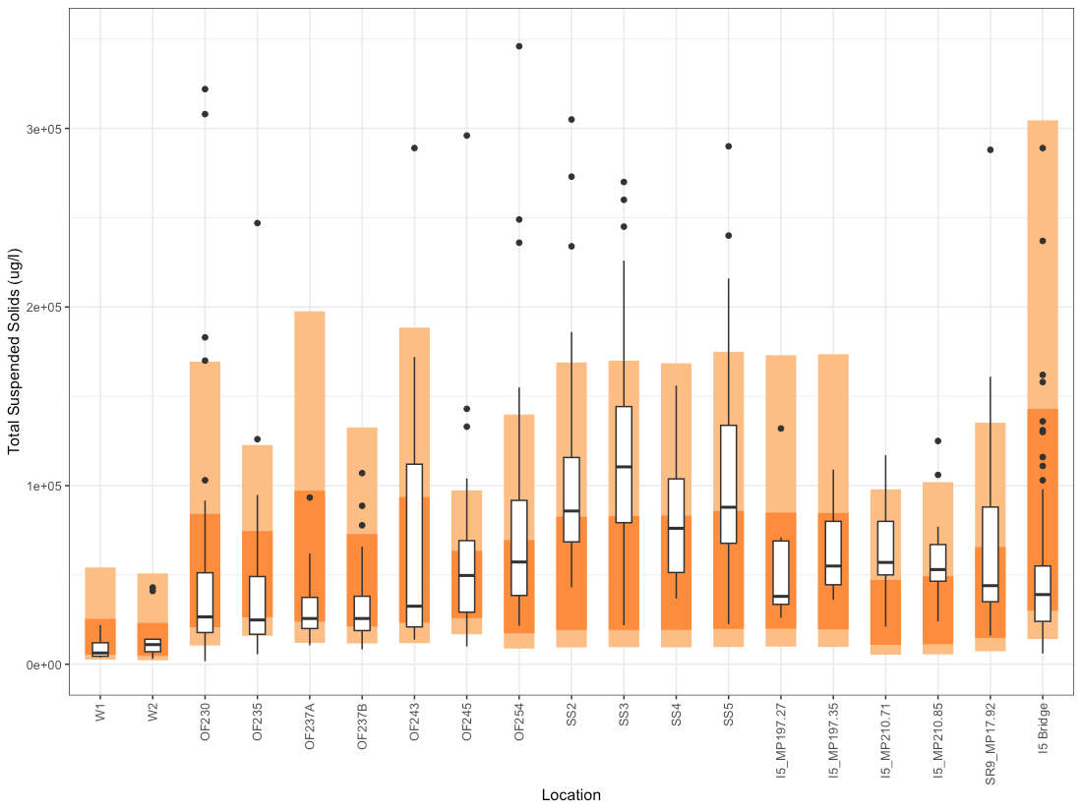
Figure 76. Box and whisker plots for TSS validation data, shown atop model-generated prediction intervals. Dark orange bands represent the 50% prediction intervals, where 50% of future data points would be expected to lie, and light orange bands represent 80% prediction intervals.

Estimated vs. observed plots show the model estimated values for each catchment plotted against observed validation data. Figure 77 shows all observed data points and their model estimated values. Figure 78 shows a series of estimated vs. observed plots where colors indicate the spatio-temporal predictor values associated with each catchment and sample. Lastly, Figure 79 shows the median estimated value vs. the median observed value as a summary of the data for each catchment. Ideally, data points should lie close to the 1:1 line indicating that model estimates are close to the observed values. For TSS, the validation data points are arranged in a cloud centered around the 1:1 line. This is in line with the S8 Data used in model fitting, which also displays high variability in TSS values. The subplots in Figure 78 do not indicate a strong pattern of correlation between data points farther from the 1:1 line and magnitude of the spatio-temporal predictors.
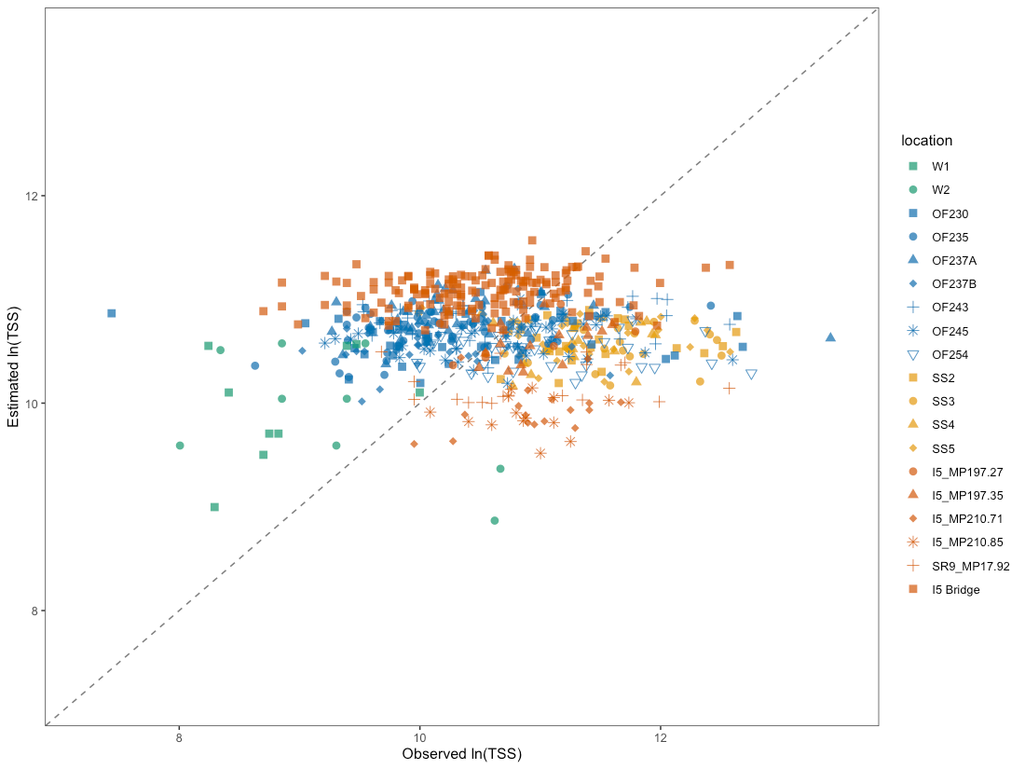
Figure 77. Estimated vs. observed plot for the TSS validation data, with point color and shape corresponding to catchment location. Individual points show how the observed value for ln(TSS) from model validation catchments (horizontal axis) compares to the mean estimated value from the Bayesian model for those same catchments (vertical axis). The diagonal dashed line shows the 1:1 relationship, where estimated=observed.

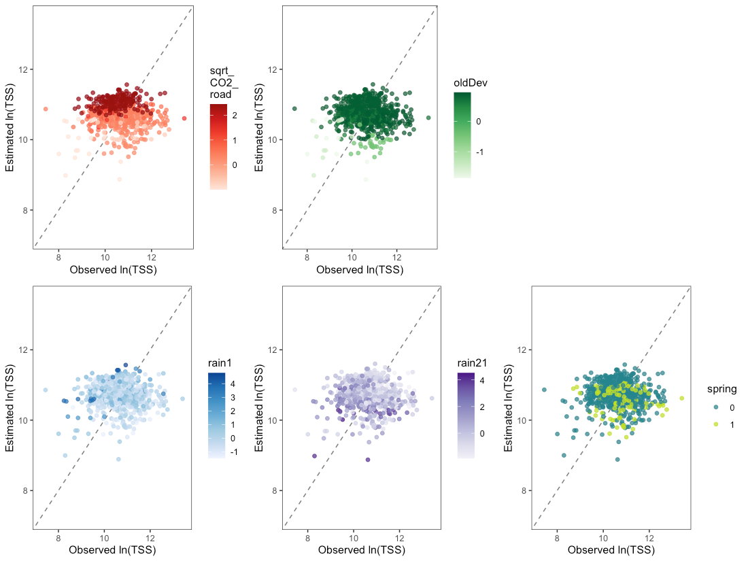
Figure 78. Estimated vs. observed plots for the TSS validation data, with colors showing the magnitude of one spatial or temporal predictor (sqrt_CO2_road, oldDev, rain1, rain21, spring) at each data point. Individual points show how the observed values for ln(TSS) at the model validation catchments compare to the mean estimated values from the Bayesian model for the same catchments. Diagonal dashed lines show the 1:1 relationship, where estimated=observed.
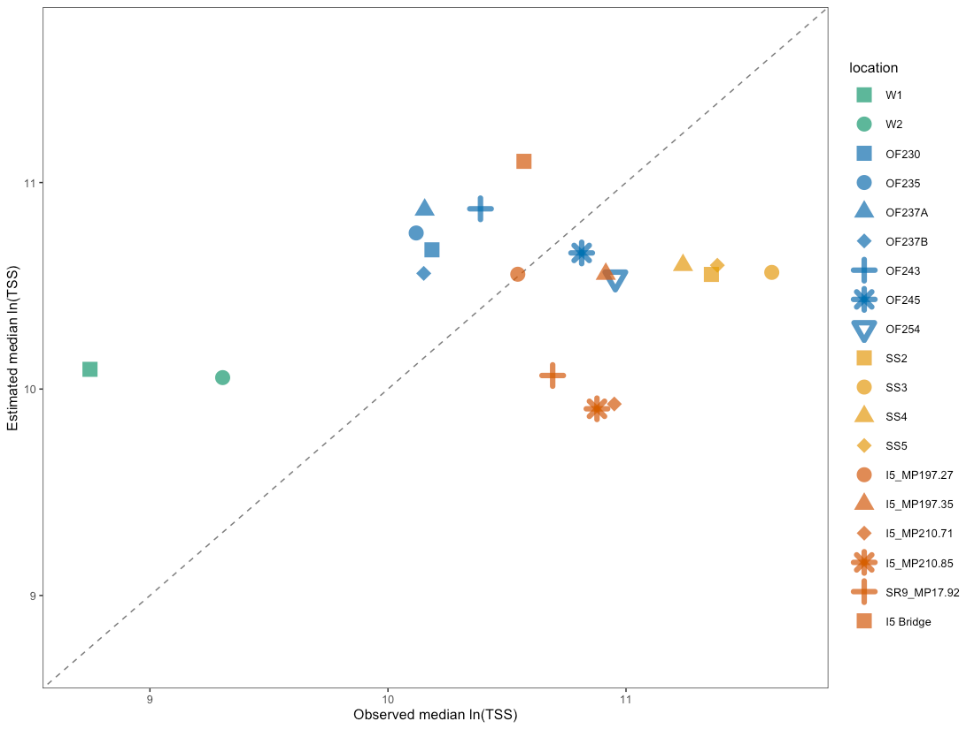
Figure 79. Median estimated vs. median observed plots for TSS at validation catchments. The diagonal dashed line shows the 1:1 relationship, where estimated=observed.

Total Phosphorus
Five of the eight model validation projects (19 catchments total) analyzed stormwater samples for total phosphorus. The phosphorus data are plotted atop prediction intervals for their catchments (Figure 80). Prediction intervals show the range into which future samples might fall. In general, the 50% prediction intervals (dark orange, Figure 80) overlap well with validation data. Several catchments had higher phosphorus concentrations than the model predicted (OF243, SS3, SS5).
Tacoma S8C outfalls (samples beginning with OF) have slightly narrower prediction intervals because the agency (the random effect) has a known agency-specific intercept from the model fitting process.
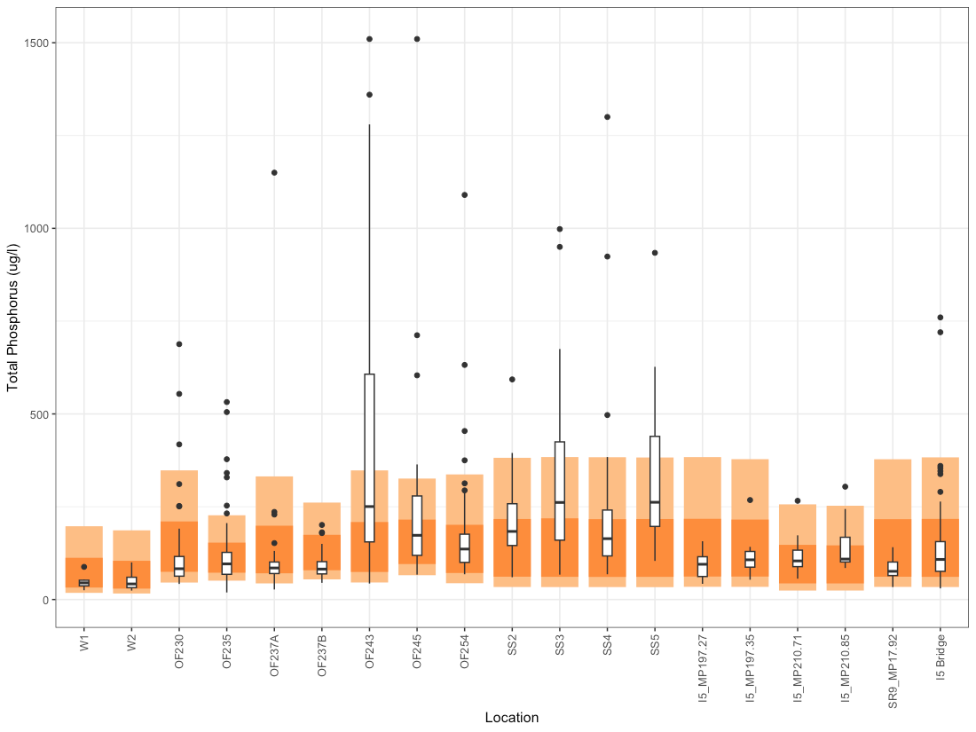
Figure 80. Box and whisker plots for total phosphorus validation data, shown atop model-generated prediction intervals. Dark orange bands represent the 50% prediction intervals, where 50% of future data points would be expected to lie, and light orange bands represent 80% prediction intervals.

Estimated vs. observed plots show the model estimated values for each catchment plotted against observed validation data. Figure 81 shows all observed data points and their model estimated values. Figure 82 shows a series of estimated vs. observed plots where colors indicate the spatio-temporal predictor values associated with each catchment and sample. Lastly, Figure 83 shows the median estimated value vs. the median observed value as a summary of the data for each catchment. Ideally, data points should lie close to the 1:1 line indicating that model estimates are close to the observed values. For total phosphorus, a few outfalls have the median of their points below the 1:1 line (OF243 and SS2), with our model underestimating phosphorus values in these catchments (Figure 83).
The subplots in Figure 82 do not indicate any pattern between data points farther from the 1:1 line and magnitude of the spatio-temporal predictors. It may be that some of the validation locations display high variability because of an unaccounted for temporal predictor.
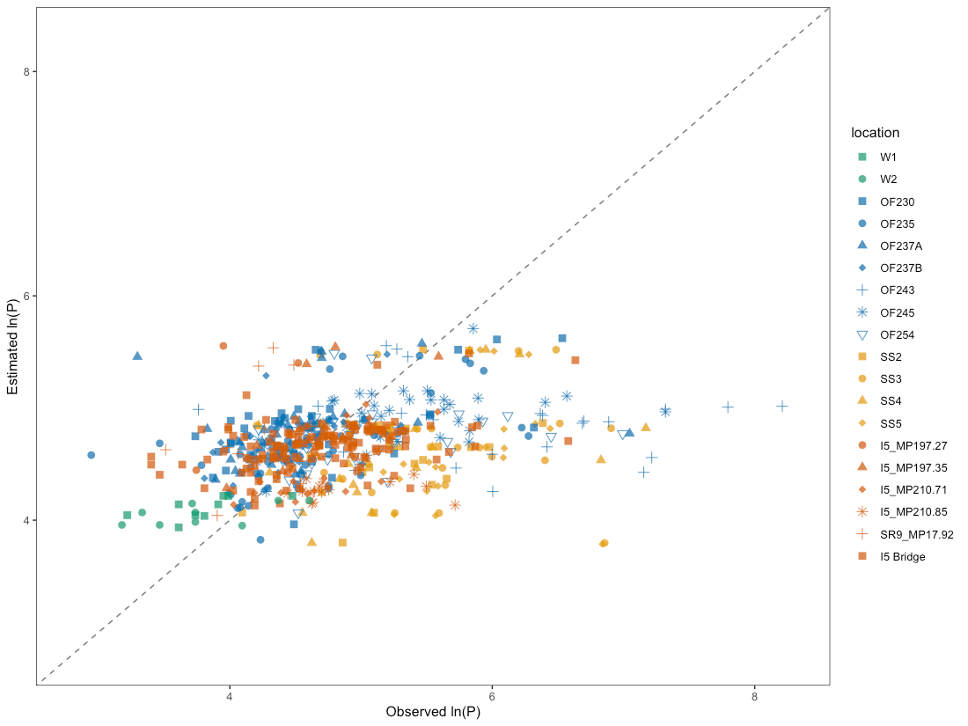
Figure 81. Estimated vs. observed plot for total phosphorus validation data, with point color and shape corresponding to catchment location. Individual points show how the observed value for ln(phosphorus) from model validation catchments (horizontal axis) compares to the mean estimated value from the Bayesian model for those same catchments (vertical axis). The diagonal dashed line shows the 1:1 relationship, where estimated=observed.

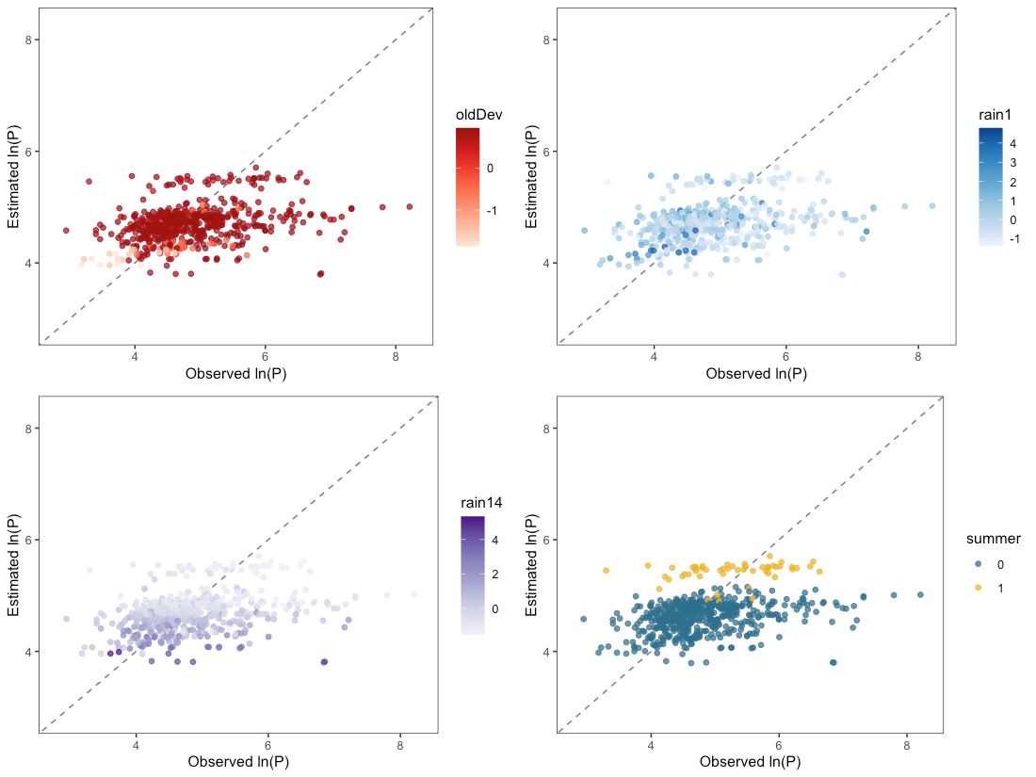
Figure 82. Estimated vs. observed plots for phosphorus validation data, with colors showing the magnitude of one spatial or temporal predictor (oldDev, rain1, rain14, summer) at each data point. Individual points show how the observed values for ln(phosphorus) at the model validation catchments compare to the mean estimated values from the Bayesian model for the same catchments. Diagonal dashed lines show the 1:1 relationship, where estimated=observed.
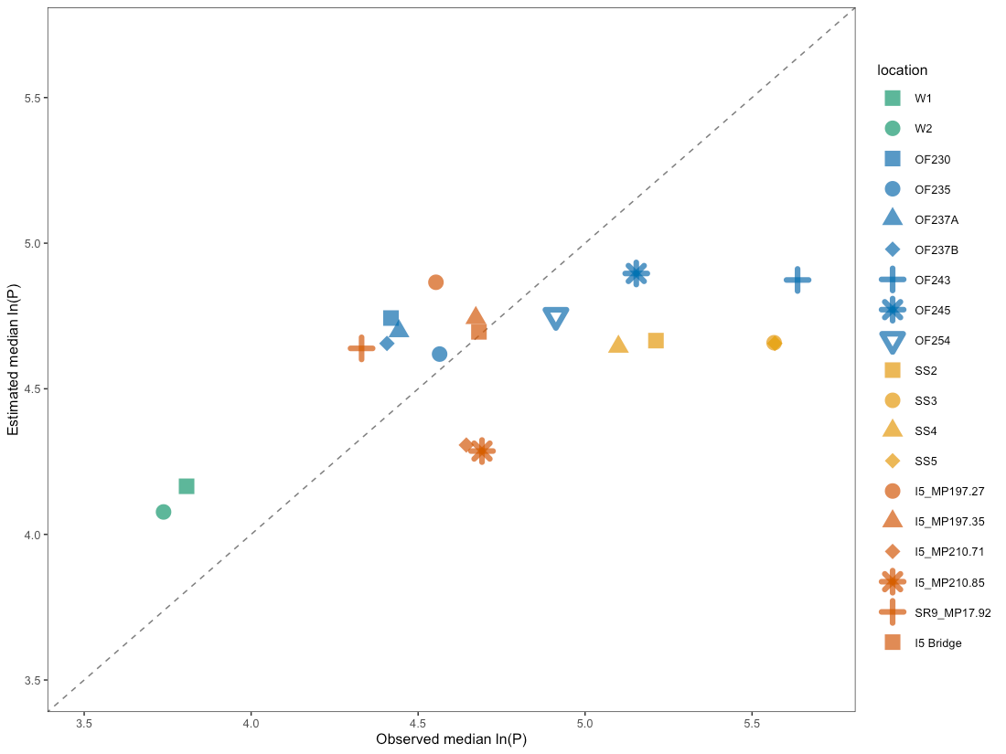
Figure 83. Median estimated vs. median observed plots for total phosphorus at validation catchments. The diagonal dashed line shows the 1:1 relationship, where estimated=observed.

Total Zinc
Five of the eight model validation projects (21 catchments total) analyzed stormwater samples for total zinc. Zinc data are plotted atop prediction intervals for their catchments (Figure 84). Prediction intervals show the range into which future samples might fall. The 50% intervals fit well for nearly half of the catchments, while the other half are over-estimated.
Tacoma S8C outfalls (samples beginning with OF) have somewhat narrower prediction intervals because the agency (the random effect) has a known agency-specific intercept from the model fitting process.
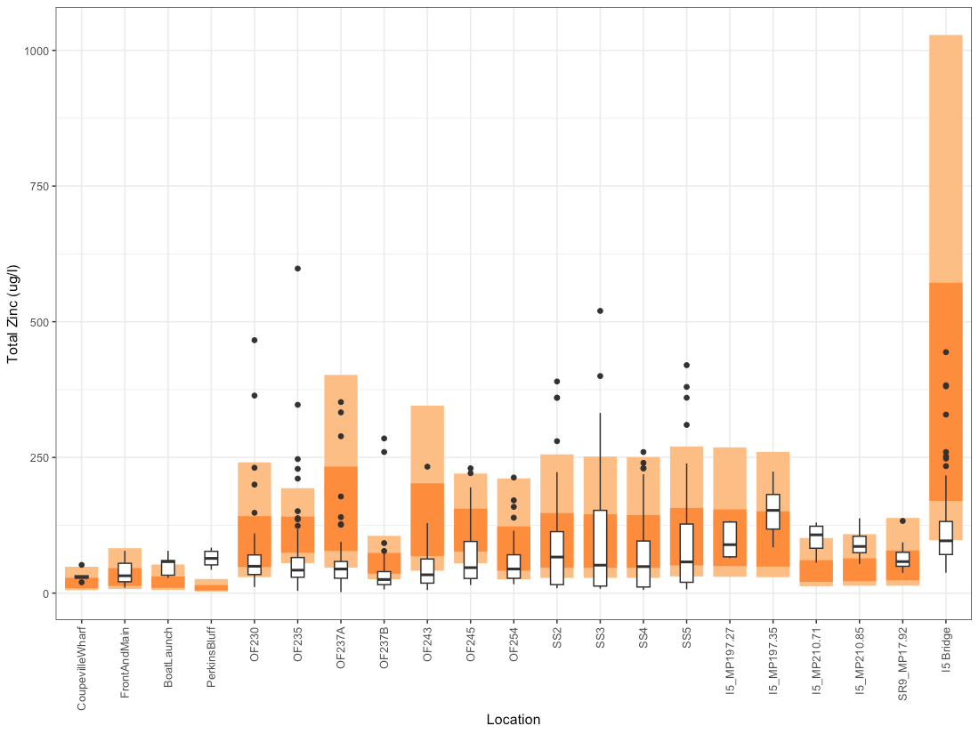
Figure 84. Box and whisker plots for total zinc validation data, shown atop model-generated prediction intervals. Dark orange bands represent the 50% prediction intervals, where 50% of future data points would be expected to lie, and light orange bands represent 80% prediction intervals.

Estimated vs. observed plots show the model estimated values for each catchment plotted against observed validation data. Figure 85 shows all observed data points and their model estimated values. Figure 86 shows a series of estimated vs. observed plots where colors indicate the spatio-temporal predictor values associated with each catchment and sample. Lastly, Figure 87 shows the median estimated value vs. the median observed value as a summary of the data for each catchment. Ideally, data points should lie close to the 1:1 line indicating that model estimates are close to the observed values. Figure 87 shows that our model is overestimating underestimating median total zinc at one outfall and overestimated at one outfall.
The subplots in Figure 86 suggest that the samples collected during the summer have high variability.
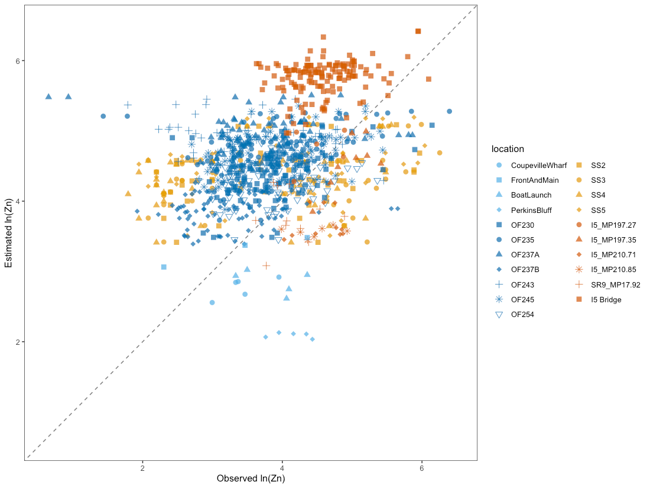
Figure 85. Estimated vs. observed plot for total zinc validation data, with point color and shape corresponding to catchment location. Individual points show how the observed value for ln(zinc) from model validation catchments (horizontal axis) compares to the mean estimated value from the Bayesian model for those same catchments (vertical axis). The diagonal dashed line shows the 1:1 relationship, where estimated=observed.
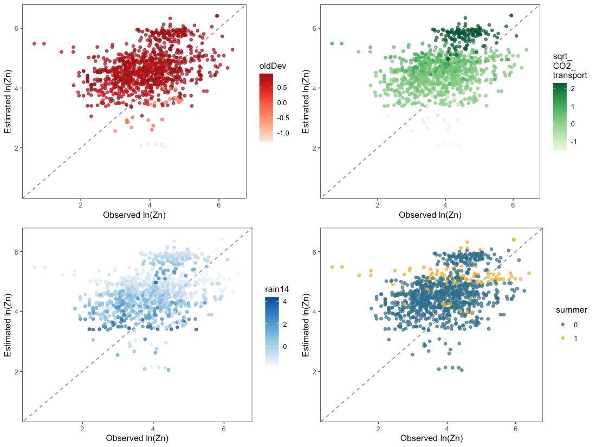
Figure 86. Estimated vs. observed plots for total zinc validation data, with colors showing the magnitude of one spatial or temporal predictor (oldDev, sqrt_CO2_transport, rain14, summer) at each data point. Individual points show how the observed values for ln(zinc) at the model validation catchments compare to the mean estimated values from the Bayesian model for the same catchments. Diagonal dashed lines show the 1:1 relationship, where estimated=observed.
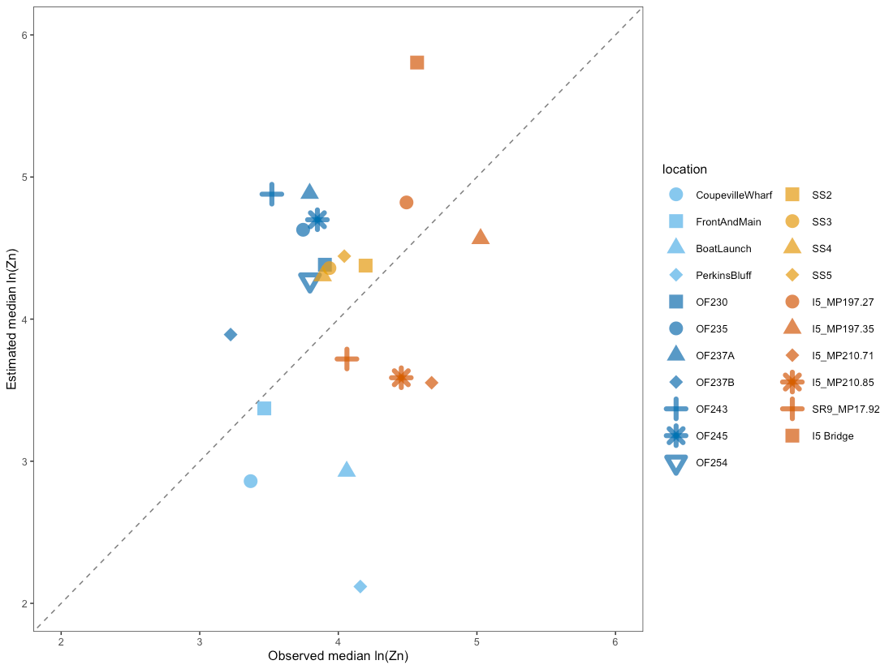
Figure 87. Median estimated vs. median observed plots for total zinc at validation catchments. The diagonal dashed line shows the 1:1 relationship, where estimated=observed.

Total Kjeldahl Nitrogen
Three of the eight model validation projects (10 catchments total) analyzed stormwater samples for total Kjeldahl nitrogen. Unfortunately, all of these catchments are located in high-traffic roadways, with nearly all of the catchments being completely paved. In Figure 88, TKN data are plotted atop prediction intervals for their catchments. Prediction intervals show the range into which future samples might fall. The prediction intervals fit well for the relatively small quantity of TKN validation data.
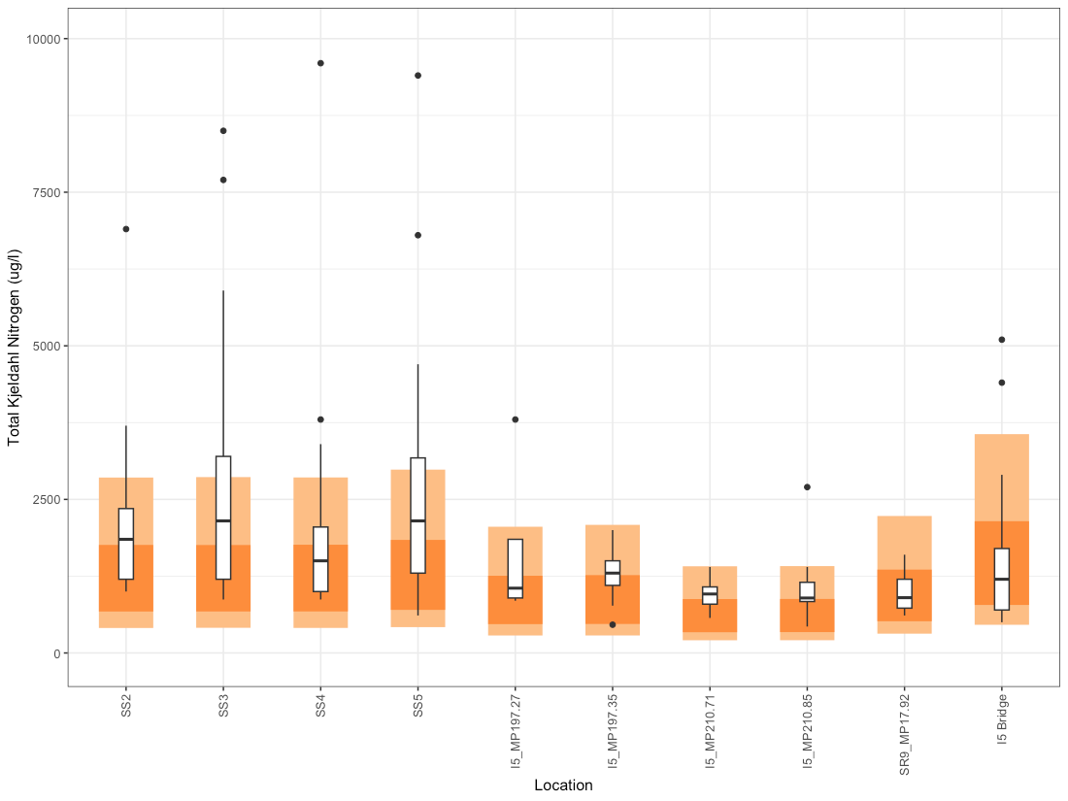
Figure 88. Box and whisker plots for TKN validation data, shown atop model-generated prediction intervals. Dark orange bands represent the 50% prediction intervals, where 50% of future data points would be expected to lie, and light orange bands represent 80% prediction intervals.

Estimated vs. observed plots show the model estimated values for each catchment plotted against observed validation data. Figure 89 shows all observed data points and their model estimated values. Figure 90 shows a series of estimated vs. observed plots where colors indicate the spatio-temporal predictor values associated with each catchment and sample. Lastly, Figure 91 shows the median estimated value vs. the median observed value as a summary of the data for each catchment. Ideally, data points should lie close to the 1:1 line indicating that model estimates are close to the observed values. With a few exceptions, most of the available TKN data lie close to the 1:1 line.
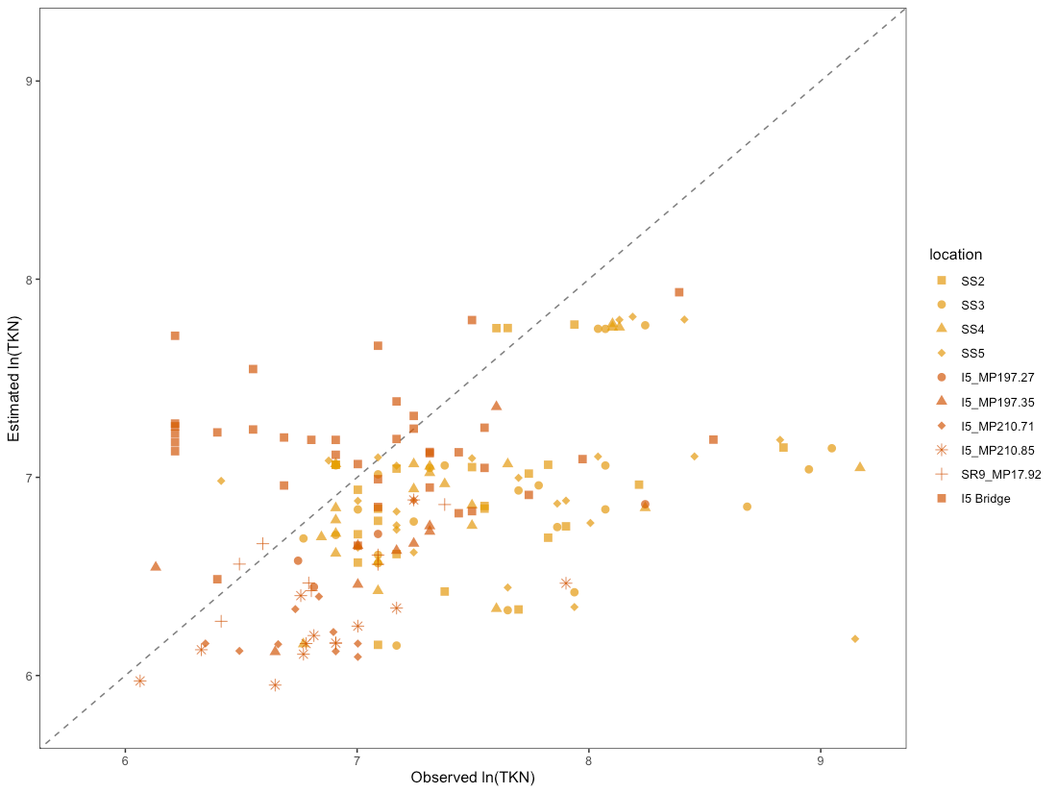
Figure 89. Estimated vs. observed plot for the TKN validation data, with point color and shape corresponding to catchment location. Individual points show how the observed value for ln(TKN) from model validation catchments (horizontal axis) compares to the mean estimated value from the Bayesian model for those same catchments (vertical axis). The diagonal dashed line shows the 1:1 relationship, where estimated=observed.

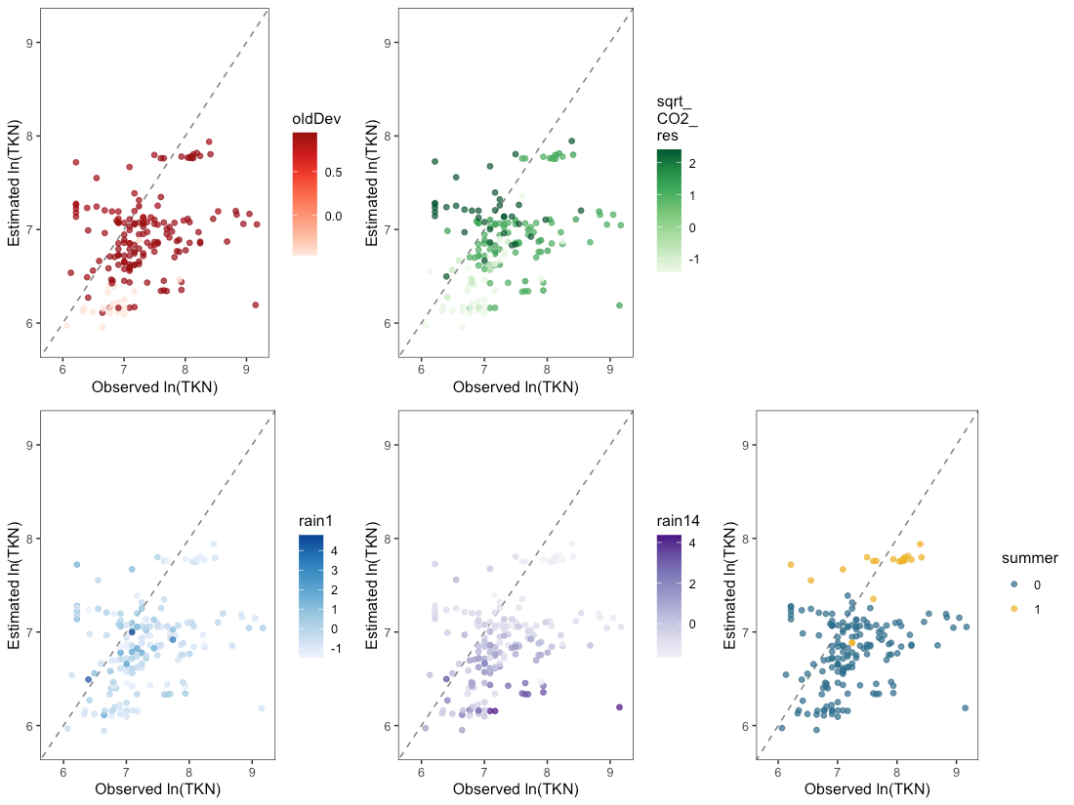
Figure 90. Estimated vs. observed plots for TKN validation data, with colors showing the magnitude of one spatial or temporal predictor (oldDev, sqrt_CO2_res, rain1, rain14, summer) at each data point. Individual points show how the observed values for ln(TKN) at the model validation catchments compare to the mean estimated values from the Bayesian model for the same catchments. Diagonal dashed lines show the 1:1 relationship, where estimated=observed.
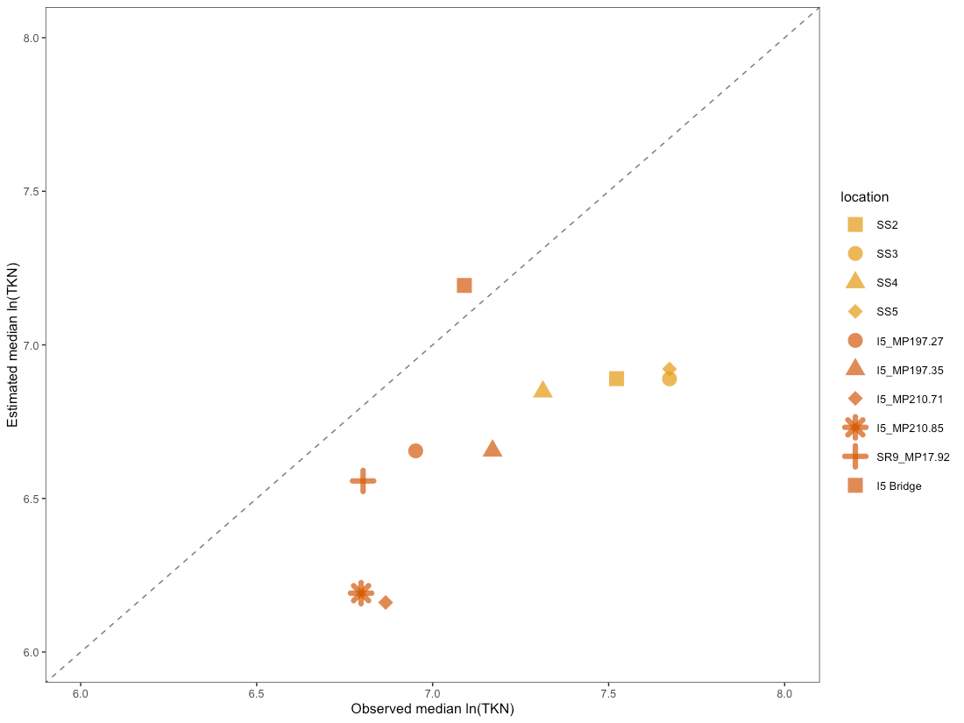
Figure 91. Median estimated vs. median observed plots for TKN at validation catchments. The diagonal dashed line shows the 1:1 relationship, where estimated=observed.

Model Fitting Conclusions
This section provides a summary of model fit for each COC, including sensitivity analysis and model validation. Discussion of water quality model utility on the Stormwater Heatmap is included for each COC.

Total Copper
Spatial predictor model: ln (total copper) = f (14-day rainfall, antecendent dry days, summer, impervious, ln_traffic_k100)
Primary sources of total copper to urban stormwater runoff in Washington State include wear of vehicle brake pads; building materials such as roofing, treated lumber and siding materials; parking lots; and vehicle exhaust (Bookter 2017). Additionally, total copper in stormwater runoff is related to flow, rainfall intensity and antecedent dry period (Sharma et al., 2016).
The spatial predictor model for total copper is a clear improvement over the land use category model, and has good fit to the S8 fitting data. The spatial predictor model has an AIC value nearly seven points lower than that of the categorical land use model as assessed in the frequentist model fitting. Furthermore, error bars around the spatial predictor model covariates were much smaller than error bars around covariates from the land use category model (Figure 9).
During the Bayesian model fitting steps, we noted that the spatial predictor model fits particularly well to data from high ln_traffic_k100 locations (Figure 14). The model seems to over-predict total copper in some of the low-traffic locations from the S8 dataset; however, this may be that locations with low traffic also have higher variability in copper concentration over time. Additionally, the variability around the population-level intercept was relatively high, with one eighth of locations showing substantially different location-specific intercepts (Figure 16). This indicates that we might expect total copper levels to vary somewhat from our model predictions in new locations, although the slope of the relationship between ln(Cu) and the scaled and centered spatial predictors should be consistent.
The spatial predictor model for total copper fits the S8 data well and is robust to changes in the model structure. The calculated RSR for the Bayesian total copper model is 0.463, indicating a very good model. Removing influential data points (only one for copper) or changing the variance structure resulted in <2% change to model coefficients. However, removing the nesting structure of the random effects from the model had a substantial effect on model coefficients (44% change in ln_traffic_k100 coefficient, 8% change in impervious coefficient).
Model validation was performed using copper data from 21 outfalls that included busy streets, highway areas, high-density urban or industrial areas, and lower density residential areas. The total copper model generally fits the trends of the validation locations well: areas with high traffic or old development are correctly predicted to have higher copper concentrations than areas with low traffic and/or new/low development (Figure 72). However, the model generally over-predicts the range of possible copper values for most outfalls. The model fit data from high traffic locations very well (Figure 74), but over-predicted copper for other areas. Low rainfall frequently coincided with data points that fell outside of the model predictions (Figure 74).
In general, we think the copper model is a solid improvement over land use category models, and can be relied upon to show areas that are likely to have higher magnitudes of total copper in stormwater throughout the Puget Sound Basin. The overall estimates (especially 80% prediction intervals) may be higher than reality, particularly for low traffic/ newer development watersheds.

Total Suspended Solids
Spatial predictor model: ln (TSS) = f (1-day rainfall, 21-day rainfall, spring, oldDev, sqrt_CO2_road)
Sources of TSS to stormwater are challenging to quantify, but are generally related to degree of urbanization (Pope & Bevans, 1987). In urban stormwater, sediment source fingerprinting indicates that coarse sediments primarily originate from road deposited sediment, while fine particles originate from soils and storm grate sediments (Zhu et al., 2024). Road-deposited sediment includes anthropogenic sources (pavement wear, vehicle exhaust, tire and vehicle body wear, road salt, road paint, pedestrian debris, building and construction material); and natural sources (soil material, plant and leaf litter, atmospheric deposition) (Taylor & Owens, 2009). Additionally, high rainfall intensity and large amounts of rainfall, along with long antecedent dry periods, can lead to higher concentrations of suspended solids in runoff (Zhu et al., 2024).
The spatial predictor model for TSS offers a slight improvement over the land use category model, and has good fit to the S8 fitting data. The spatial predictor model has an AIC value 0.5 points lower than that of the categorical land use model as assessed in the frequentist model fitting. Furthermore, error bars around the spatial predictor model covariates were much smaller than error bars around covariates from the land use category model (Figure 21).
In the Bayesian model fitting plots, we see a large spread in TSS values at each location, indicating high inter-location variability (Figure 25). Nearly all location-specific intercepts arising from the nested structure of the model’s random effects overlapped well with the population-level intercept 95% credible intervals (Figure 28), indicating that we might expect the TSS model to fit well at new locations.
The calculated RSR for the Bayesian TSS model is 0.777, indicating an unsatisfactory model. However, the large spread in TSS values over time at each location is a clear contributor to the high RSR value. Because the Stormwater Heatmap links chemicals of concern to spatial landscape predictors (rather than temporal ones), we think that the high RSR is not reflective of the model’s utility in this context.
The TSS model is robust to changes in the model structure. Removing influential data points (two for TSS) or changing the variance structure resulted in a maximum of 7.2% change to model coefficients. Removing the nesting structure from the model had a moderate effect on the sqrt_CO2_road coefficient (14% change), but less effect on the oldDev coefficient (5.6% change) and the intercept (0.2% change).
Model validation was performed using TSS data from 19 outfalls that included busy streets, highway areas, high density urban or industrial areas, and low density residential areas. The TSS model fits the validation locations well, with the 50% prediction intervals doing a good job of capturing the median, and 80% prediction intervals capture almost all outlying data points (Figure 76). As with the S8 fitting data, the validation catchments also show a broad spread of TSS values over time for each catchment. Low quantities of rainfall may have limited effectiveness at transporting solids to storm drains, resulting in high variability over time.
In general, we think the TSS model is a solid improvement over land use category models, and can be relied upon to show locations of high TSS in the Puget Sound Basin. The model also has been shown to provide reliable predictions for TSS magnitude at new locations. Large variability in TSS values at each location may be the result of variable effectiveness of precipitation in transporting solids to storm drains.

Total Phosphorus
Spatial predictor model: ln (total phosphorus) = f (14-day rainfall, 1-day rainfall, summer, oldDev)
Sources of phosphorus in urban landscapes are heterogeneously distributed and include disparate contributors such as construction activities, fertilizers, street solids, animal waste, grass clippings, municipal wastewater, leaf litter, atmospheric deposition and automobile emissions (Zhou et al., 2026). Furthermore, impervious land cover increases total phosphorus in urban stormwater through decreased infiltration into soil and accelerated surface runoff (Jacobson, 2011; Yang and Lusk, 2018).
The spatial predictor model for total phosphorus offers a solid improvement over the land use category model, and has decent fit to the S8 fitting data. The spatial predictor model has an AIC value two and a half points lower than that of the categorical land use model as assessed by frequentist model fitting. Additionally, error bars around coefficients from the land use category model were substantially larger than those around spatial landscape model coefficients, further indicating that the spatial predictor model provides an improvement over the land use category model (Figure 34).
In the Bayesian model fitting plots, we see a large spread in total phosphorus values at some outfalls, with no clear pattern associated with spatial or temporal predictors (Figure 39). Temporally-specific contributors to phosphorus in urban landscapes include fertilizer application, grass clippings and leaf litter. These sources vary in their prevalence by season, which may not be captured by using only summer as a temporal predictor. Another portion of the Bayesian analysis involved examining location-specific intercepts that arise from the nested random effects structure, and comparing them to the population-level intercept. Location-specific intercepts showed some variability between locations (Figure 41), indicating that we might expect new locations to have a similar level of variability in their intercept values.
The calculated RSR for the Bayesian total phosphorus model is 0.656, indicating a satisfactory model. The large spread in total phosphorus values at some outfalls is a clear contributor to the high RSR value. Because the Stormwater Heatmap links chemicals of concern to spatial landscape predictors (rather than temporal ones), we think that the high RSR is not reflective of the model’s utility in this context.
The total phosphorus model is robust to some changes in the model structure. Removing influential data points (three for total phosphorus) or changing the variance structure had little effect on model coefficients (less than 5% change to coefficient values). However, removing the nesting structure from the model’s random effects resulted in a 37% increase in the oldDev coefficient.
Model validation was performed using total phosphorus data from 19 catchments that included busy streets, highway areas, high density urban or industrial areas, and a few low density residential areas. Three of the 19 catchments had high variability in total phosphorus values, while the other catchments had much less variability (Figure 80). Fifty percent prediction intervals fit the catchments with low variability well. ln contrast, the three catchments with high variability were generally underestimated by the model. The model validation catchments offer no clear pattern for catchments where model fit is good versus those where it is less good.
Total phosphorus turned out to be a challenging chemical to model in stormwater, perhaps because its main sources in urban areas are from divergent land uses. Lawns and roads contribute the majority of phosphorous load to stormwater, but land use affects the contribution from different sources. Lawns and leaf litter are more important in residential areas, while roads are more important in commercial and industrial areas (Waschbusch et al, 1999). These varied sources proved difficult to model with the data that were available. The unique timing of plant-based phosphorus sources to stormwater (fertilizer application, grass clipping, leaf litter) also led to high variability at monitored locations. While the total phosphorus spatial predictor model is a solid improvement over the land use category model, future modeling efforts would benefit from additional data as well as exploration of new spatial and temporal predictors for total phosphorus. Catchments in agricultural areas should also be included in a future analysis, as agricultural runoff is usually higher than urban runoff in total phosphorus, and the S8 fitting dataset was focused on catchments in urban areas rather than agricultural areas.

Total Zinc
Spatial predictor model: ln (total zinc) = f (14-day precip, summer, oldDev, sqrt_CO2_transport)
The largest contributing sources of zinc to stormwater are galvanized metals including roofs, ductwork and fences; and vehicle tire wear (Davis et al, 2001). In the spatial predictor model, the oldDev predictor serves as a method for capturing developed areas that may be more likely to contain galvanized metals, while the sqrt_CO2_transport predictor catches the contribution of vehicle tires to zinc in stormwater.
The spatial predictor model for total zinc offers improvement over the land use category model in terms of reduced uncertainty around coefficients. Model comparison with AIC indicates that the spatial predictor model has better fit to the S8 data than the land use category model by nearly four points. Error bars around coefficients from the land use category model are substantially larger than those around spatial predictor model coefficients, indicating a large level of uncertainty in the land use category model (Figure 47). This further reduces the utility of the land use category model across the Puget Sound basin.
In the Bayesian model fitting plots, we see a large spread in total zinc values at a few locations (Figure 51), with no pattern detected for which locations have high variability. This may be caused by a combination of two factors: zinc from galvanized metal is heterogeneously distributed across landscapes, and rainfall dynamics can mobilize zinc in different ways. Within a single catchment, stormwater pollutant concentrations can vary based on when samples are collected during a storm, with high concentrations during initial runoff, and intra-event variability as different parts of the catchment contribute runoff at different times. Additionally, storm intensity, duration, and antecedant dry period can affect how much zinc is mobilized into stormwater. Interestingly, sites with high oldDev and sites with high sqrt_CO2_transport had lower variability (Figure 52, top panels).
Another portion of the Bayesian analysis involved examining location-specific intercepts that arise from the nested random effects structure, and comparing them to the population-level intercept. Location-specific intercepts show high variability between locations, with only half of the locations overlapping significantly with the population-level intercept (Figure 54). This indicates that we might expect total zinc levels to vary somewhat from our model predictions in new locations, and that we might expect high variability around prediction intervals for new samples.
The calculated RSR for the Bayesian total zinc model is 0.489, indicating a very good model. Despite the large spread in total zinc values at several locations, the spatial predictor model fit the majority of S8 data reasonably well (Figure 51).
The total zinc model is robust to changes in the model structure. Removing influential data points (five for total zinc) had little effect on model coefficients (maximum of 2% change in coefficient values). Changing the model variance structure had a small impact (5% change in oldDev coefficient), and removing the random effects nesting structure had little impact (up to 3.5% change in coefficient values).
Model validation was performed using total zinc data from 21 catchments that included busy streets, highway areas, high density urban or industrial areas, and several low density residential areas. Prediction intervals generated from the model overestimate zinc concentrations for some sites, and under-estimated them in others (Figure 84). Rainfall and season also seem to play a role: samples where zinc was overestimated had low 14-day cumulative rainfall (Figure 86, bottom left), and the most over-estimated samples occurred in summer in areas with high sqrt_CO2_transport. This indicates the possibility of low mobilization of zinc to outfalls during collection of some samples.
One of the challenges of fitting zinc models is that a major contributor, galvanized metals, are found in localized hotspots that are difficult to categorize across a landscape. Galvanized materials may be more prevalent in commercial and industrial areas, but residential areas can also be sources of galvanized metal. Currently, there are no remote sensing tools that can distinguish galvanized metal surfaces from non-galvanized surfaces, although this capability may be available in the future. A spatial predictor layer for galvanized surfaces will likely be a game-changer for modeling zinc concentrations in stormwater. For now, the Stormwater Heatmap zinc layer can serve to highlight areas where zinc is likely to have higher concentrations.

Total Kjeldahl Nitrogen
Spatial predictor model: ln (TKN) = f (14-day rainfall, 1-day rainfall, summer, oldDev, sqrt_CO2_res)
TKN represents the sum of total organic nitrogen (nitrogen bound to carbon from living organisms), ammonia and ammonium. Its primary sources into stormwater are from plant debris (Jani et al., 2020), road runoff (Ma et al., 2021), pet waste, chemical fertilizers, leaking sewers and soil erosion (Carey et al., 2013). The nitrogen components of TKN are positively correlated with total rainfall and antecedant dry period (Jani et al, 2020).
During frequentist model fitting, we determined that the spatial predictor model for TKN is a clear improvement over the land use category model, with an AIC value almost five points lower than that of the categorical land use model. Furthermore, error bars around the spatial predictor model covariates were much smaller than error bars around covariates from the land use category model (Figure 62). Approximately 10% of samples analyzed for TKN were non-detect. Regression on order statistics (ROS) were used during frequentist model fitting to generate TKN values below the detection limit, utilizing the data distribution for each location.
In the Bayesian model fitting, we used a built-in censored data function from the brms package (Buerkner, 2017) to address the censored data points. In data plots, we see a large spread in TKN values at all three Snohomish County location (Figure 66). This intra-location variablity in TKN coincides with low sqrt_CO2_res and oldDev locations (Figure 67, top panels), and may be caused by variability in the timing of plant debris that is swept into storm drains in less urban areas.
The calculated RSR for the Bayesian TKN model is 0.682, indicating a satisfactory model. The large spread in TKN values in several of the locations is a clear contributor to the high RSR value.
Location-specific intercepts arising from the nested structure of the model’s random effects showed a relatively small amount of variability between locations (Figure 69), indicating that we might expect the TKN model to fit well at new locations.
The TKN model is relatively robust to changes in the model structure. Removing influential data points (2 for TKN, one of which was randomly generated for a censored data point) resulted in a small impact to the oldDev coefficient, which changed by 3.5%. Changing the variance structure resulted in a moderate impact to the coefficient for oldDev (9.2% change) and little impact to the other coefficients. Removing the random effects nesting structure from the model had a relatively larger effect on the sqrt_CO2_res coefficient (23% change).
Model validation was performed using TKN data from 10 outfalls. Nine of these catchments were located in high-traffic roads/ highways, while the remaining catchment was centered on a high-traffic bridge but also included some surrounding high-density residential area. The model prediction intervals overlap the validation data very nicely, indicating good fit of the model to the validation data (Figure 88). These results are promising, but additional data in commercial, industrial and low-density residential areas would be valuable for validating model fit in a variety of environments.
In general, we think the TKN model is a solid improvement over land use category models, and can be relied upon to show locations of high TKN in the Puget Sound Basin. The model also has been shown to provide reliable predictions for TKN magnitude at new (but mostly high-traffic roadway) locations.

Translating Equations to the Stormwater Heatmap
The process of translating water quality equations for constituents of concern to the Stormwater Heatmap involved manipulation of the spatial predictor data grid followed by application of Bayesian COC equations to calculate estimated COC concentrations by location.

Preparing Spatial Predictors Images Across the Puget Sound Basin
Multi-band spatial landscape predictor images across the Puget Sound basin (described in Chapter 2: High-Resolution Land Cover) were first transformed where necessary (CO2_res, CO2_road, and CO2_transport predictors were square-root transformed, and traffic was ln-transformed) then scaled and centered using the mean and standard deviation from the fourteen S8 catchment locations. The resulting images were convolved with a circular kernel of 100 meters to calculate the mean value in the neighborhood of each point. Finally, the convolved spatial predictor images were clamped at +/- 3 standard deviations of the S8 catchment location values. Clamping was necessary to avoid extrapolating beyond the range where linear relationships between spatial predictors and COCs may no longer apply.

Preparing Visualization Layers
To visualize COC concentrations via a webmap, we applied water quality regression equations to the prepared spatial predictor images to generate predicted concentrations for the study area.
Using the scaled and centered multi-band spatial landscape predictor image, we applied the simplified Bayesian regression equations to the convolved spatial predictor dataset.

Applying Mixed Effects Equations to the Stormwater Heatmap
The equations that were fitted to the S8 monitoring data required a specified variance structure to account for heteroskedasticity, as well as a nested structure for the random effects.
With respect to translating mixed effects model equations to the Stormwater Heatmap, the equations are substantially simplified. Predicting mean COC concentrations allow the variance structure and nested random effects terms to go to their mean values of 0. Furthermore, rainfall, antecedent dry days and seasonal predictors, where applicable, are also set to their mean value of 0. Thus the generic COC equation:
$$ln(COC_{ijk})=β_{0}+β_{1}*rain_{i}+β_{2}*summer_{i}+β_{3}*predictor1_{ijk}+β_{4}*predictor2_{ijk}+a_{k}+a_{j|k}+ϵ_{ijk}$$
$$a_{k}∼N(0,σ_{agency})$$
$$a_{j|k}∼N(0,σ_{location})$$
$$ϵ_{ijk}∼N(0,σ_{k})$$
becomes simplified to:
$$ln(COC)=β_{0}+β_{1}*0+β_{2}*0+β_{3}*predictor1+β_{4}*predictor2+0+0+0$$
and finally:
$$ln(COC)=β_{0}+β_{3}*predictor1+β_{4}*predictor2$$

Citations:
Amini, H., M. Danesh-Yazdi, Q. Di, W. Requia, Y. Wei, Y. AbuAwad, L. Shi, M. Franklin, C.-M. Kang, J. M. Wolfson, P. James, R. Habre, Q. Zhu, J. S. Apte, Z. J. Andersen, X. Xing, C. Hultquist, I. Kloog, F. Dominici, P. Koutrakis, and J. Schwartz. 2022. Hyperlocal super-learned PM2.5 components across the contiguous US. Research Square. https://doi.org/10.21203/rs.3.rs-1745433/v2.
Bookter, A. 2017. Copper and zinc in urban runoff: Phase 1 - Potential pollutant sources and release rates. Washington State Department of Ecology. 17-03-018. https://fortress.wa.gov/ecy/publications/SummaryPages/1703018.html
Buerkner, Paul-Christian, 2017. brms: An R Package for Bayesian Multilevel Models Using Stan. Journal of Statistical Software, 80(1), 1-28. doi:10.18637/jss.v080.i01
Carey, R.O., G.J. Hochmuth, C.J. Martinez, T.H. Boyer, M.D. Dukes, G.S. Toor, J.L. Cisar, 2013. Evaluating nutrient impacts in urban watersheds: Challenges and research opportunities. Environmental Pollution, Vol 173, pp 138-149. https://doi.org/10.1016/j.envpol.2012.10.004
Davis, A.P, M Shokouhian, S. Ni, 2001. Loading estimates of lead, copper, cadmium, and zinc in urban runoff from specific sources. Chemosphere 44 (5), pp 997-1009. https://doi.org/10.1016/S0045-6535(00)00561-0
Faraway, Julian J. Extending the Linear Model with R: Generalized Linear, Mixed Effects and Nonparametric Regression Models. Boca Raton (FL): Chapman & Hall/CRC; 2006.
Gurney, K.R., J. Liang, R. Patarasuk, Y. Song, J. Huang, and G. Roest. 2019. Vulcan: High-Resolution Annual Fossil Fuel CO2 Emissions in USA, 2010-2015, Version 3. ORNL DAAC, Oak Ridge, Tennessee, USA. https://doi.org/10.3334/ORNLDAAC/1741
Helsel, Dennis R. Statistics for Censored Environmental Data Using Minitab and R. 2nd Edition. Hoboken, NJ: John Wiley & Sons, Inc; 2012.
Hobbs, W., B. Lubliner, N. Kale, and E. Newell, 2015. Western Washington NPDES Phase 1 Stormwater Permit: Final Data Characterization 2009-2013. Washington State Department of Ecology, Olympia, WA. Publication No. 15-03-001. Available online at: https://fortress.wa.gov/ecy/publications/SummaryPages/1503001.html
Jacobson, CR, 2011. Identification and quantification of the hydrological impacts of imperviousness in urban catchments: A review. Journal of Environmental Management 96 (6), pp 1438-1448. https://doi.org/10.1016/j.jenvman.2011.01.018
Jani, Jariani, Yun-Ya Yang, Mary G. Lusk, Gurpal S. Toor, 2020. Composition of nitrogen in urban residential stormwater runoff: concentrations, loads, and source characterization of nitrate and organic nitrogen. PLoS One. https://doi.org/10.1371/journal.pone.0229715
Kay, M, 2022. tidybayes: Tidy Data and Geoms for Bayesian Models. R package version 3.0.2. Available online at: http://mjskay.github.io/tidybayes/
King County Maps ArcGIS: Catchment boundaries derived from terrain data layer. Website visited 9/14/2026. Available online at: https://kingcounty.maps.arcgis.com/apps/mapviewer/index.html?layers=3bae11e8b97642ae8bdd1f86d8bd0441
Lee, Lopaka, 2020. NADA: Nondetects and Data Analysis for Environmental Data. R package version 1.6-1.1. Available online at: https://CRAN.R-project.org/package=NADA
Loy A, Hofmann H, 2014. HLMdiag: A suite of diagnostics for hierarchical linear models in R. Journal of Statistical Software, 56(5), 1-28. doi:10.18637/jss.v056.i05.
Ma, Yukun, Shihui Wang, Xiaoyue Zhang, Zhenyao Shen, 2021. Transport process and source contribution of nitrogen in stormwater runoff from urban catchments. Environmental Pollution. Vol 289 (15). https://doi.org/10.1016/j.envpol.2021.117824
Moriasi D N, Arnold J G, Van Liew M W, Bingner R L, Harmel R D, Veith T L, 2007. Model evaluation guidelines for systematic quantification of accuracy in watershed simuations. American Society of Agricultural and Biological Engineers. Vol 50(3): 885-900.
Pesaresi M, Ehrlich D, Florczyk A, Freire S, Julea A, Kemper T, Soille P, Syrris V (2015): GHS- BUILT R2015B - GHS built-up grid, derived from Landsat, multitemporal (1975, 1990, 2000, 2014) European Commission, Joint Research Centre (JRC) [Dataset] PID: https://data.jrc.ec.europa.eu/dataset/jrc-ghsl-ghs_built_ldsmt_globe_r2015b
Pierce County Public Works and Utilities (2012). Water Year 2011 Annual Stormwater Monitoring Report NPDES Municipal Phase 1 Permit (Effective Feb 2007) Section S8.D - Stormwater Charaterization Monitoring. Tacoma, WA.
Pinheiro J, Bates D, DebRoy S, Sarkar D, R Core Team, 2021. nlme: Linear and Nonlinear Mixed Effects Models. R package version 3.1-152. Available online at: https://CRAN.R-project.org/package=nlme
Pope, L.M and H.E. Bevans, 1987. Relation of urban landuse and dry-weather, storm, and snowmelt flow characteristics to stream-water quality, Shanganunga Creek Basin. Topeka Kansas, US Geologic Survey Water-Supply. Paper 2283.
Quality Assurance Project Plan for King County Stormwater Monitoring Under the NPDES Phase 1 Municipal Permit WAR04-4501 (Issued February 2007). Updated November 2010. King County Department of Natural Resources and Parks, Water and Land Resources Division, Science Section. King Street Center, KSC-NR-0600, 201 South Jackson Street, Suite 600, Seattle, WA 98104.
Quality Assurance Project Plan (QAPP) Stormwater Characterization Monitoring S8.D Final. December 2008. Prepared by Snohomish County Public Works, Surface Water Management Division, 3000 Rockefeller Ave, Everett, WA 98201.
R Core Team, 2021. R: A language and environment for statistical computing. R Foundation for Statistical Computing, Vienna, Austria. Available online at: https://www.R-project.org/
Robertson J, Howe E. High-resolution raster dataset of Annual Daily Traffic on roads in the Puget Sound trough during 2016 and 2018. [Manuscript in preparation]
Robertson J, Pierce KB, Nilsen C and Howe E. High-resolution 7-class Land Cover Dataset of the Puget Sound. [Manuscript in preparation]
Section S8.D - Stormwater Characterization Quality Management System Planning Document, Quality Assurance Project Plan. NPDES Phase I Municipal Stormwater Permit, Permit No.: WAR04-4503. Revision: R2D0 (Final). Draft revised: 03/31/2011.
Sharma, A.K., L. Vezzaro, H. Birch, K. Arnbjerg-Nielsen, P.S. Mikkelsen, 2016. Effect of climate change on stormwater runoff characteristics and treatment efficiencies of stormwater retention ponds: a case study from Denmark using TSS and Cu as indicator pollutants. Springerplus 5(1): 1984. doi: 10.1186/s40064-016-3103-7
Singh J, Knapp H V, and Demissie M, 2004. Hydrologic modeling of the Iroquois River watershed using HSPF and SWAT. ISWS CR 2004-08. Champaign, Ill.: Illinois State Water Survey. Available online at: https://www.isws.illinois.edu/pubdoc/cr/iswscr2004-08.pdf
Stan Development Team, 2022. Stan Modeling Language User’s Guide and Reference Manual. Available online at: https://mc-stan.org/users/documentation/.
Taylor, K.G., and P.N. Owens, 2009. Sediments in urban river basins: a review of sediment-contaminant dynamics in an environmental system conditioned by human activities. Journal of Soils and Sediments 9(4): 281-303. DOI:[10.1007/s11368-009-0103-z](DOI:%5B10.1007/s11368-009-0103-z){.uri}
Thornton, M. M., Shrestha, R., Wei, Y., Thornton, P. E., & Kao, S.-C. (2022). Daymet: Daily Surface Weather Data on a 1-km Grid for North America, Version 4 R1 (Version 4.1). ORNL Distributed Active Archive Center. https://doi.org/10.3334/ORNLDAAC/2129
United States Census Bureau: 2010 Census Blocks. Website visited 2/8/2024. Available online at: https://www.census.gov/geographies/mapping-files/time-series/geo/tiger-line-file.2010.html#list-tab-790442341
U.S. Environmental Protection Agency, 2009, Statistical analysis of groundwater monitoring data at RCRA facilities, Unified guidance, EPA 530-R-09-007.
USGS Highway Runoff DataBase. Website visited 11/01/2021. Available online at: https://www.usgs.gov/software/hrdb-highway-runoff-database-software-page
USGS National Elevation Dataset. Website visited 2/8/2024. Available online at: https://pubs.usgs.gov/of/2011/1127/ned.html
USGS StreamStats. Website visited 9/14/2026. Available online at: https://streamstats.usgs.gov/ss/
Waschbusch, R.J., W.R. Selbig, and R.T. Bannerman, 1999. Sources of Phosphorus in Stormwater and Street Dirt from Two Urban Residential Basins In Madison, Wisconsin, 1994–95. U.S. Geological Survey Water-Resources Investigations Report 99–4021.
Washington Department of Commerce: Puget Sound Mapping Project. Website visited 2/8/2024. Available online at: https://www.commerce.wa.gov/serving-communities/growth-management/puget-sound-mapping-project
Yang, YY., and Lusk, M.G., 2018. Nutrients in Urban Stormwater Runoff: Current State of the Science and Potential Mitigation Options. Curr Pollution Rep 4, 112–127. https://doi.org/10.1007/s40726-018-0087-7
Zhou, B., J. Radosavljevic, C.T. Parsons, F. Rezanezhad, B. MacVicar, K. Pi, Y. Deng, A.R. Shahvaran, S. Slowinski, B. Gharabaghi, P. Van Cappellen, 2026. Phosphorus in urban stormwater runoff: a review of sources, transport pathways, and control solutions. Environmental Reviews 34, pp. 1-24, 10.1139/er-2025-0247
Zhu, Y., W.C. Hinds, S. Kim and C. Sioutas, 2002a. Concentration and size distribution of ultrafine particles near a major highway in Los Angeles. Atmospheric Environment, 36(27) 4323-4335
Zhu, Y., W.C. Hinds, S. Kim, S. Shen and C. Sioutas, 2002b. Study of the ultrafine particles and other vehicular pollutants near a major highway in Los Angeles. Atmospheric Environment, 36(27) 4337-4346
Zhu, Ling, Yukun Ma, Ashantha Goonetilleke, 2004. Fingerprinting to trace sources of suspended soilds in the transport of heavy metals in urban stormwater runoff. Environmental Pollution, Vol 363(1). https://doi.org/10.1016/j.envpol.2024.125088
Zuur, AF, Ieno EN, Walker NJ, Saveliev AA, Smith GM. Mixed Effects Models and Extensions in Ecology with R. New York (NY): Springer; 2009.

Phase I Permittees include: cities of Tacoma and Seattle; King, Snohomish, Pierce and Clark counties; Ports of Tacoma and Seattle. For this study, all data were used with the exception of those from Clark County (outside of the Puget Sound region) and Port of Seattle (too different from all other Puget Sound watersheds).
As described in Faraway (2006), pg 156, REML estimation should not be used to compare models with different fixed effects because REML estimates the random effects by considering linear combinations of the data that remove the fixed effects. If the fixed effects change, the likelihoods of the two models will not be directly comparable. However, REML is generally considered to give better estimates for the random effects, so final models were fitted with REML

